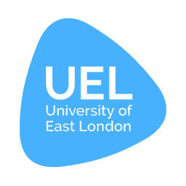
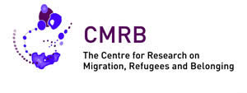

Centre for Research on Migration, Refugees and Belonging (CMRB)
Annual Report
2015/16

Content

Aims and Objectives
2

Message from the Directors
3

Events 2015 -16
4

Events 2016 - 17
10

EUBORDERSCAPES
11

Racism and Political Mobilisation, thinking historically and transnationally
13

Refugee Council Archive at UEL
19

Centre related Mas
23

Directors’ Activities
24

Members & Associated Members
26

PhDs and Post-Doctoral Researchers
32

Aims and Objectives

The Centre for Research on Migration, Refugees and Belonging (CMRB), based in the School of Social Sciences of the University of East London, is led by Directors Professors Nira Yuval-Davis and Gargi Bhattacharyya. It brings together interdisciplinary work carried out within the school in the related areas of migration and refugee studies; diasporas and social cohesion; racism, nationalism and political religions and citizenship, identity and belonging. CMRB collaborates with individuals, academic institutions and organisations inside and outside UEL on a national and international level. The aim is to facilitate research, conferences and seminars, in order to build knowledge and provide a space for debate and creative thinking. Disciplinary and methodological approaches employed by CMRB members demonstrate an enriching heterogeneity, ranging from history to ethnography, narrative analysis to performance, anthropology to cultural studies, and sociology to film studies. Research seeks to engage with political and policy debates as well as more abstract theoretical concerns, and aims to involve participants in various stages of the research and dissemination of results.

CMRB benefits from its unique location at the heart of East London, an area which has seen some of the highest rates of international settlement in Europe. The Refugee Archive and other related collections held at the University enhance the potential of the Centre to be at the cutting edge of its fields of study.

Aims and objectives:

- To advance excellence in theoretical, applied and policy-oriented research on migration, especially forced migration, and on citizenship and belonging.

- To promote multidisciplinary approaches.

- To contribute to consolidation of systematic and coherent perspectives on migration and belonging in the areas of theory, policy and practice.

- To give the views of migrants and other marginalised and racialised groups an active voice.

- To promote dissemination of information about migration, especially forced migration, from migrant/refugee perspectives.

- To inform the practice of those working with and for migrants and other marginalised and racialised groups.

- To maintain and develop the Refugee Archive at UEL as a leading international resource in the study of forced migration and other related areas of concern to the Centre, and to encourage wide access.

- To promote links with migrant and racialised communities in East London, especially refugee communities.

- To serve as a centre of reference for those interested in migration to/from East London, and the latter’s role as an historic place of asylum.

- To support teaching programmes in the field of migration, notably the postgraduate programme in Refugee Studies and Conflict, Displacement and Human Security.

- To organise seminars, workshops, conferences and other activities which will serve internal and external audiences.

- To liaise among UEL staff and postgraduate students with the aim of initiating and sponsoring research projects consistent with the aims of the Centre and which are to be funded by external agencies.

- To strengthen international links with academic and non-academic institutions in related fields.

Message from the Directors
Welcome to this edition of the CMRB Annual Report.
This year has seen significant developments in the work of CMRB, both in its academic and impact work. Much of it was linked to activities around our research on Everyday Bordering as part of the EUBorderscapes project which has now been formally completed. CMRB hosted the Policy Impact international conference of the project in November (10 - 12th) as well as led a variety of public engagements, in universities and in many other venues (including the House of Commons) together with its civic partners to discuss issues of everyday bordering, often focused around the film the team produced last year https://www.youtube.com/watch?v=myoXPB9naAU. In addition the UEL everyday bordering research team (composed of Georgie Wemyss, Kathryn Cassidy and Nira Yuval-Davis) has been busy writing academic and non-academic papers, editing two special issues of highly respected academic journals and starting to write a book on Bordering for Polity Press (see the section on publications), analysing and reporting the findings of the research, which can be viewed at http://cms.uel.ac.uk/~/media/Schools/Social-Sciences/CMRB/EUBorderscapes-project-leaflet-report.ashx?la=en
At the same time Gargi Bhattacharyya, under the auspices of CMRB, has continued to organise the ESRC-funded seminar series, ‘Racism and Political Mobilisation’ with successful events in Birmingham, Manchester, London and Glasgow. The series will end with a two-day international conference to be held at UEL in January 2017. We hope that members of CMRB will take an active part in this conference and a call for papers will be circulated in the autumn. A number of journal special issues and other publications are planned from the outcomes of this series.
We also continued our series of once a semester symposia on different aspects of Gender and Fundamentalism co-hosted with SOAS’s Centre for Gender Studies and are working on a special issue of the journal Feminist Dissent http://journals.warwick.ac.uk/index.php/feministdissent/issue/view/2 based on a selection of papers presented in these symposia, due to be published next March.
Other CMRB publications emanated out of our last year's conference on Anti-Jewish and Anti-Muslim Racisms and the Question of Palestine/Israel, in the form of a Working Papers series co-edited by Jamie Hakim and Nira Yuval-Davis. http://hdl.handle.net/10552/4944
CMRB also continued to host our successful seminar series, including important events on the themes of Black Lives Matter in the UK context, histories of Anti-Jewish racisms, Nation and Belonging. We also supported an exciting event co-ordinated by Alice Mukaka at the Arcola Theatre on performance and activism.
We would like to use this opportunity to thank Jamie Hakim for his hard and loyal work as CMRB research administrator and wish him the best of luck in his new full time academic lectureship at the University of East Anglia as well as his new exciting research project on masculinities. However, CMRB could not have continued working so efficiently if it had not been for Lizzy Shrimpton taking over from Jamie and we would very much like to use this space to let her know how much we appreciate her hard and committed work on our behalf.
CMRB, as can be seen from its varied and rich activities, works closely together with various partners, academic and non-academic, local, national and international. It is considered an international centre of excellence and as can be seen from the members’ activities we are in constant demand to engage in various academic and non-academic forums. Given the current multi-layered political, social and economic crisis and its close relationship with issues of refugees, migration and various forms of belonging, racism and right wing populism and authoritarianism, our work is more important and urgent than ever.
We are pleased to let you know that we have asked two other major members of CMRB, Professor Giorgia Dona and Dr Georgie Wemyss, to join us to co-direct CMRB from the beginning of next academic year, so that we can expand our activities in response to the current demands and we warmly welcome them. CMRB members will have the official opportunity to meet and hear them in CMRB AGM which will take place on Monday, the 10th of October.
Nira Yuval-Davis
Gargi Bhattacharyya
Events 2015 – 16
Gender, Fundamentalism and the 'Prevent Agenda'
Saturday 17th October 2015, 2 – 5pm, SOAS, University of London
This seminar looked at various issues raised by the 'Prevent agenda' in relation to gender and fundamentalism. The speakers were Tehmina Kazi (British Muslims for Secular Democracy), Irene Zempi (Nottingham Trent University), Aisha Phoenix (Goldsmiths) and Rahila Gupta (Southall Black Sisters).
Black Lives Matter – the UK context
October 2015

Adam Elliott-Cooper (University of Oxford) and Cherelle Brown (Birkbeck and Black Lives Matter US) led a discussion about police violence against black communities and how we can learn to resist state violence against black communities in an event that included participation by many students.

Borderscapes: Borders and Bordering in Contemporary Europe
(EUBORDERSCAPES Policy & Impact Conference)
10 – 12th November 2015, Docklands Campus, University of East London (UEL)
EUBORDERSCAPES is an international research project funded through the EU’s FP7 Programme. Since 2013, the project has explored conceptual change in relation to the fundamental social, economic, cultural and geopolitical transformations that have taken place in relation to borders and bordering in and around the EU in the past three decades. This is a large-scale project with a consortium that includes 22 partner institutions from 17 different states, incorporating several non-EU countries.
As an EU funded project, EUBORDERSCAPES has a strong policy orientation. The purpose of the conference was to disseminate the major research findings of the project to EU and other European policy-makers, activist groups, academics and other interested parties whilst at the same time providing a space for engaged discussion on the themes arising from the project. Various leading representatives of these groups spoke at the conference on a range of topics that included: The Reconfiguration of Post-Soviet Borders and Conceptual Change; Borders and Critical Geographies of Neighbourhoods; Post Colonial Bordering and Euro-African Borderscapes and Borders, Intersectionality and the Everyday. There was also a film festival that exhibits films based on ethnographic work conducted by different project partners, drama-based workshops exploring the conference themes and guided walks around London’s borderscapes.

New Research on the Middle East
Monday 14th December 2015, 4 – 6pm, Docklands Campus, UEL
Giulia Daniele, CMRB, UEL
Women, Reconciliation and the Israeli-Palestinian Conflict: The Road Not Yet Taken
Giulia Daniele’s talk was founded on the theoretical analysis and the fieldwork evaluation reported on in her Ph.D. dissertation, which has been published by Routledge in the form of a book entitled Women, Reconciliation and the Israeli-Palestinian Conflict: The Road Not Yet Taken. One of the main objectives of her research has been to analyse the most significant Palestinian and Israeli women’s political initiatives that have been influenced by and, in the majority of cases, prevented by obstacles associated with the Israeli military occupation in the last decade.

Despite the majority of women’s political proposals and actions that have been relegated to the margins of the mainstream arena, a few of them have succeeded in finding alternative politics and approaches that have assisted them in their commitment to the struggle to end the Israeli military occupation. In such a framework, the academic salience of Giulia’s study is the provision of an additional contribution to the current debate on the process of making Palestinian and Israeli women activists more visible, and the importance of this process as being one of the most meaningful ways in which to open up areas of enquiry around relevant prospects for a fair resolution of the Israeli-Palestinian conflict.
Sharri Plonski, SOAS
New Borders – Carving a Palestinian Space into the Mixed City of Jaffa-Tel Aviv
Acts of subversive cartography have become a common practice of Palestinian-citizen resistances inside Israel. Intertwined as part of the dialectic, if asymmetrical, relationship that exists between ‘power’ and ‘resistance’, they act as a window both into the apparatuses employed to colonise Palestinian space inside Israel and the insurgent practices different communities have articulated in response. This encounter – between Zionist erasures and the struggle to root and re-entrench Palestinian space – produces the particular story, the particular space, in which both are housed, the lines and borders of which are articulated and disrupted through unique spatial relations. In this talk, Sharri Plonski explored the everyday and catalytic resistances that re-map, re-sign and reclaim Palestinian
space in Jaffa-Tel Aviv. Through an exploration of a spectrum of practices, she investigated how power is activated, disarticulated and reshaped through struggle that is both present and absent from Israeli-Zionist productions of space; and how struggle is articulated and mediated by the same conditions.
Eylem Atakav, University of East Anglia
‘Until Every Child is Safe’: Representing ‘Legitimised’ Abuse and Child Brides on Screen
According to the UNICEF report entitled ‘Ending Child Marriage: Progress and Prospects’ (2013), there are 700 million women who were married as children, and 280 million girls are at risk of becoming child brides. In Turkey, according to the reports written by feminist organisations 1 in 3 marriages there is a child. These figures are alarming and signal the need for further and urgent research in the field. Working on a documentary film on ‘child brides’ in Turkey is Eylem Atakav’s first exposure to filmmaking, therefore it poses challenges to her as an academic, who focuses on theories around feminism and media rather than filmmaking practice.

In this paper, Eylem critically reflected upon and shared the findings of her research into the representation of child brides in the media, with the aim of answering a key question: what kind of a visual language is used in the Turkish media in the depiction of girls as brides? She argued that on screen portrayals of married girls are presented as individualised stories of victims, and they reinforce a focus on tradition and religion rather than identify issues inherent in the law, politics and society. In linking theory and practice, she also presented an account of the methodological issues around representation in the production of her documentary on ‘child brides’ in Turkey. The film explores what happens after child marriage by focusing on the stories of four women and making their experiences visible, in an attempt to contribute to and advance debates around this significant, complex and emotionally charged human rights issue which has often been discursively silenced.

The Role of Rights Activism, Academia and Performing Arts Practices: A conversation (UEL/Nine Lives Symposium)
Monday 25th January 2016, 3 - 9pm, Arcola Theatre
Bridging the gap between arts practitioners, academia and migrant rights activists

As part of Nine Lives Theatre National Tour, one of the important pre-show events organized with partners was a critical discussion day on 25th January 2016 at Arcola Theatre, London.

Organized by Alice Mukaka, a UEL PhD student affiliated with CMRB & CNR and supported by the UEL’s School of Social Sciences, Global Studies and ADI, a symposium titled “Rights Activism, Academia and Arts Practices: a Conversation” brought together inspiring speakers and audience from the arts community, rights activists and researchers in Higher Education and engaged them in a dialogue on the issues of migration, belonging, social justice and identity.

Drawing on the usefulness of raising awareness on the pressing issues of migration and belonging facing asylum seekers and refugees, the discussions and contributions reflected on the coming together of arts practices, the university scholarship and rights activism as educational areas to inspire change. It also extended to finding possible strategies on how to consolidate isolated efforts together in a more aware and engaged framework for activism for the rights of asylum seekers, refugees and LGBTs. With over 100 bookings and an extensive waiting list, the event’s success was largely due to the cooperation, contributions and the enthusiasm all the attendees demonstrated which helped the discussions both productive and encouraging.

The contributors and participants provided in-depth insight as well as actionable and practical tools of engagement models, approaches and strategies that have worked in some specific contexts. Participants also provided various perspectives on how the discussed approaches could be utilized to aid the rights activism to become more effective in the on-going efforts of the projects of social justice and social change.

The activities of the day involved four sessions which covered a range of presentations that reflected on 1)the historicity of migration and border performance, 2)best practices in teaching ‘organizing’ as well as 3)practical approaches that work and 4)comparing experiences and on –the-ground stories of activism.

Alex Chisholm opened the first session “WHY STORIES MATTER” reflecting on her experiences of making, directing and touring Nine Lives Theatre. Her presentation eloquently reaffirmed the reasons why such a symposium was summoned in the first place: the importance of ‘bearing witness’ to stories that “deserve to be fairly heard’’. Debora Singer (Asylum Aid) gave a policy perspective and shared some of the highlights from her work in which arts is utilized in framing and performing some of their most sensitive Asylum Aid’s visions. Gargi Bhattacharyya (UEL) gave a thought provoking presentation on state border performance and its impact on the subjects of control. Activist and Feminist PJ Samuels performed some of her poetry and tackled the powerlessness of being made invisible, PJ Samuels’s notes: “Sometimes it is more comforting to be hated than to be invisible".

Professor Nira Yuval Davis (UEL) spoke about ‘identity, performance and social action’ with examples from her previous research with participatory theatre among refugees in London. Nira highlighted the benefits of theatre in sociological research, particularly, how using technics such as Playback and Forum Theatre as sociological research tools when exploring identity constructions produce different kinds of knowledge and insights for the participants as well as for the researchers.

Ruth Adele Tompsett (Middlesex University) spoke about the functions and impacts of some performing arts practices within academia and outside it. Dr Ananda Breed (UEL) gave a post conflict perspective on the use of political theatre and spoke about applying performance in such context. Tom Green (Platforma) highlighted how arts can respond to a refugee and migration crisis illustrating examples from the projects Platforma has been running for refugees. Visual artist and activist Bern O’Donogue introduced her project ‘Refugee Crossing and Dead Reckoning’, an art work of boats connecting us with people who died in the sea drowning in the pursuance of safety to Europe.

Catherine Donaldson (University of Brighton) shared with participants about her production project of a feature length documentary Not 1066 about migration in Hastings. In her presentation ‘Actors for Human Rights: holding audiences to account through testimony’, Christine Bacon (Ice &Fire) described the ways in which actors for human Rights use asylum monologues as a way to share stories and motivate. Charlotte Bence (EQUITY) gave a historical perspective of campaigns and collective action that made a difference in contemporary society thus called for bringing together isolated efforts as there is power in union. The sessions ended with a powerful performance by activist, poet and feminist Zita Holbourne who shared inspirational details of her campaigning experiences as a trade unionist and co-founder of Black Rising Against Cuts (BARAC).

The speakers and participants reiterated that performance arts indeed add to our understanding of asylum and migration. Feedback from the symposium indicated that the activists, artists and researchers should support each other’s efforts and speak to each other. Overall, attendees found the symposium a worthwhile conversation.

Alice Mukaka summed up the event:

As a student at UEL I think today has been an eye opening day. The different people, ideas, experiences have really moved me and motivated me to participate in things I’d never thought I’d such a gut reaction to. Amazing! (UEL student/symposium participant)

Positive and good practical approaches of engaging not only British citizens but global involvement to help make the challenges of refugees get address (symposium participant)

A wonderful event, rich with insights, compassion and passion! All compliments to the organizers who brought such a wonderful collaboration of UEL & non UEL participants (symposium participant)

Attendees were treated to a special live performance of Nine Lives after sharing refreshments and food provided by external sponsor ‘the Moshal Scholarship Foundation’.

An email was sent shortly after to all the attendees providing a channel through which they could continue the conversations via email as they think of the way forward.

The Immigration Bills and 'Everyday Bordering'
Tuesday 26th January 2016, 6 - 8pm, House of Commons
This meeting was chaired by Meg Hillier MP for Hackney South and Shoreditch and also had a panel of speakers, including Baroness Sally Hamwee, Liberal Democrats, House of Lord, member of the Joint Committee on Human Rights; Lucy Jones, UK Programme Manager, Doctors of the World; Stuart C. McDonald, MP for Cumbernauld, Kilsyth and Kirkintilloch East, Shadow SNP Spokesperson (Immigration, Asylum and Border Control); and Rachel Robinson, Policy Officer, Liberty.

Before the panel discussion, Nira Yuval-Davis was asked by the chair to introduce the issues involved and the film 'Everyday Borders’, which is based on our research findings and was produced in co-operation with Migrants Rights Network (MRN), Refugee and Migrant Forum for Essex and London (RAMFEL) and Southall Black Sisters (SBS) was shown. The experts who took part in the film also attended the meeting and took part in the discussion.
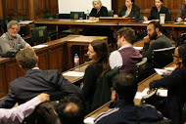
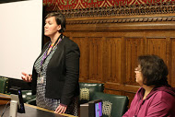
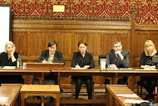
While there have been public debates on some aspects of the immigration bills, we believe that the issues raised in
the meeting have been relatively neglected till now in spite of their major importance to issues of civil liberties and community cohesion, and we hope that following the meeting, we can mobilize cross-party support and with your help, much more public attention.

Everyday Bordering and the Undermining of Multi-Ethnic Britain
'Everyday Borders' film screening and discussion
Monday 14th March 2016, 7 - 9pm, LSE
18 years after the Runnymede Trust set up The Commission for the Future of Multi-Ethnic Britain, chaired by Lord Bhikhu Parekh, immigration legislation is increasingly outsourcing border-guard roles to ordinary citizens extending the UK border further into everyday life. A recent example are the ‘Right to Rent‘ checks, introduced in the 2014 Immigration Act and compulsory in England since 1st February 2016 under which private landlords are obliged to check the identities and immigration status of any adult living in their properties. If they fail to do so they face fines and if the 2015 Immigration Bill becomes law, imprisonment. Similar requirements for employers, bank workers, health workers and education institutions to carry out immigration related checks and monitoring as part of their everyday work, are threatening the ‘vibrant multicultural society, at ease with its rich diversity’ that the Parekh Report hoped Britain would become.
There was a screening of the film ‘Everyday Borders’ (dir Orson Nava), followed by a panel discussion.
Speakers
Lord Bhikhu Parekh: Chair of The Commission for the Future of Multi-Ethnic Britain and author of the Parekh ReportOmar Khan: Director, Runnymede Trust
Pragna Patel: Director, Southall Black Sisters
Professor Nira Yuval-Davis: Director, Centre for research on Migration, Refugees and Belonging at UEL
Chair: Dr Suki Ali, Department of Sociology, LSE

Histories of anti-Semitism
Monday 14th March 2016, 4 - 6pm, UEL Docklands Campus

James Renton, Edgehill University
The Theology of Semitism
A significant body of scholarship has been published over the last few years that emphasises the Christian theological basis of late modern European ideas about Jews. Ivan Kalmar and Gil Anidjar, in particular, have arrived at this point as part of their wider critiques of the notion of a post-Enlightenment secular Europe. Central to their analyses has been their interest in the European pairing of Jews and Muslims. In this paper, I will build on this work by exploring the genealogy and life-story of the trinity of the Semite, the Semitic, and Semitism. I will argue that, contrary to most writing on the subject, the Semitic frame was shaped by traditions of Christian thought, which, crucially, holds answers for us regarding the tensions at the heart of the European pairing of Jews and Muslims, and why Semitism disappeared so suddenly from European thought in the middle of the twentieth century.

David Feldman, Birkbeck University
Antisemitism and the linguistic turn
It is well known that the term antisemitism was used in Germany in the 1870s and1880s by a movement of people who believed Jewish emancipation had been a great error. The movement imagined itself to be engaged in a war between German and Jewish interests. But what happened to the term antisemitism when it was taken up by Jews and their friends and when it travelled beyond Germany? This paper will explore the changing meanings of the term in antisemitism as it developed in Britain from the 1880s to the present. It will argue that these changes point to an epochal shift in Jewish history.

Brendan McGeever, Birkbeck University
The Racialisation of Class Politics in the Russian Revolution: a case study of the so-called 'Jewish Question'
The Bolsheviks came to power in 1917 with the promise of building a world free of class exploitation and other forms of oppression and domination. In the very moment of revolution, however, these sentiments were put to the test as a devastating wave of anti-Jewish violence broke out across the western borderlands of the former Russian empire. The pogroms posed fundamental questions of Marxist theory and practice, particularly since they revealed the nature and extent of working class attachments to anti-Semitic representations of Jewishness.
This paper seeks to offer a theoretically informed historical understanding of the remarkable capacity for class politics to become racialised in revolutionary Russia. It does so by mobilising the concept of ‘elective affinity’ and by situating its empirical findings within a wider discussion of the sociology of race and class.

Britishness, belonging and borders
Wednesday 11th May 2016, 2 - 4pm, UEL University Square Stratford (USS)

Nira Yuval-Davis
Everyday Bordering as a Contemporary British Political Project of Belonging
In this presentation Nira Yuval-Davis argued that everyday bordering has become a major technology of control of both social diversity and discourses on diversity in the UK, in a way that threatens to undermine the convivial co-existence of pluralist multi-cultural Britain. Drawing on research carried out in London between 2013 and 2015, Nira argued that such tendencies have been developing especially since the drive for securitisation following the events of 9/11 in 2001. However, these developments cannot be understood to be an outcome solely of securitisation, but rather they are part of an autochthonic political project of belonging, which emerged as a counter narrative to the multiculturalist project dominant during the 1980’s and 90’s. Nira also argued that such political project of belonging needs to be understood via the dialogical lens of situated intersectionality.

Eric Woods and Helen Kim
Unresolved Empire: Art, Identity and the Meaning of Britain’s Imperial Past
In this paper, Eric Woods and Helen Kim undertook a cultural analysis of Tate Britain’s recent exhibit, Artist and Empire: Facing Britain’s Imperial Past. To bring to light the multiple layers of affect and meaning that are imbricated in the exhibition, they draw on ethnographic interviews with curators and visitors, published reviews, and a close reading of the exhibition itself. Their analysis reveals a set of troubling findings regarding the status of British national identity and the significance of its imperial past, whose urgent implications reach far beyond the walls of the museum. In sum, they find that empire continues to be an unresolved, ambivalent and yet deeply felt issue in Britain today, which we analogise as a collective trauma simmering below the surface of contemporary social life. To conclude, they discuss how the exhibitions of this kind might better provide a locus for reconciliation.

Gargi Bhattacharyya
Disentitlement and the shifting boundaries of national belonging
This paper considers recent debates about the post-political and the emergence of anti-politics in order to revisit understandings of national belonging. The paper includes a review of ideas of disentitlement and of the impact of such processes of expropriation and expulsion on lived experiences of national belonging. Overall, Gargi Bhattacharyya argues that the performance of ethnic or cultural belonging is no longer (and perhaps never was) enough to ensure inclusion in the terms of everyday nationhood and it is in the light of these multiple exclusions that we should understand highly theatricalised claims of alternative nationhood.

For recordings of our events, please subscribe to the centre’s YouTube channel CMRB UEL, which can be found at https://www.youtube.com/channel/UC14gjMneXBcSp4XXbVR8i8w

Events 2016-17

Monday 10th October 2016, 4 – 6.30pm, Docklands Campus, Room EB.G.06
AGM, followed by seminar Brexit as a political project of un/belonging
Refreshments will be served at 5pm, prior to the seminar.
www.eventbrite.co.uk/e/cmrb-agm-and-seminar-brexit-as-a-political-project-of-unbelonging-tickets-28036499926

Wednesday 23rd November 2016, 4 – 6pm, Docklands Campus, Room EB.G.06
Seminar to be hosted by CMRB Visiting Fellows
Diasporas Survivals

Wednesday 30th November 2016, 1 – 2pm, Docklands Campus, Room EB.1.40
This is a collaborative event with the Centre for Narrative Research (CNR)
Taking Our Country Back: ‘Racism, Xenophobia and Donald Trump’s Place in Context’

Monday 12th December 2016, 5 – 7pm, USS Campus, Room US2.30
CMRB with CNR present, on behalf of the Academy of Social Sciences Study Group on Refugee Issues the AcSS Refugee Issues Special Interest Group Inaugural Event
Refugees, Belonging and Society

Thursday 19th and Friday 20th January 2017, 2 day conference, USS
ESRC Series End of Project Conference
Racism and Political Mobilisation

Wednesday 22nd February 2017, 4 – 6pm, Docklands Campus, Room EB.G.06
This is a collaborative event with the Centre for Cultural Studies Research (CCSR).
Stuart Hall’s legacy: Ongoing conversations around migration, politics and representation

Wednesday 15th March 2017, 4 – 6pm, Docklands Campus, Room EB.G.06
TBA

17th May 2017, 4 – 6pm, University Square Stratford (USS), Room US2.30
‘Go Home’ vans – Book launch

June 2017
Refugee Week

*Please note that this programme is subject to change and further details will be circulated nearer the time of each event. To keep up to date with events and other activities please subscribe to the CMRB mailing list at www.jiscmail.ac.uk, like CMRB on Facebook www.facebook.com/CMRBuel/?ref=aymt_homepage_panel and visit the centre’s website www.uel.ac.uk/Schools/Social-Sciences/What-we-do/Research/Centre-for-Research-on-Migration-Refugees-and-Belonging

If you have any suggestions for an event, would like to host a seminar, or just have a query, email Lizzy Shrimpton at e.shrimpton@uel.ac.uk

EUBorderscapes

What was the EUBORDERSCAPES project?
EUBORDERSCAPES was a 4 year project tracking and interpreting conceptual change in the study of borders through examining how different conceptualisations of state borders resonate in concrete contexts in everyday life. It included institutions from 17 countries within and outside the EU. It was led by Professor James Scott at the University of Eastern Finland and financed through the EU 7th Framework Programme: http://www.euborderscapes.eu/

What was UEL’s role in EUBORDERSCAPES?
Work Package 9, Borders, Intersectionality and the Everyday, included institutions in the UK, Russia, Ukraine, Turkey, Poland, Spain, Hungary and Finland and was led by Professor Nira Yuval-Davis from UEL and Umea University. The project aimed to promote hitherto neglected areas of border research agendas that address situated and intersectional (e.g. gender, age, ethnicity) aspects of state borders. Teams used in-depth case studies, to compare how borders, including internal and external EU borders, and internal state bordering processes affect groups, including Roma, with regard to gender, race, citizenship, socio-economic status and sexuality. This report refers to the tasks carried out by the Umea/UEL team at the Schengen border located at Calais/Dover and in London where the team researched everyday state borderings.

What evidence has been produced?
At the France/UK border, the research produced insights from 9 focus groups and 65 interviews with people from a range of backgrounds and ages, including those who have crossed the border with and without papers, who live near but do not cross the border, labour migrants, people whose everyday employment is directly or indirectly related to the border, those who are ‘local’ and those who have had experience of crossing multiple borders. In London, experiences were recorded from 4 focus groups and 43 interviews with a range of differently situated individuals who experience everyday state bordering in diverse ways. 9 individuals and a women’s group contributed to the film produced by the team, Everyday Borders: https://www.youtube.com/watch?v=myoXPB9naAU

What did the research find?
The overarching finding is the identification of the discourse and practices of what we call ‘everyday bordering’ as a political project of belonging experienced in contrasting ways by differently situated people and constructed as both a bottom-up populist discourse and a hegemonic policy discourse constructed by new immigration legislation and penetrating into all areas of public services. It has become a powerful autochthonic discourse that dominated debates in the EU referendum and is a form of temporal-territorial racialization, of exclusion and inferiorization, the outcome of the relatively new presence of particular collectivities in specific places in the context of local manifestations of neo-liberal mobilizations. Like other autochthonic discourses, everyday bordering works to privilege the belonging of specific groups who claim to ‘be here before you’, dividing those who belong and those who do not in their everyday lives. It is a racialized exclusionary narrative in which ethnic and national origin as well as citizenship status signifies who should have access to various public resources and who should not. Becoming unpaid and untrained borderguards becomes a new kind of everyday citizenship duty, dividing and undermining convivial pluralist multicultural co-existence. Our identification of everyday bordering as an increasingly dominant discourse configured in contexts of neo-liberal economic changes developed from our key findings relating to the reconfiguration of post-borderlands, de-territorialized everyday bordering legislation and the resulting condition of inbetweenness experienced at the UK/France border and in London.

KEY FINDINGS
The reconfiguration of post-borderlands: Dover is an example of ‘post-borderlanding’, in which old territorial borders are stripped of their traditional ‘border-industry’ roles, with some of their functions being de- and re-terriorialized elsewhere, making local communities feel vulnerable to change. Complex de-bordering processes include the decline in ferry traffic due to the Channel Tunnel, the juxtaposed immigration and customs controls and everyday bordering legislation;
- The decline of the border as an industry has had a disproportionate impact on lower income families due to the decline in local employment and the ability of those with higher incomes to travel.
- New discourses of everyday bordering emerged, which discriminate against EU labour migrants from marginalised groups, in this case Roma, settled in the borderlands and lacking the social and economic capital to move elsewhere.
- The ‘work ethic’ of EU labour migrants becomes the focus of exclusionary discourses in which those amongst the local population unable to find employment are blamed by those in more privileged socio-economic positions.
Everyday bordering legislation: The changes in law via the 2014 and 2016 Immigration Acts further de-territorialized the border through extending the legal requirements for residents to carry out bordering duties as part of their everyday lives;
- Every UK resident is encouraged to carry out border-guarding roles (e.g. by reporting ‘immigration abuse’) and all adults are made subjects of everyday bordering (e.g. in applying for accommodation), but the ways that these are experienced vary so that some experience bordering through 360 degrees of their private and public lives whilst others experience it less frequently and less directly.
- As border controls are outsourced from professional border guards, a harsher regime of penalties is experienced differentially by diverse employers, landlords and service providers, when carrying out state bordering roles.
- State bordering has brought citizenship and migration status into the heart of British social and economic relations and has inserted senses of distrust and precarity into everyday encounters.
Inbetweenness: ‘Inbetweenness’ characterizes everyday bordering for migrants in Calais and for ‘irregular migrants’ once they arrive in the UK as they are permanently stuck in the in-between world of migration, along both territorial and de-territorialized borders.
- In Calais their stay in the camp and squats is temporary, but can be years; They are ‘undocumented’ but most have some kind of papers; Their camp is exists because of funding and control by French and British government agencies and NGOs. Migrants are not meant to be economically active but a parallel economy of shops and smuggling is entangled with the local Calais economy.
- Once in the UK asylum seekers are stuck for years in a situation in which they are not allowed to work and have little legal resources to live on; they can be arrested and/or deported and cannot plan a future, or have any sense of entitlement for citizenship rights.
- The growing existential fear we found among the local people in Calais and the growth of the extreme Right are some situated echoes of the inbetweenness of the migrants on the local population. The growing securitisation of policing, fences and physical separateness has exacerbated fear amongst the population.

Major Publications, Dissemination and Impact:
Monograph (forthcoming): Bordering, Cambridge: Polity Press.
Journal Special Issues (forthcoming): 1. Ethnic and Racial Studies; 2. Political Geography.
International Conference: EUBORDERSCAPES Policy and Impact, UEL, November 2015.
Online media: ‘Want to know how to kill a multicultural Society? The Independent. 15/12/15; ‘Changing the racialized ‘common sense’ of everyday bordering’ Open Democracy. February 2016.
National Tour (with a consortium of migrants’ organizations) of the Everyday Borders film (2015-6).

Racism and Political Mobilisation, thinking historically and transnationally

This series, funded by the ESRC, launched with an opening conference in May 2015 at UEL. More than one hundred participants gathered at Docklands to take part in debates about histories of racism and modes of resistance. Keynote presentations were given by Professor Stephen Small (Berkeley) on Decolonial movements and slave museums and Professor John Solomos (Warwick) on Rethinking, Racisms and Resistances. Six parallel workshops included papers on migrant rights and bordering, institutional practices and anti-racism, Islamophobia, anti-Jewish racisms, futures for black politics, social movements against racisms.

The second event in this series was held in September 2015 at Birmingham City University, with the title ‘The role of intellectual life in struggles for racial justice’. This was a seminar for invited participants with the following speakers:

Session 1: Critical theories of ‘race’ and racisms
Paul Warmington (University of Birmingham)
'We say race; they say class': a decade of critical race theory in England
This paper examined the development of CRT, its impact on black scholarship and the opposition that CRT has met in the UK. It suggests that current debates over the legitimacy of CRT tell us much about the place of black voices in the public space – and about the terms of order in which whiteness and interest convergence operate in the English context.

Andrew Smith (University of Glasgow), 'Passing Through Difference': C.L.R. James and Henri Lefebvre
A paper in which the speaker presented a critical juxtaposition of the work of C.L.R. James and Henri Lefebvre and their parallel search for a Marxist politics centred on the creative and expressive needs of human beings, and for a critical imagination informed by a popular search for 'happiness'.

Session 2: Challenging state racisms: other ways of being and thinking
Lisa Palmer (Birmingham City University) 'Each one teach one'. - Black intellectual life beyond the academy.’
This paper revisited the role of black working class community activism in histories of self learning and self education in Britain. Black intellectual life was critical to the establishment of setting up what bell hooks has called home spaces such as Bookshops, sound systems, radio stations, faith groups, Saturday schools and self-help organisations. This paper reflected on examples of archival sources that capture the vital public spaces of black intellectual life in Britain.

Felix Boggio (Paris, France)
From colorblindness to postcolonialism: how (not) to speak of race in France
In this paper, the speaker presented the story of the appropriation, uses and misuses of postcolonialism both as a catalyst for antiracist praxis and as a bulwark against it. This was done firstly by showing how postcolonial studies were introduced in French social sciences to play a conservative role in relation to Marxism, Third Worldism and the colonizer/colonized divide. Secondly by showing how the more public use of "postcolonial" was raised by activists of colour trying to argue for a more principled form of antiracism. The paper ended with an account of how the term was reappropriated by another strand of social scientists in order to put to the fore the more liberal dimensions of anti-colorblind discourse and practice.

Minkah Makalani (University of Texas, Austin)
‘Past futures: The politically unimaginable in Black Marxist Thought’
This paper explored a train within black Marxist thought that, while pursuing an alternative political future, has refused to name or outline what such a future would look like. It something of a truism that without a vision of what a future society will look like, a revolutionary is merely destructive. Rather the tendency within black Marxist thought to pursue an unknowable political future reflects not a crisis in thought or the lack of political imagination. It signals recognition of the inherent limits of any political imaginary that would bring into existence an already known future. What might we gain by attempting to conceptualize that which is beyond our ability to picture as a possibility? What generative potentialities follow from leaving the future undecided?

The event ended with a conversation with celebrated black arts practitioner Marlene Smith on histories of black arts in the UK and the role of memory and creativity in anti-racist movements.

Seminar 3: Economic crisis, racism and working lives, Friday 8th January 2016, University of Manchester
This third event focused on workplace struggles and anti-racist mobilising and included a number of speakers from the international trade union movement.
Session 1: Learning from our histories – community mobilisations against workplace racism
Ian Manborde, Ruskin College, Oxford and GFTU
The role of trade unions and workers' organisation in mobilising against workplace racism: Lessons for today
What can be learnt from historically important workplace disputes linked to racism and discrimination, which help shape future mobilising strategies for unions and other social movements? Ian reflected on histories of industrial struggle by black workers, including disputes where black workers have taken a leadership role.

Sundari Anitha, University of Lincoln
South Asian Women’s industrial militancy from Grunwick to Gate Gourmet: Finding (and losing?) our place in the British Labour Movement
The focus of this presentation was on two disputes, the Grunwick dispute (1976-78) which is celebrated as a turning point in the UK's trade union history and the Gate Gourmet dispute, which took place some 30 years later at an airline catering company in Heathrow, where the workers were effectively shunned by their union and are uncelebrated and largely forgotten. Life history interviews with these two groups of South Asian women workers were presented to help us to understand the manner of their racialized, gendered and classed incorporation into the UK labour market and their mobilisations against discrimination at work. As a part of a team of South Asian and British feminist researchers, the speaker sought to complement the authorized version of the Grunwick story, largely constructed by male trade unionists and analysts, recovering the first hand perspectives of surviving participants. While the project aimed initially to challenge the stereotypes circulating about the docility of South Asian women in the UK; in doing so researchers inevitably challenged the received wisdom about the success of the trade union movement in mainstreaming the interests of migrant and ethnic minority women workers.
Roger McKenzie, Assistant General Secretary, UNISON
As a highly experienced black official and a historian of the black labour movement in Britain, Roger reflected on the organising lessons that arise from a consideration of the political histories of black communities and consider ways in which these resources might be mobilised to address contemporary challenges.
Session 2: Contemporary challenges and changing working lives
Wilf Sullivan, Trade Union Congress
‘The Relevance and Future of Black Self Organisation in the British Trade Union movement’
Black self-organisation has and will continue to have a major influence in the formation and renewal of trade union and working class organisation in the UK. Indeed it is arguable that in if trade union renewal in the UK is to be a success, Black workers because of their vulnerability, the sectors they work in and their need of collective organisation to effect change in the workplace are in the vanguard of workers who can make that renewal a reality.

Chidi King, ITUC
Chidi King is the Director of the Equality Department at the International Trade Union Confederation (ITUC), dealing with issues such as gender equality, migrant labour, youth employment, social protection and the informal economy. The ITUC is based in Brussels and is the umbrella organisation for trade union national centres worldwide, with a membership of 175 million workers in 153 countries and territories. In her presentation, Chidi reflected on recent challenges across workplaces in an era of austerity and economic crisis and consider the responses that have been mounted by the international labour movement.
Session 3: Where next? Building resistance in times of crisis
Amarjite Singh, Communications Workers Union and President of Wales TUC
‘Creating a labour movement that reflects our members’
CWU has undertaken considerable internal work to change its structures to resemble its members. Amarjite reflected on this process and also on issues of representation in the wider trade union movement and political society and the barriers that continue to exclude black communities.
Marie Clarke Walker, Vice-President, Canadian Labour Congress
‘Discrimination, Work and Inclusion’
Marie started her career working in a home for the elderly, later with adults and children with developmental disabilities, as a counsellor and family-support worker in Toronto and once again at the School Board as an Early Childhood Educator working with children with disabilities. She rose rapidly through the ranks of the Canadian Union of Public Employees (CUPE). She eventually became CUPE Ontario’s Equity Vice-President and her union’s first ever national Diversity Vice-President, before being elected to her current position at the Canadian Labour Congress (CLC).

Marie made history in 2002 when she was elected as the first racialized woman and youngest person to the position of Executive Vice-President of the Canadian Labour Congress. In May 2014, she was re-elected as Executive Vice-President for her 5th term. Her presentation reflected on the challenges facing black people at work and the role of trade unions in Canada and across the world.

Seminar 4: Racialising Violence: State and Non-State Actors, 19 May 2016
British Sociological Association (BSA) Meeting Room, Imperial Wharf, Townmead Road, Fulham

The fourth event in the series brought together different approaches to studying racialised violence and created the space for a critical debate about the challenges of racist violence in our time.

Session 1: Colonialism, Post-colonialism, Racism and Violence

William ‘Lez’ Henry (University of West London)
Rastafari: righteousness and rebellion in the pursuit of nattyness
Rastafari emerged as a movement in Jamaica as a vehicle for the disaffected and disenfranchised descendants of African Chattel enslavement and was in many respects a consolidation of various movements that had Ethiopianism at their core. That is why the founders, who in many respects had different religious and ideological perspectives, recognised the commonality of their condition as the foremost recipients of colonial domination and white racism. This aspect of the history of Rastafari is too often overlooked, with an emphasis on religious symbolism and ritual practices such as smoking ganja and playing drums. For this reason I will present an account of Rastafari that explains how deeply they were/are involved in the struggle for African Liberation, as well as speaking to the conditions of the globally downpressed.

Nisha Kapoor (York)
What happens when citizenship becomes a privilege not a right?
This paper considered the expansive state powers for removing citizenship that are becoming a trend across the western world, with a focus on Britain, reflecting on the stories of individuals who have had their passports removed and what they reveal about contemporary racisms and forms of state violence.

Session 2: Racism and Violence

Liz Fekete (Institute of Race Relations)
Racism against refugees: Cologne and its aftermath
Liz Fekete discussed the links between the hysteria over Cologne, and the manner in which the EU has abandoned the Geneva Convention. She will contrast Cologne to the thousands of crimes committed against migrants and refugees each and every day inside Europe. The militarised and war-like response to the greatest humanitarian crisis since the Second World War relies on dehumanising processes that treat people as commodities to be parcelled and packaged out of Europe. But the humanitarian initiatives of civil society that emphasise a common humanity present a framework for peace, not war, at borders.

Aaron Winter (University of East London)
White Terror: Racism, the Far Right and the Racialisation of Violence in 'Post-Race' America
This paper examined what the re-emergence of far-right mobilisation such as the KKK say about the post-race thesis, the relationship between state, structural and violent racism, and representations of the history of American racism. It examined the ways that the Klan has been used to signify racism in America, previously acceptable and mainstream, and at the same time extremist, not just in the current context, but throughout history. The paper went on to look at specific periods of Klan and wider far right activity in which their rise and mainstream power was ended by processes of political delegitimisation and criminalisation, often based on their use of violence, when they posed threat to the enforcement of federal laws and racism needed to be symbolically exorcised, thereby helping to produce the illusion of an egalitarian and eventually a post-race America.

Session 3:

Maryanne Pearce (LL.D. Manager/OIC Vulnerable Persons Unit, Contract and Aboriginal Policing, Royal Canadian Mounted Police (RCMP))
Violence against First Nations Women in Canada
In this session, Maryanne Pearce presented her ground-breaking work on the murders of First Nations women in Canada and explained the manner in which this work had arisen and how her findings have been taken up by the Canadian authorities and by other researchers.

Session 4:

Vijay Prashad (Trinity College)
Capitalism and the Problem of Terrorism
The event ended with a wide-ranging and highly informative and entertaining talk by Vijay Prashad, reflecting on his recent visits to Syria and on the erosion of secure work across the globe. Vijay explains his interests in the following manner.

‘The theme for the seminar is Racialised Violence. I've been interested in the roots of the emergence of social dysfunction from the Americas to Asia - from Mexican Drug Gangs, for instance, to ISIS. These eruptions of organised dysfunction are rarely seen in the same frame and are almost never unravelled for their relationship to the contemporary process of accumulation. This presentation will attempt to provide an explanation, at the level of political economy, of the emergence of homologous groups such as Mexican Drug Gangs, ISIS and so on.’

Seminar 5: Austerity, Racism and Resistance, University of Glasgow, 7th September 2016

The fifth event in the series focused on issues of austerity and resurgent popular and state racisms in a time of austerity. As this event was held in Glasgow, speakers also focused on the Scottish dimension of these questions.

Gina Netto (Heriot Watt University)
Race and Gender Inequalities in the Labour market in the UK: the role of informal workplace cultures
Recent changes in the labour market include widespread organisational restructuring, job losses, the outsourcing of low skilled work, increased use of short term contracts and under-employment. Drawing on Joseph Rowntree Foundation commissioned research carried out in four sites in England and Scotland (Hudson et al, 2015; Netto et al, 2015), this paper explores how race and gender interact with informal workplace cultures in shaping opportunities for progression from low paid work.

Lucy Mort (Manchester Metropolitan University)
‘Now I realise I just have to keep strong’: Migrant family narratives in a time of austerity
While the welfare rights of migrants have always been contested and precarious - particularly in terms of statutory provision - cuts to the voluntary sector since 2008 have seen a widening gap in the provision of support to migrant communities. Ethnographic research and narrative interviews with migrant families have painted a complex picture. Families contend with marginalisation, precarity and loss, but rarely name austerity as a key factor in their lives. This paper addresses three main aspects from the project: the everyday precariousness of migrant family lives; the difficulty of narrating austerity in family stories; and the gendered negotiations of making a liveable life in austerity Britain.

Sujata Aurora (Grunwick 40)
Building solidarity: Race, class and the Grunwick strike
The Grunwick strike is often described as a turning point in the relationship between trade unions and black workers. This talk interrogates this claim through a comparison with similar disputes and examine the extent to which trade union support for Grunwick represented a meaningful shift. A look at the divergence between the attitude of rank and file trade unionists and that of the trade union bureaucracy will give us perspectives on how the solidarity that we saw at Grunwick can be reformed today.

Suresh Grover (The Monitoring Group)
Before my memory dies: Black and anti-racist struggles that changed Britain
The struggle waged by Black & Asian communities against racism in all its forms - state, institutional and violent over the last four decades have had a profound impact on British society but an analysis and acknowledgment of its significance, tempo, method and lessons remains absent from mainstream British literature and politics. The deficit continually diminishes the possibility of real root and branch reforms of institutions, engagement with white working class communities and marginalization of antiracist politics and a culpable inability to tackle levels of violence, institutional neglect and inequality persistent in everyday life.

Jagdish Patel (The Monitoring Group)
Picturing ourselves: some thoughts on the visual arts, race and resistance
Federico Olivieri (University of Pisa)
Free movement as a matter of justice: Exploring border struggles during economic and migration crises in Italy
This presentation addressed, from a theoretical and socio-political point of view, freedom of movement and residence as a matter of justice. This entailed a mapping of different types of “border struggles” enacted by migrants and “No border" activists in Italy, during the years of the economic and the “refugee crisis”. Each kind of border struggle provides critical insights “from below” on specific aspects of the current European border regime, while thinking about justice-oriented yet realistic alternatives.

Teresa Piacentini (University of Glasgow)
Hostility at the national level versus hospitality at the local level? Irn Bru warnings, warm words and accidental activism, a Glaswegian response to European States’ crisis of solidarity
Since September 2015, the outpouring of empathy and solidarity for refugees from people throughout Europe, citizens and non-citizens alike has marked a turning point. Whilst authorities in a number of EU states have been erecting barbed wire fences, ordinary Europeans have been assisting refugees with food, shelter, and offering welcome. Whilst we condemn the barbed wire fences across Europe, in the UK we have built our own barriers and borders through words, policies and legislative tools. This has created a chasm of sorts: a groundswell of compassion for those in need ‘elsewhere’ with limited engagement with or indeed interest in the lived reality of being an asylum seeker and refugee ‘over here’. In turning to the local, this talk focuses on the Glaswegian response, which is focused on everyday acts of solidarity with asylum seekers and refugees living across the city. Whilst certain spaces of encounter and solidarity are disappearing, new ones are being created. This talk explores these through key moments in the dispersal of asylum seekers and refugees to Glasgow and Scotland in 2000, 2007 and 2015.

Graham Campbell (African Caribbean Cultures Glasgow)
Circles of resistance, circles of hope: how economic inequality and racist policing make Black Lives Matter in Scotland
This talk considered how austerity has further marginalised Black and Minority Ethnic communities in Scotland by removing community accountability and bringing in authoritarian and racist forms of policing under the merged Police Scotland. The presentation included the story of behind the scenes lobbying of Scottish MPs to back the Sheku Bayoh campaign and the economic consequences of exclusion from public and private sector job markets on crime and policing. The talk discussed the failure of mainstream 'gatekeeper' anti-racism groups (BEMIS, CEMVO, WSREC/ELREC/GREC/CSREC) to stand up to the Scottish Government and how the Black Lives Matter movement connected to Scotland via the United Families and Friends Campaign (UFFC).

Jaime A. Alves (College of Staten Island, CUNY)
'Bloody Transactions': White Civil Life and Racial Terror in the Brazilian Polity
This paper discussed the work of police terror in structuring and organizing white civil life in Brazil. The speaker argued that, contrary to mainstream critiques of police violence as a symptom of the dysfunctionality of Brazilian democracy, police terror is a mode of social organizing and social reproduction. Racialized policing terror is not only functional but it also strengthens the racialized regime of rights the Brazilian polity conveys. How might we understand a political community constituted in/and through black suffering? What kind of political transaction is needed so the Brazilian nation can be imagined as a racial democracy at the same time that black lives are stolen in the everyday regime of terror that governs urban life in Brazil? How might we render black suffering legible and black lives meaningful within a necropolitical context that requires racial terror as a condition of possibility for (white) civil life?

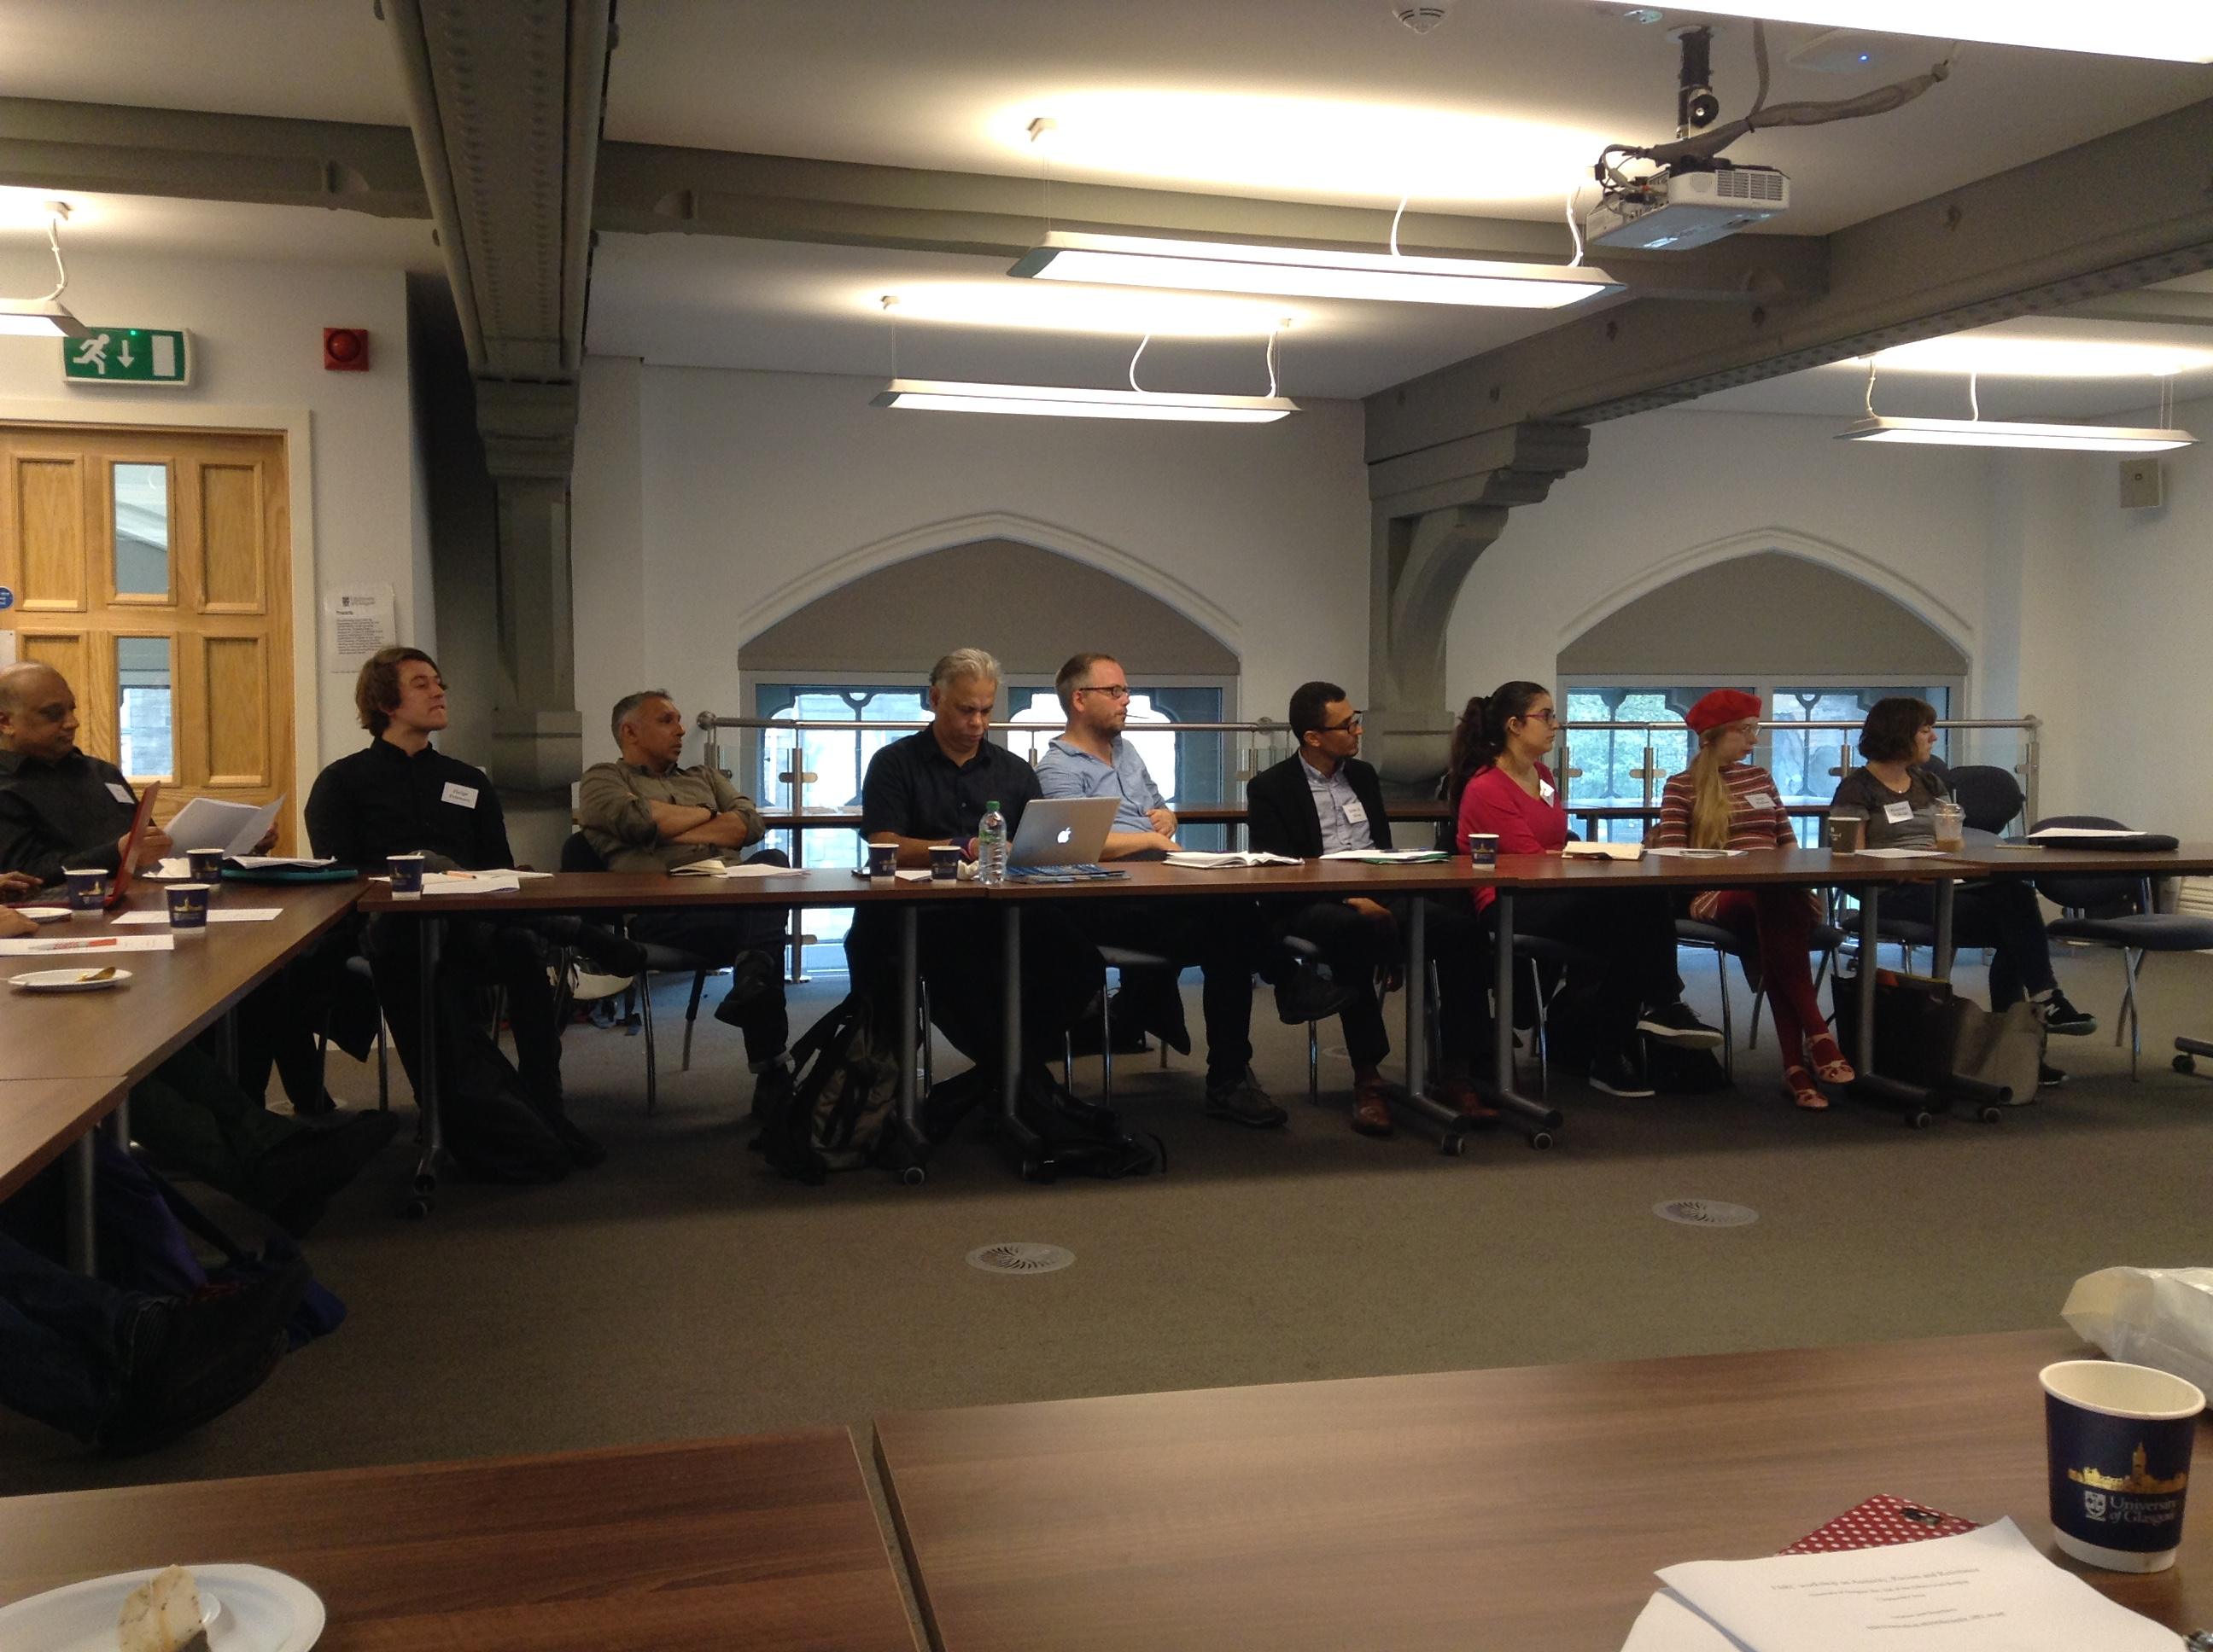

January 2017 – End of Project Conference

We are in the process of organising a final series conference to be held in January 2017. Further details of this two-day event will be circulated in the autumn term. We hope members and associates of CMRB will attend.

Refugee Council Archive at UEL

By Paul Dudman, Archivist.

The academic year very 2015 - 16 has been a very challenging yet successful year for the Refugee Council Archive at UEL. A number of successful projects and outreach activities have been undertaken on both a local, national and international level.

Update on the Archive
To focus on the core of our work with the Archive first, we have been continuing to catalogue and make our Archives accessible both internally to UEL staff and students but also externally to researchers and members of the public. We were very pleased to welcome the physical archive for the Information Centre for Asylum and Refugees (ICAR) during this period and once catalogued, this will provide a very useful additional to our collections. An archived version of the ICAR website is also available on our Living Refugee Archive portal at http://icar.livingrefugeearchive.org/

Our existing Refugee Archives now incorporate: The Refugee Council Archive; the Council for Assisting At-Risk Academics (CARA) modern history archive; an audio-visual collection from the London office of UNHCR; Northern Refugee Centre; Cambridge Refuge Support Group; and Charter 87. We also continue to receive individual items and smaller donations of materials including several boxes from the charity Asylum Aid over the last year. In addition, we also continue to hold the British Olympic Association archive and library; the Hackney Empire Theatre Archive; the East London People’s Archive of oral histories; and the UEL institutional archive.

We are still actively looking for new materials so if you are aware of any related materials which may of benefit to the archive, please do let us know.

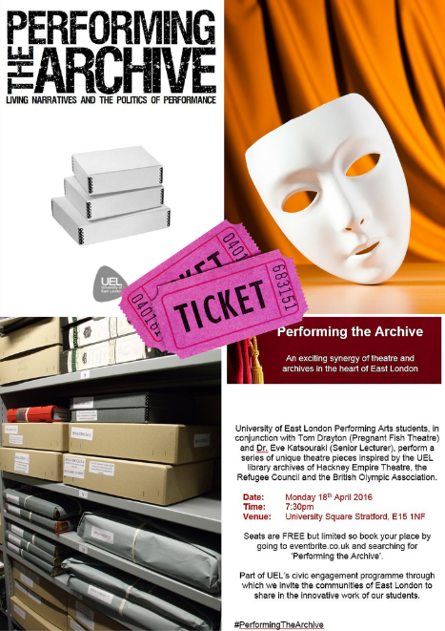
Civic Engagement and Outreach

2015-2016 has been a very busy year for the Archives in terms of civic engagement and outreach activities, including two successful UEL funded civic engagement projects and several external projects and events as well. These have included:

Performing the Archive: Living Narratives and the Politics of Performance. A UEL Civic Engagement Fund project in which we were able to work in conjunction with Dr Eve Katsouraki, (Senior Lecturer at UEL) and Tom Drayton (Director of Pregnant Fish Theatre) in conjunction with our second year performing arts students to start formulating their performance pieces. We decided that we would encourage the students to make use of possible narratives from all of our archive collections.

As part of a yearlong module investigating themes associated with the Politics of Memory and Performance,’ the students were tasked in the second half of the course to develop their own performance pieces on the theme of ‘Performing the Archive.’ The concept being that the students would be able to explore archival collections and be encouraged to discover the breadth and range of narratives held within these collections and then to create their own pieces of performance theatre based upon the narratives they had discovered.

“The process of talking something static, something safely and securely put away, catalogued, labelled and put on shelves; tucked amongst other boxes, hundreds and hundreds of its brother nestled amongst each other, hidden and sheltered, and moulding it into something theatrical, breathing, kinetic and alive – that is what our students have been faced with.” (Tom Drayton).
A video of the students’ performance, in front of a live audience, is available online via YouTube at: https://www.youtube.com/watch?v=WLjQvOZdnjo

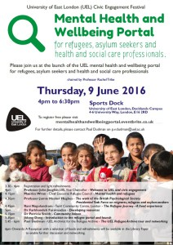
Mental Health and Wellbeing Portal for Refugees, Asylum Seekers and Health and Social Care Professionals Online Portal. Thursday 9th June, 2016 saw the launch of our second UEL funded Civic Engagement project, namely the online portal focusing on the Mental Health and Wellbeing Portal for Refugees, Asylum Seekers and Health and Social Care Professionals. This was a collaborative project between academic colleagues including Dr. Rachel Tribe in the UEL School of Psychology and the Refugee Council Archive at UEL. Combined with the invaluable help and support of external practitioners. We have undertaken an interdisciplinary approach to the creation of an online resource which can be utilised as a first-stop resource for refugees and asylum seekers as well as mental health practitioners working in the field with refugees, migrants and asylum seekers and with the recent influx of refugees from war torn countries of Iraq, Syria and Libya, we hope the project website will be an invaluable source nationally to mental health professionals, community organisations, refugees and asylum seekers themselves and internationally to people in refugee camps or internally displaced people.

Mental Health and Wellbeing Portal for Refugees, Asylum Seekers and Health and Social Care Professionals: www.uel.ac.uk/Schools/Psychology/Research/Refugee-Mental-Health-and-Wellbeing-Portal

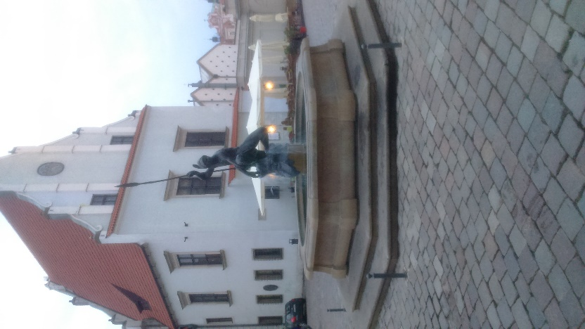
Working Group for Archiving and Documentation of History of Forced Migration and Refugees. This Working Group was established by Dr Rumana Hashem and Paul Dudman in the Autumn of 2015 in response to a call for seed funding by the International Association for the Study of Forced Migration (IASFM) to establish new working groups to focus on specific topics of relevance with the refugee and forced migration field. The purpose of this Working Group will be to serve as a focal point for members of the IASFM interested and/or working in within the fields of forced migration archives e.g. documentation, preservation and researching the history of forced migration.

Our aim for this Working Group, therefore, will be to bring together researcher, academics, librarians, archivists, activists, advocates (i.e. NGOs) who are either interested in the history of forced migration and related fields, or are interested in the care and preservation of the archival and library collections that help to preserve the often hidden voices of the migration journey. With a focus on networking on history of forced migration, we will also address the growing critique of the divide between experts and forced migrants themselves. We would like to take steps to ensure that the documentation of testimonies associated with the migration journey are actively preserved. The Working Group is, however, devoted to develop a cross-spectrum approach to the management and preservation of important archival, library and related collections of materials. We also have a strong commitment to the use of oral history to help fill in the gaps which often exist within the more traditional archival collection. In this age of financial austerity, we are fully aware of the dangers posed to efforts that help to preserve the historical legacy of often marginalised group.
Poznan

Activities for 2015-16 culminated with a very successful conference panel at the IASFM16 Annual Conference in Poznan, Poland. Our panel was entitled: “Documentation, Preservation and Researching the History of Forced Migration and Refugee History: Ethical and Methodological Developments” and was chaired by Dr. Rumana Hashem, CMRB. Our panel was international and the papers included:

- The ‘self’, ethics & ‘voice’ in migration research: a reflective critique of ‘insider’ ethnography. Amadu Wurie Khan, International Commission on Survivor Centered Disaster Recovery
- Ethical issues in collecting oral histories of the 1947 partition. Shailja Sharma, DePaul University
- Refugee voices and living narratives: Reflections, challenges and Opportunities for (Re-) Constructing, Documenting, and Preserving Refugee and Migrant Testimonies within the Archive. Paul Dudman, UEL.
- Historical Components of Archival Ethics and Methodologies. Brittany Lauren Wheeler, Emerging Scholars and Practitioners on Migration Issues

IASFM Working Group: http://iasfm.org/adfm/
Twitter: @ADHFM_WG
Facebook: https://www.facebook.com/groups/adhfmr/

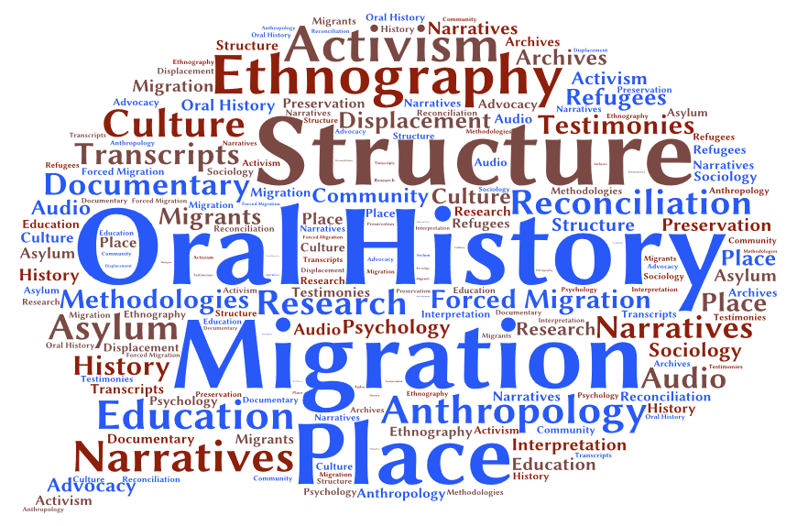
OHS Migration SIG. In the early summer of 2016 we submitted a proposal to the UK Oral History Society for the creation of an Oral History Society Special Interest Group on the subject of Migration.
After undertaking a civic engagement funded project in 2015 looking at documenting the life histories of refugees through an oral history methodology, questions arose as to how should we document the current refugee and migration crisis? Refugee and migration narratives polarise opinion both in our politics, our media discourse, and amongst public opinion. How do we document, preserve and make accessible these complex interplays of narrative; and by attempting to so, are we in danger of neglecting the very voices of the refugees and migrants themselves?

This has subsequently resulted in the creation of the OHS Migration SIG, which aims to bring together Oral History Society members who are working within the fields of refugee and migration studies, or who are interested in the issues and practice involved, to gather and share knowledge, to explore these and related questions, and to formulate an Oral History Society response that can be useful for the wider oral history community. Given the complexity of terminology within this field, and for the purposes of the Special Interest Group, the term `migration’ will be used to incorporate issues around both forced migration and voluntary migration. The Migration Special Interest Group (MSIG) will aim to focus on all aspects of the migration experience, incorporating voluntary and internal migration, forced migrants, refugees, and asylum seekers.

OHS Migration Special Interest Group: www.ohs.org.uk/information-for/migration/
Twitter: @OHSMigrationSIG
Facebook: www.facebook.com/groups/MigrationSIG/

Additional Outreach

Paul Dudman, the UEL Archivist, has presented at several conferences over the last twelve months on behalf of the Refugee Council Archive and has also been involved in exhibitions and other activities. Details on all of these can be found on the Living Refugee Archive blog at: www.livingrefugeearchive.org/blog/

Events have included:

- Panel discussion at UEL Human Rights Day on UEL Human Rights Day. Thursday, 10 December 2015.

International Migrants Day 2015 and the Living Refugee Archive exhibition in UEL Docklands Library.

Conference paper at the 17th Annual Cambridge Heritage Research Group Seminar: The Heritage of Displacement Forced Migration in the Mediterranean through History.
- “Different Pasts: Shared Futures”: Showcasing UEL Initiatives Supporting Refugees. Paul co-ordinated a UEL event for Refugee Week 2016 in conjunction with colleagues from the UEL Centre for Narrative Research and the MA programmes in Refugee Studies and Conflict, Security and Displacement. June 2016.
- Paul also organised a conference panel for the 2016 Archives and Records Association Annual Conference held in Wembley, North London, from Wednesday 31st August until Friday 2nd September 2016. Our conference panel was entitled: ““Inclusivity meets `History of the Present’: Living History, Ethics and the Role of Archives in Documenting Under-Represented Communities,” and included the following papers:

- Evan Easton-Calabria. (Oxford). Title: Stepping Back: Archival research on refugees as a heuristic for refugee assistance today
- Anne Irfan. (LSE). Title: Over-researched, Under-represented: The Case of the Palestinian Refugee Camps
- Liz Tilley. (Open University). Title: ‘Co-producing a living archive of learning disability history’: exploring ethics, consent and inclusion.’
- Paul V. Dudman. (UEL). Title: Archives, Ethics and Civic Engagement: Refugee Voices, Participatory Performance and Oral History – the Role of Civic Engagement in Enhancing Archives?
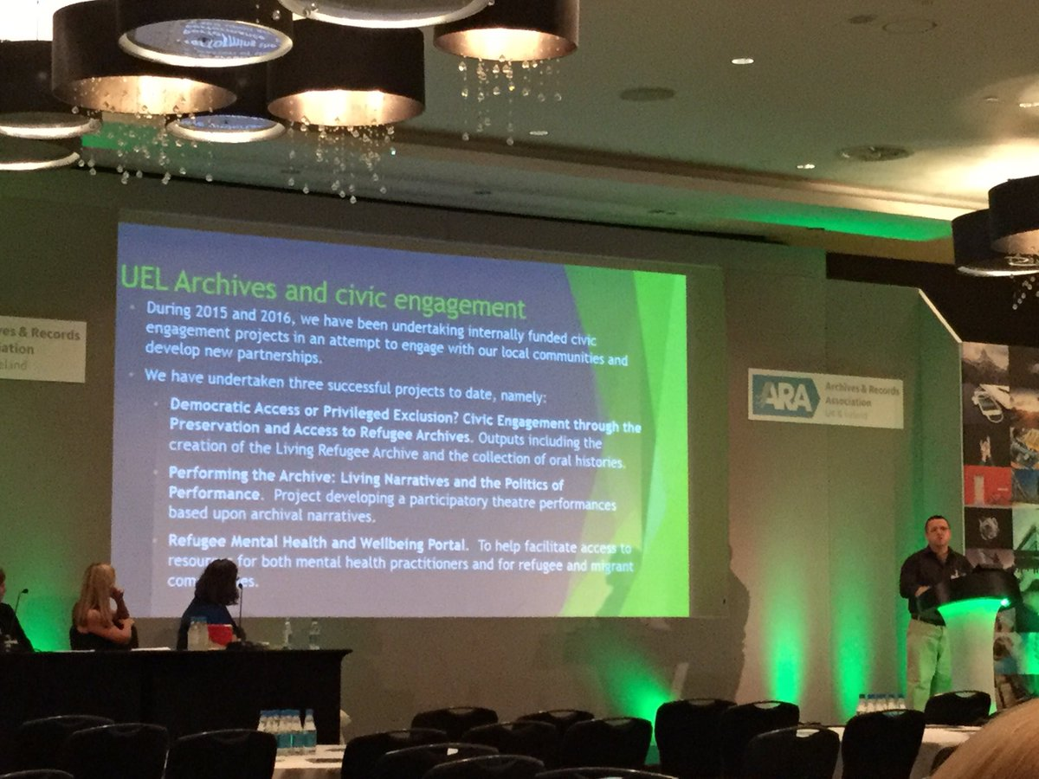

Paul Dudman presenting at ARA2016.

Publications

Rumana Hashem and Paul Vernon Dudman.
Paradoxical narratives of transcultural encounters of the “other”: Civic engagement with refugees and migrants in London
Transnational Social Review Vol. 6, Iss. 1-2, 2016, pp. 192-199.
www.tandfonline.com/doi/full/10.1080/21931674.2016.1186376

Website and Contact

For anyone wishing to learn more about the Archives held at UEL, please visit our newly refurbished website at: www.uel.ac.uk/Discover/Library/Library-archive

We are also available on social media via Twitter () and Facebook (). Details of all our archival collections can be found on the Archives Hub (http://archiveshub.ac.uk/contributors/universityofeastlondon.html) and our Living Refugee Archive and blog are available at:

Paul Dudman, the Archivist, can be contacted via: email at p.v.dudman@uel.ac.uk; by phone on +44 (0) 20 8223 7676; by Twitter at @pauldudman; or by Skype at paul_dudman.

Background to the Archive

The Refugee Council Archive is one of the foremost archival collections relating to the study of migration and refugee issues. Materials held are relevant to research in refugee studies, demography and migration studies, politics, history, geography, law, legal studies, international relations, sociology, social welfare, ethnic and gender studies, diasporic studies, psycho-social studies, community studies and social studies. There are rare documents unique to this collection including the early minutes and administrative records charting the foundation of what was to become the Refugee Council and an extensive archive of the Refugee Council as an organization. There is also an extensive special collection of books and journals; a large quantity of published and unpublished articles and reports; conference papers and grey literature; newsletters, research documents; field reports and working papers.

Centre related MAs

MA Refugee Studies

Forced migration is a global phenomenon and an area of increasing concern in Europe and beyond. On this course you will study the multiple factors associated with refugee crises and the economic, political, social, cultural, and environment pressures which lie behind the search for asylum.
A distinctive feature of this course is that it considers the perspective and experiences of the people forced to flee conflict, generalised violence, and human rights violations. It highlights social, cultural and community responses to people in search of sanctuary in the contexts of restrictive border practices. It encourages informed understanding about contemporary conflicts, forced displacement and human security.
Although the majority of refugees are in countries of the developing world, structures of exclusion are most fully developed in the post-industrial societies, notably within Europe.
The course highlights problems associated with limitations of asylum rights in the European states and the climate of hostility towards refugees from countries outside Western Europe. It also considers alternative, positive, approaches to asylum rights.
For more information visit https://www.uel.ac.uk/Postgraduate/Courses/MA-Refugee-Studies

MA Conflict, Displacement and Human Security
On this cutting-edge course, we specialise in giving our students an advanced and comprehensive understanding of the relationship between conflict, displacement and human insecurity.
We will help you to develop the skills and understanding to prepare for employment in the fields of conflict management and resolution, humanitarian assistance and displacement, human rights and development initiatives.
The key aspects of your learning will be the focus on conflict and displacement. We value a people-centred approach and an emphasis on human security which combines both human rights and human development.
The course approaches development as an important security strategy and considers displacement a measure of human security. We will encourage you to adopt an independent critical approach to contemporary theories of conflict, human rights and human security.
You will work with academics involved in the latest research and have access to wide-ranging expertise in our research centres, covering human rights in conflict, social justice and change, migration, refugees and belonging and gender research.
For more information visit https://www.uel.ac.uk/Postgraduate/Courses/MA-Conflict-Displacement-and-Human-Security

Director’s Activities

During the academic year 2015 - 16 Professor Nira Yuval-Davis continued to lead Work Package 9 of the EUBorderscapes project on everyday bordering as well as the Umea/UEL team. As part of this work she took part in all the project international meeting as well as organising the London Policy conference in November 2015 and participating in the national impact tour focusing on the London team’s film “Everyday Borders” https://vimeo.com/126315982

Some of her major speaking engagements relating to the project included:

- ‘Researching intersectional everyday bordering: methodological comments’, Social Sciences School Launching Conference, UEL, 9 November, 2015
- ‘Introduction: the policy implications of everyday bordering in the UK’, Borderscapes Policy Conference, UEL, 10 November 2015
- ‘Introductory welcome to the meeting in the House of Commons on ‘Everyday Bordering’, 26 January, 2016
- ‘Research migration and bordering from a situated intersectional gaze’, a conference of London Higher, Brussels, 3 February, 2016
- ‘Multi-Ethnic Britain and Everyday Bordering’, a seminar on Everyday Bordering, LSE, 14 March, 2016

Other speaking engagements included:

- ‘Gender, nationalism and violence’, Annual Cultural National Conference, Sulimani, Iraqi Kurdistan, 19 November, 2015
- Key contribution on Intersectionality, at the launch event of GRAND (Gender, Rights and Development Network) at the University of Edinburgh, 25 April, 2016
- The Chrystal Macmillan Annual Lecture on ‘Everyday Bordering and the re-orientation of Immigration Legislation in the UK’, Edinburgh, 25 April, 2016
- ‘Everyday bordering as a political project of belonging in contemporary Britain’, 25 June, keynote presentation at the IRIS conference on ‘Superdiversity: Theory, method and practice’, University of Birmingham
- ‘Contemporary politics of belonging and everyday bordering’, a common plenary presentation at the International Sociological Association Forum, Vienna, 13 July 2016
- ‘Brexit’ and the rise of autochthonic political projects of belonging in contemporary Europe’, a public lecture at the Thyssen-Bornemisza Art Contemporary forum, 15 July, 2016, Vienna

Her project related publications during this period included:

- “Borders studies: relevant for international relations and ‘border-guard’ university staff’, by M. Reisz, based on interviews with David Newman and Nira Yuval-Davis, Times Higher Education, December 10, 2015
- “Want to know how to kill multi-cultural society? Turn its ordinary citizens into border-guards”,
www.independent.co.uk/voices/want-to-know-how-to-kill-a-multicultural-society-turn-its-ordinary-citizens-into-border-guards-a6774151.html
- “Challenging the racialized ‘common sense’ of everyday bordering”, with G. Wemyss and K. Cassidy, Open Democracy, 17 February, 2016“Those who belong and those who don't – Physical and mental borders in Europe”, European Greens Journal, March 2016

Her non project related publications during this period included:

- ‘Situated Intersectionality and Social Inequality’ in Raisons Politiques no. 58:91-100, 2015
- ‘Politiken um Klasse, Identitat und Intersekionalitat. Sozialistisch-feministische Streitfragen’, in Wege des Marxismus-Feminismus, Das Argument no. 314:583-590, 2016
- ‘Inclusive nationalism’ in Antonsich, M., Mavroudi, L. & Mihelj, S. collection of essays ‘Building inclusive nations in the age of migration’ in Identities: Global Studies in Culture and Power, April 2016 http://www.tandfonline.com/doi/full/10.1080/1070289X.2016.1148607
- ‘The caring question: the emotional and the political’, in Dominanz-Kultur Reloaded, a memorial book to Birgit Rommelschpcher, ed. By I. Attia, S. Kobsell and N. Prasad, Bielefeld: Transcript, 2015:199-215 (in German)
- ‘Power, intersectionality and the politics of belonging’ and ‘A dialogical conversation: a response to the responses’ in The Palgrave Handbook of Gender and Development, ed. By Wendy Harcourt, Basingstoke: Palgrave Macmillan, 2016:367-381 & 434-440
- “Two Roads to Public Sociology”, Global Dialogue”, 2015, vol. 5(1), http://isa-global-dialogue.net/two-roads-to-public-sociology/
- “Feminism and the S-word”, Jo Little in discussion with Mandy Merck, Hilary Wainright, Nira Yuval-Davis and Deborah Grayson, Soundings, no.61:95-112, 2015
- “Anti-Jewish and anti-Muslim racisms and the question of Palestine/|Israel”, with J. Hakim, Open Democracy, 28 September, 2015

Recent publications by Gargi Bhattacharyya:

Book:
Crisis, austerity and everyday life, living in a time of diminishing expectations, Palgrave Macmillan, 2015

Articles:
‘Racism, class and the racialised outsider’, Ethnic and Racial Studies Review, volume 38, issue 13, October 2015
‘Rereading the empire strikes back’, Ethnic and Racial Studies Review, volume 37, issue 10, September 2014

Chapters:
‘Trying to discern the impact of austerity in lived experience’, chapter in Hard Times, Routledge, forthcoming 2016
‘Narrative Pleasure in Homeland: The Competing Femininities of "Rogue Agents" and "Terror Wives"’ chapter in The Routledge Companion to Media and Gender, edited Cynthia Carter, Linda Steiner and Lisa McLaughlin, 2014

Members & Associated Members

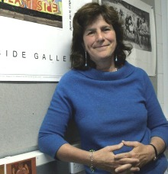
Molly Andrews is Professor of Political Psychology, and Co-director of the Centre for Narrative Research (www.uel.ac.uk/cnr/index.htm) at the University of East London. Her research interests include the psychological basis of political commitment, psychological challenges posed by societies in transition to democracy, patriotism, conversations between generations, gender and aging, and counter-narratives. Her current project, ‘The Unbuilding of East Germany: Excavating Biography and History’ is supported by the Wissenschaftszentrum Berlin für Sozialforschung and the University of East London. Her monographs include Lifetimes of Commitment: Aging, Politics, Psychology (Cambridge, 1991/2008) Shaping History: Narratives of Political Change (Cambridge, 2007) and Narrative Imagination and Everyday Life (Oxford, 2014). Shaping History won the 2008 Outstanding book of the year award of the American Education Research Association, Narrative and Research Special Interest Group, and is currently being translated in to Chinese. She is a co-investigator on the NOVELLA project (Narratives of Varied Everyday Lives and Linked Approaches) a three year project funded by Britain’s National Centre for Research Methods.

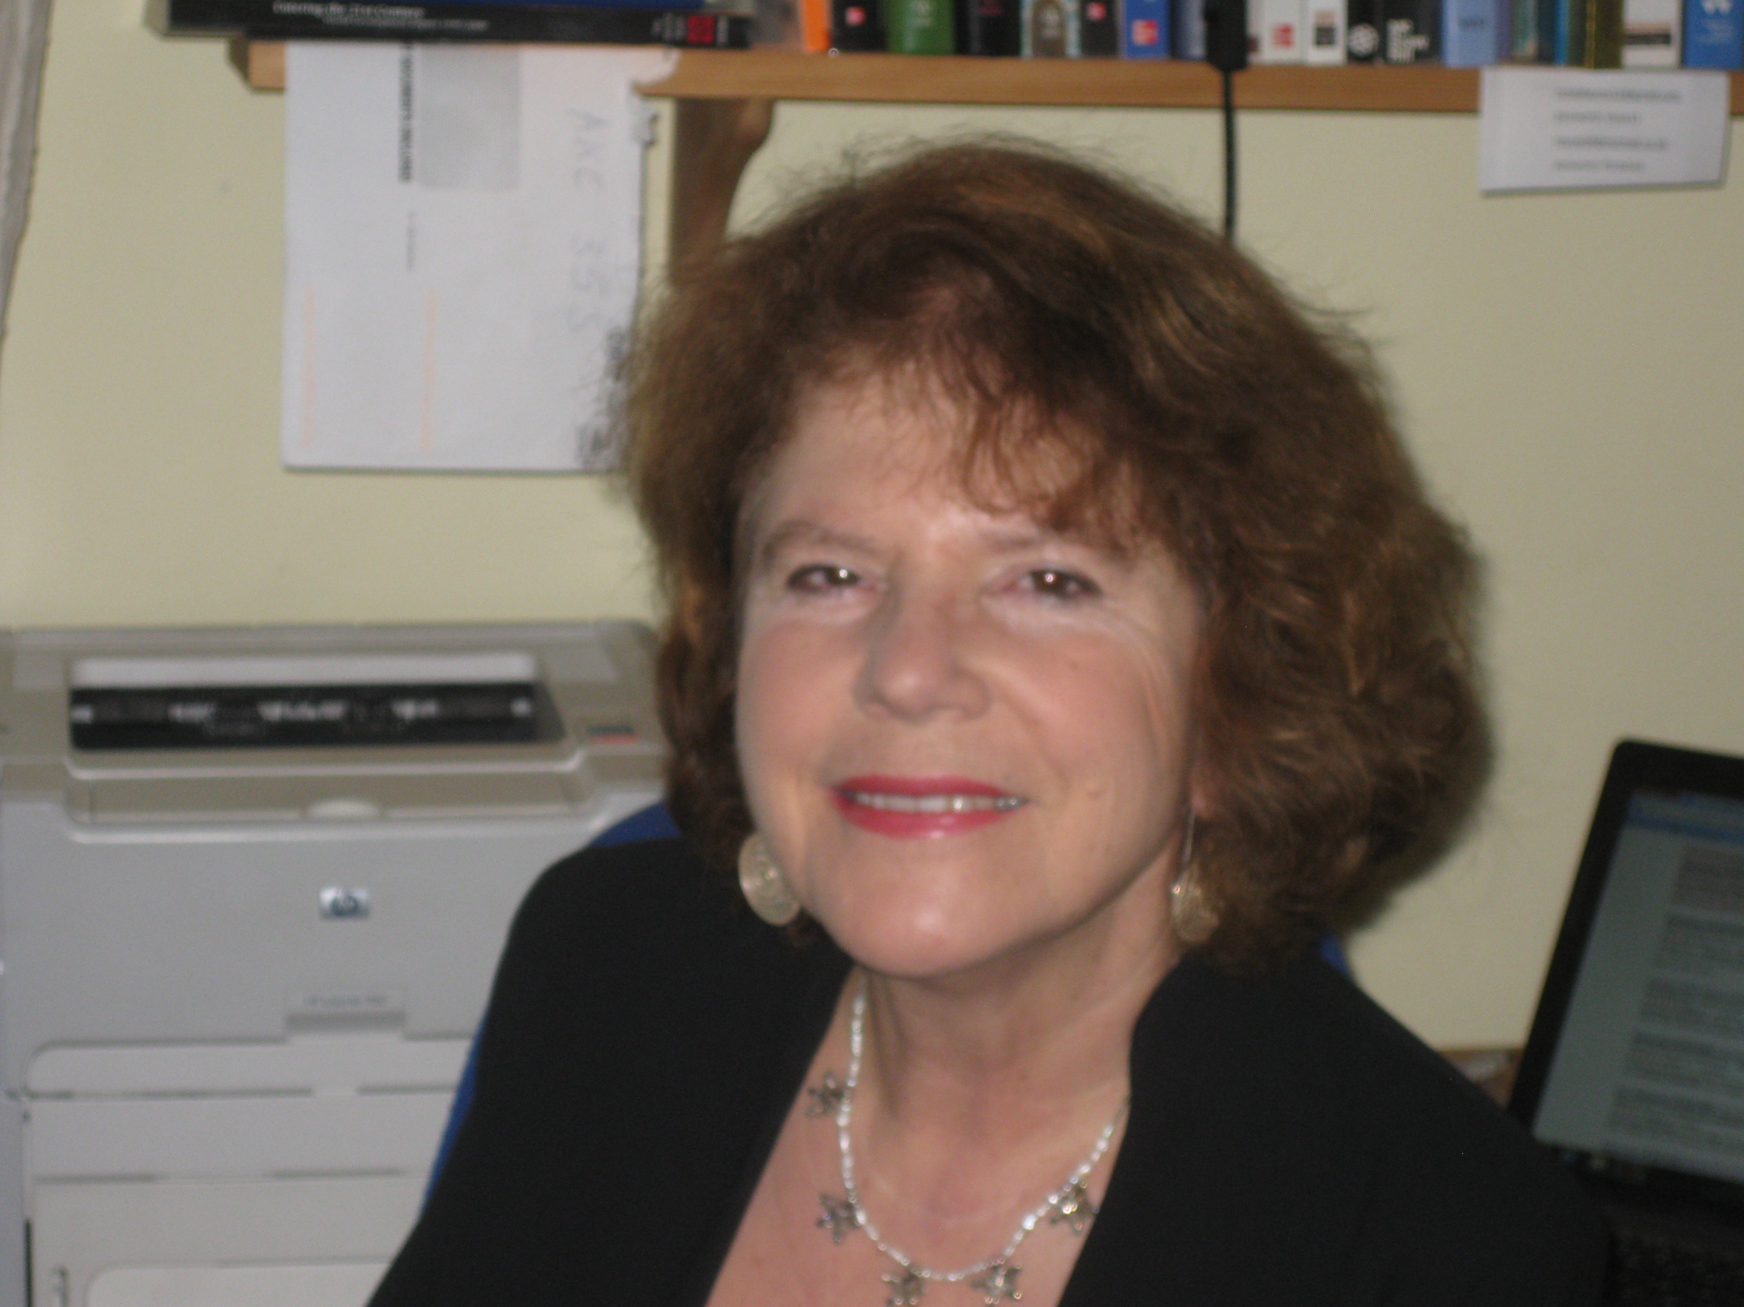
Prior to becoming a Professor of Sociology at UEL in 2013 Floya Anthias was Professor of Sociology and Social Justice at the University of Roehampton (where she remains as Emeritus Professor). She has also been Professor of Sociology at the University of Greenwich and Oxford Brookes University. Floya was born in Cyprus and migrated as a small child with her parents to Britain. She was educated at the London School of Economics (B.Sc. Soc.) the University of Birmingham (M.Soc.Sc) and Royal Holloway College (Ph.D.). She is an Academician of the Academy of the Social Sciences (AcSS). Her main academic writings have explored different forms of stratification, social hierarchy and inequality, and how they interconnect. Her research spans a range of theoretical and empirical concerns relating to this. This has included a focus on racism, diaspora and hybridity, multiculturalism, gender and migration, labour market disadvantages and class position. Her most recent work has been developing the concept of translocational positionality as a way of addressing some of the difficulties identified with concepts of hybridity, identity and intersectionality. She has published on these issues in a range of top peer reviewed journals. Floya’s books include Woman Nation State, Palgrave (with N. Yuval Davis), Racialised Boundaries: nation, race, ethnicity, colour and class and the anti racist struggle (with N Yuval-Davis), Routledge, Ethnicity, Class, Gender and Migration, Greek Cypriots in Britain, Avebury, Into the Margins: Migration and Exclusion in Southern Europe, (with G. Lazaridis), Ashgate, Gender and Migration in Southern Europe: women on the move (with G. Lazaridis), Berg, Rethinking Anti-racisms: from theory to practice, (with Cathie Lloyd), Routledge, Paradoxes of Integration: Female Migrants in Europe, (with M. Kontos and M. Morokvasic), Springer, Contesting Integration, Engendering Migration, Palgrave (with M. Pajnik), and Work and the Challenges of Belonging (with M. Pajnik), Cambridge Scholars Publishing.

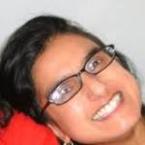
Prof Gargi Bhattacharyya joined UEL in Spring 2013, after living and working in Birmingham for over twenty years. Previously, she worked at the Universities of Wolverhampton, Birmingham and Aston. Her work centres around issues of racism, gender and sexuality, injustice and inequality and global cultures. My publications include: Tales of Dark-Skinned Women (UCL, 1998), Race and Power (Routledge, 2001), Sexuality and Society (Routledge, 2002), Traffick, the illicit movement of people and things (Pluto, 2005), Dangerous Brown Men (Zed, 2008) and Ethnicities and Values in a Changing World (Ashgate, 2009). Recently, in common with many colleagues, she has been concerned to understand more about the construction and workings of ‘austerity’.

Prof Haim Bresheeth is a filmmaker, photographer and film studies scholar, teaching at SOAS in London. He has written on the Israel/Palestine conflict and worked with Palestinian refugees. His books include the best-selling Introduction to the Holocaust. His edited volumes include The Gulf War and the New World Order, (with Nira Yuval-Davis) published in 1992 by Zed Books, Cinema and Memory: Dangerous Liaisons, Co-edited with Zand, S and Zimmerman, M, and published by Zalman Shazar Centre, Jerusalem (Hebrew) 2004, and a special double-issue of Third Text (September, 2006), on Palestinian and Israeli art, photography, architecture and cinema (co-edited with Haifa Hammami). His latest film London is Burning (2012) info on http://www.haimbresheeth.com/lib/London_is_Burning/Welcome.html

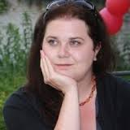
Kathryn Cassidy is Senior Research Fellow on the EUBORDERSCAPES project and works in the Centre for Research on Migration, Refugees and Belonging. She is a feminist human geographer, whose research on informal economies and borderlands is located at the nexus of social and economic geography and anthropology. She has an interdisciplinary PhD (anthropology and geography) awarded by the University of Birmingham, funded by the ESRC and entitled The Informal Economies of the Ukrainian-Romanian Borderlands, two Masters degrees in the Social Sciences (Birmingham and UCL) and an undergraduate degree in Geography from the University of Nottingham. She is a specialist in post-socialist Europe and has been carrying out ethnographic research in Romania and Ukraine since the late 1990s.

Prof Allaine Cerwonka is the Dean of the School of Social Sciences at UEL. She has pursued a research and teaching career drawing on several of the social science disciplines. With a PhD in Political Science, some of her research has explored questions concerning national belonging and identity and has intersected political theory with anthropology and social geography. She has also been interested in interdisciplinary theories of the human, combining her foundation in the social sciences with theories of the body and of evolution in science studies.
Allaine also has a great deal of experience in international education and has worked in a variety of national contexts. She has taught and/or conducted extensive research in the United States, England, Hungary, India and Australia. She has been a visiting research at Goldsmiths College and with the International Gender Studies Centre at Oxford University (Lady Margaret College). She has been part of the design team on several European degrees and joint programmes.

This collective experience has underscored for her the importance of degree programmes that help prepare graduates for 21st century professions and which prepare them to be responsible citizens and leaders in a global world.

Catherine Donaldson is fascinated by the different worlds in which people live. In 2004 she combined her theatre and film experience with a degree in Archaeology and Anthropology to become a documentary filmmaker. She honed her skills working with community, arts and educational groups, including with Nira at UEL, before founding Eggplant12 Films Ltd in 2007. Eggplant12 works to inform, to inspire and empower others because we are passionate about how people think, feel and live. She is currently a Lecturer in Documentaries at University of Brighton and making a documentary about migration in Hastings.

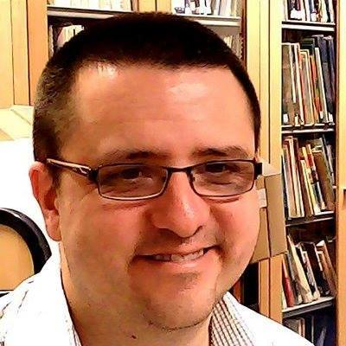
Paul Dudman is the Archivist based at the University of East London. Paul has been responsible for the Refugee Council Archive at UEL since 2002 and has over a decade’s experience working within higher education archives. Paul is responsible for the UEL Archives which also includes the British Olympic Association Archive; Hackney Empire Theatre Archive; and the East London People’s Archive. Recent projects within UEL have included three successful civic engagement projects, including the establishment of the Living Refugee Archive portal with colleagues from CMRB; a project in collaboration with the UEL School of Psychology to establish the Refugee Mental Health and Wellbeing Portal for Asylum Seekers, Refugees and Health and Social Care Professionals; and working with colleagues in the UEL Centre for Performing Arts Development and performing arts students on the project Performing the Archive: Living Narratives and the Politics of Performance to create participatory performance pieces based upon narratives found in our archival collections.

Paul a co-convenor of the IASFM (International Association for the Study of Forced Migration) Working Group on for the Archiving and Documentation of the History of Forced Migration and Refugees and is also the Lead Convenor of the Oral History Society Migration Special Interest Group. Externally, Paul has been involved with the Campaign for Voluntary Sector Archives and is involved in web based projects with the Migration and Asylum Network and the Emerging Scholars and Practitioners on Migration Issues (ESPMI) Network.

Paul is interested in the role of archives in helping to support the collection and preservation of first-hand life histories and testimonies both for their importance for allowing often marginalised voices to be heard and for their ability to support refugee advocacy. On behalf of the Refugee Archives at UEL, Paul has been undertaken civic engagement and outreach work to raise awareness of the importance of refugee archives and to encourage the use of oral history in documenting life histories of refugees. Paul is a member of a range of professional bodies including the Archives and Records Association, the Oral History Society, the International Council on Archives, the British Records Association and the International Association for the Study of Forced Migration.

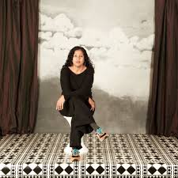
Rahila Gupta is a freelance journalist and writer and a longstanding member of Southall Black Sisters. Her work has appeared in The Guardian and openDemocracy among other papers and websites. Her books include, From Homebreakers to Jailbreakers: Southall Black Sisters (ed.) (Zed Press, 2003), Provoked (Harper Collins, India, 2007) and Enslaved: The New British Slavery (Portobello Books, 2007). Her play, Don't Wake Me: The Ballad of Nihal Armstrong, was part of the Brits off Broadway festival 2014 and has been nominated for various awards. She is currently collaborating on a book with Beatrix Campbell, provisionally entitled, Why Doesn't Patriarchy Die?

Dr Jamie Hakim was the research administrator at CMRB where he was particularly active in the EUBorderscapes research. Whilst working at CMRB he and Nira Yuval-Davis co-ordinated the ‘Anti-Jewish and Anti-Muslim Racisms and the Question of Palestine/Israel’ project that resulted in two conferences, an online paper series and a week guest editing OpenDemocracy. He was awarded his PhD in 2014 and it was entitled ‘Affect and Cultural Change: the Rise of Popular Zionism in the British Jewish Community after the Six Day War’. He is currently pursuing his research interests in affect, popular culture and politics in a new project that looks at male embodiment in the age of austerity.

Dr Narmala Halstead has carried out long-term anthropological fieldwork on East Indians and other groups in Guyana and on migrants in New York. Her research began with an interest in exploring the connections and divergences between the local and the global in terms of people’s lived experiences. She has looked at cultural performativity and considered issues of status, identity and forms of socio-political violence. Her research sites included ‘wedding houses’, ‘chutney’ music sessions, interactions between people and state-like institutions, and cafes outside law courts among others. She has also carried out research at airports, on Caribbean migrants in London and on Portuguese migrants in Wales.

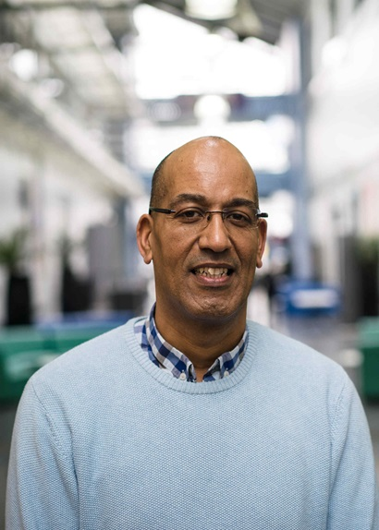
Syd Jeffers is Senior Lecturer in Sociology at UEL. His research interests include race, public policy and social theory. His most recent research was an evaluation of a mental health project with young people in a school in Newham.

Dr Roshini Kempadoo is a photographer, Media Artist and Reader in Media Practice. Her research, multimedia and photographic projects combine factual and fictional re-imaginings of contemporary experiences with history and memory. As a founder member of Autograph ABP, the Association of Black Photographer’s and having worked as a social documentary photographer for the Format Women’s Picture Agency, her recent work as a media artist includes photographs and screen-based interactive art installations that fictionalise Caribbean archive material, objects and spaces. They introduce characters that once may have existed, evoking hidden and untold narratives. Recent projects include: the photomontage series State of Play (2011) on Obama’s Presidency; the chapter ‘Imagining Her (story): Engendering Archives’ in the recently published Renewing Feminisms: Radical Narratives, Fantasies and Futures in Media Studies; and ‘Gazing Outwards and Looking Back: Configuring Caribbean visual culture’ for the current special issue of Small Axe: A Caribbean journal of criticism. She is represented by Autograph ABP.

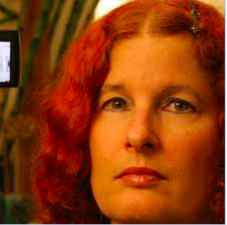
Yosefa Loshitzky is Professorial Research Associate at the Centre for Media and Film Studies, School of Oriental and African Studies (SOAS), and a Visiting Fellow at the Institute of Modern Languages Research (IMLR), School of Advanced Study, University of London. From September 2014 she will be a Leverhulme Trust Emeritus Fellow. She is the author of The Radical Faces of Godard and Bertolucci (1995), Identity Politics on the Israeli Screen (2001), selected by Choice Magazine as an outstanding academic title for 2002, Screening Strangers: Diaspora and Migration in Contemporary European Cinema (2010), the editor of Spielberg¹s Holocaust: Critical Perspectives on Schindler’s List (1997), and a guest editor of a special issue of Third Text on ‘Fortress Europe: Migration, Culture, Representation’ (2006). She is currently writing a book entitled ‘Just Jews? Antisemitism and Islamophobia in Contemporary Culture and Beyond’. Author of numerous articles and book chapters, Loshitzky¹s work has been translated into French, German, Swedish, Danish, Italian, Arabic and Hebrew. She has been a Visiting Research Fellow and Professorial Research Associate at the Institute of Germanic and Romance Studies, School of Advanced Study, University of London, The Annenberg School of Communication, University of Pennsylvania, USA, The Yitzhak Rabin Centre for Israel Studies, The Jerusalem Van Leer Institute, The French CNRS, The Italian CNR and The United Nations University Institute on Globalization, Culture and Mobility, Barcelona, Spain. Until 2002 she was a Professor in the Department of Communication and Journalism at the Hebrew University of Jerusalem. From 2003-2004 she was a Visiting Professor at King¹s College, University of London, from 2004-5 she was a Leverhulme Trust Visiting Professor at University College London (UCL) and from 2005-2012 she was a Professor of Film, Media and Cultural Studies at the University of East London (UEL). She has given keynote and plenary papers in the USA, Canada, UK, France, Germany, Italy, Denmark, Brazil, Israel and elsewhere. From 1994-2003 she served on the editorial board of Cinema Journal, the official organ of the Society for Cinema and Media Studies, the largest Film Studies Scholarly Association in the world. Currently she is a member on the international advisory board of The Middle East Journal of Culture and Communication.

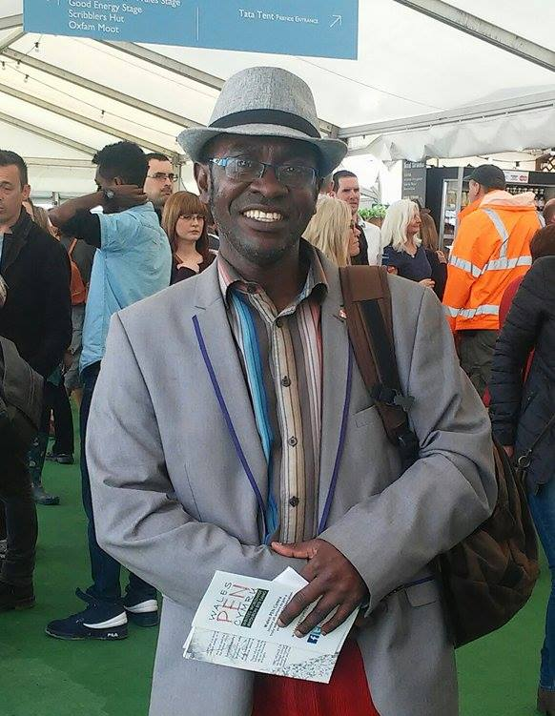
Born in the democratic Republic of Congo, former Zaire, Norbert MBU-MPUTU is currently studying film at the University of East London. Having a degree in philosophy, he holds some qualifications and certificates in computer sciences, journalism, anthropology and sociology from universities in Congo, Belgium and the UK.

Former journalist for Radio Elikya, the Catholic Radio Kinshasa and columnist in several magazines and newspapers, he is the correspondent of Congo Vision/USA (www.congovision.com) and Radio Mangembo FM/Paris (www.mangembo-fm .com) and is often invited by several Medias including the BBC and RFI for analyzes and comments on Africa, Congo and migration issues.

Researcher at the Centre of Ethnological Studies of Bandundu (CEEBA) where he collaborated in several collective publications such the Ritual Dictionary in 20 volumes; writer with number of books and contributions in several forum and publications on his fields of researches: the endogenous knowledge and witchcraft, the dialogue of cultures and the dialogue of the religions with the Africans Traditional Religions.

Former teacher in secondary school, former United Nations worker and former Director (Team Leader) of a British NGO in Africa; when in the UK, he founded an international NGO South Peoples' Projects-SoPPro before coordinating the project Community Space Partnership (Newport/Wales, UK). Member of several organisations and corporations including Church Action on Poverty, Sub Saharan Advisory Panel (SSAP), United Nations Associations (Wales / Wales), Pen / Wales (Wales), Anti-Poverty Network Cymru (Country Wales) and National Union of Journalists (UK). He launched a community magazine in London and coordinated the "Bamonimambo (The Witnesses)" project in the footsteps of Henry Morton Stanley, the Welsh greatest explorer of Africa. Not only that he discovered the graves of the two Congolese boys brought to the country in 1884 in Colwyn Bay (North Wales), but it took also an active part in the first statue of Stanley in his native town of Denbigh and also drew up a first map of sites of historical connections between the British Isles and the Congo and published a reference book about those connections.

Dr Peter G Morey is a Reader in English at UEL, teaching and researching mainly in the areas of 20th–21st century literature with a particular interest in postcolonial literature and theory, especially pertaining to South Asia and its diasporas. He has recently been a co-ordinator of an AHRC and ESRC research project on ‘Reframing Muslims’. He taught at Sussex, Leeds and Worcester before arriving at UEL in 1998. Although he mainly focuses on literature, his work is informed by adjacent disciplines such as cultural and media studies and their attendant theories. In particular he is interested in matters of narrative and power, and his research broadly addresses the question of how narrative and representational forms are complicit with (and how they contest and problematise) established power relations.

Dr John Nassari is an artist and academic. He has exhibited practice-based research nationally and internationally and is the director of PhotoInsight, an online art and theory website dedicated to issues in forced migration. John works on interdisciplinary and multidisciplinary methodologies in refugee studies, and has published widely on refugee representation, identity, memory and narrative.

Prof Mica Nava is an Emeritus Professor of Cultural Studies at UEL. Her publications include Gender and Generation (1984); Changing Cultures: Feminism, Youth and Consumerism (1992); Modern Times: A Century of English Modernity (1996); Buy This Book (1997) and Visceral Cosmopolitanism (2007). For her most recent publications, see https://uel.academia.edu/MicaNava . Since the 1980s her work has been widely cited and reprinted and has contributed to the expansion of cultural studies in UK and abroad. She was founder of the Centre for Cultural Studies Research (CCSR) at UEL. She has been invited to give keynote conference papers and/or special lectures on her research in Australia, Austria, Bulgaria, Brazil, Canada, Czech Republic, Denmark, Holland, Mexico, Portugal, Spain, Sweden, Ukraine and the United States as well as at universities and other venues throughout Britain. Her current research is on race relations social investigators in in the UK in the 1950s and '60s.
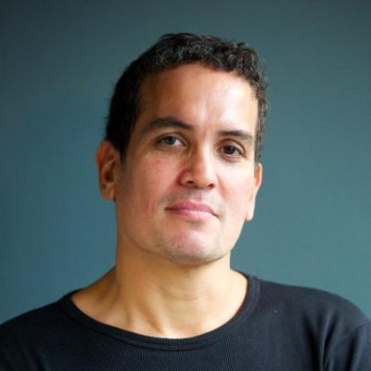
Orson Nava is a freelance film-maker and has a background directing dramas and documentaries for the BBC, C4 and ITV. In 2015 he directed Everyday Borders, a 45 minute documentary for the CMRB that looked at the impact of the 2014 Immigration act on British society. The film has been screened at the Houses of Parliament, SOAS, LSE, Westminster University, Oxford University, Cambridge University, Northumbria University, Leeds University, Sussex University, the EUBORDERSCAPES conference (at UEL), The British Sociological Association Annual Conference and The Whitechapel Gallery.

Orson is a graduate of the Northern Media School and The National Film and Television School and has taught Media, Film Studies and Creative Industries modules (at BA and MA level) at Middlesex University, the University Of East London, Central Film School and Sheffield Hallam University. He has also run numerous participatory video projects with young people throughout the UK. He is currently doing PhD research into the role of race and cultural identity in the creative industries regeneration of East London (for which he was awarded a UEL excellence bursary in 2015) and developing a feature film project with Bedlam films (makers of ‘The Kings Speech’) centred around a young character who has been illegally trafficked into the UK.

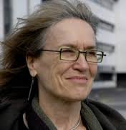
Dr Marta Rabikowska is a Principal Lecturer in Creative Industries at the University of Hertfordshire. Her research incorporates practice-based methods, including autoethnography, visual practice and documentary film-making. She has co-directed and co-produced (with Matthew Hawkins) a number of award-winning films, such as Belonging, Consumption and Place (First Jury Prize at the Film Festival of the Association of Consumer Research in Milan in 2007) and Migration, Health and Place (funded by the Leverhulme Trust in 2010). She has also been engaged in community activism is South London, mainly as Director of the Short Film Festival, Edge of the City. She is a recipients of research grants from the AHRC, British Academy and the Leverhulme Trust, among others. Dr Rabikowska has published widely on the politics of culture and creativity, Eastern European migration, visual methods, well-being and ethics. She is guest editor of the special issue of the journals Communist and Post-Communist Studies on 'The Ghosts of the Past: 20 Years After the Fall of Communism in Europe' (Elsevier, 2009), and Social Identities on the negotiations of normality and identity amongst Eastern European migrants (Taylor & Francis, 2010), and editor of the book The Everyday of Memory: Between Communism and Postcommunism (Peter Lang, 2013). She is currently writing a monograph on the role of perception in urban regeneration. At the University of Hertfordshire she is a member of T(E)VAD: Theorising Visual Arts and Design Research and of the Media and Screen Studies Research Centres.

Ashwani Sharma is a Principal Lecturer in Media and Cultural Studies at the University of East London (UEL), UK. He is a member of the Centre for Cultural Studies Research Centre at UEL. He teaches, researches and has published in the areas race, diaspora, postcolonialism, visual, urban, digital and popular media. He is currently completing a book on race, memory, utopia and contemporary visual culture, and was a co-editor of Dis-Orienting Rhythms: The Politics of the New Asian Dance Music (Zed Book). Sharma is the co-founder and co-editor of the online journal darkmatter (www.darkmatter101.org), where he has edited numerous issues including on ‘Post-racial Imaginaries’ and ‘The Wire.’ He is also developing a creative project reimagining suburban London Must We Burn Croydon? (http://burncroydon.tumblr.com/), and co-edits and writes poetry and experimental non-fiction on the ‘zine Southern Discomfort https://southerndiscomfortzine.wordpress.com/

Elizabeth (Lizzy) Shrimpton is the Research Assistant for the Research Centres and Groups within the School of Social Sciences at the University of East London (UEL). She joined UEL in September 2015 and has been assisting them in a wide administrative capacity, including organising and promoting events, and managing their webpages and social media accounts in order to increase the visibility of their events and research.

Dr Michael Skey is a Lecturer in Communication & Media at Loughborough University. His research interests are in the areas of national identity and globalisation, discourse theory, media events, sport and everyday life. He has published work on mass rituals, theories of nationalism and cosmopolitan identities and his monograph, National Belonging and Everyday Life was joint winner of the BSA/Philip Abrams Memorial Prize, 2012. He currently leads an AHRC-funded project on young people and football as part of the Connected Communities research strand.
Prof Corinne Squire is a Professor of Social Sciences and Co-director of the Centre for Narrative Research at UEL; with CNR, part of the ESRC-funded NOVELLA research methods node. Her most recent publications are HIV in South Africa: Talking about the Big Thing (2007), HIV Technologies in International Perspective (edited with Mark Davis, 2010) and Doing Narrative Research (edited with Molly Andrews and Maria Tamboukou, 2013 and 2008). Her research interests are in HIV and citizenship, narrative theory and methods, and popular cultures and subjectivities.

Arlington Trotman is a British citizen, born and raised in Barbados; lived and worked in Britain since 1970; Currently Ordained Minister, Methodist Church in the UK (2010); formerly Managing Director, AW Trotman Associates, a research, mentoring, training and management consultancy, (2005-2012), inter alia, responsible for Review of Section 75 of Northern Ireland Act 1998 for OFMDFM Northern Ireland. Chief Executive Officer, Churches' Commission for Racial Justice (1998-2006), in the fields of migration, asylum and refugees, racism and discrimination in Britain and Ireland; monitoring community relations and equality and diversity policy trends across UK, Ireland and EU. Moderator Churches’ Commission for Migrants in Europe (CCME) (2005-2011), a pan-European ecumenical NGO on policy development and practice in the fields of migration, asylum and refugees, anti-racism and discrimination 18 European countries; chaired Forum of Non-Governmental Organisations, ECR Preparatory Conference Against Racism, and Thematic Commission (WCAR), Durban 2001. Provides lectures and trainings on Being, Identity and Belonging. Among several publications, Author: Ethnicity, Nationality and Ecclesiological Identity, in Vieraanvaraisuus Ja Muukalaisuus, Suomalainen teologinen Kirjallisuusseura, Helsinki 2011, (The theological Finnish Literature Society ‘And the Alien in hospitality’). Ed., Asylum Voices, The Experience of People Seeking Asylum in the UK, Church House Publishing, (London: 2003), first publication of its kind; Sanctuary, Guidelines for Church and Society Offering Asylum Protection, CCRJ (London: 2005).

Dr Abel Ugba is a Senior Lecturer in Journalism at UEL. He has worked as a reporter, correspondent and subeditor in newspapers in Nigeria, Germany and Ireland. In 2000, Dr Ugba and Chinedu Onyejelem established Metro Eireann, Ireland’s most popular multicultural newspaper. He is on the editorial boards of Translocation and of EJN News. He is also the current President of the Exiled Journalists’ Network (EJN).
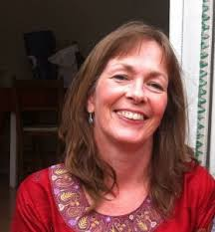
Dr Georgie Wemyss is currently Senior Lecturer in Sociology at UEL, CMRB. She previously researched 'everyday bordering' as part of the EUBORDERSCAPES research project, which built on her earlier ethnographic research about Britishness and belonging. Her book, The Invisible Empire: White Discourse, Tolerance and Belonging (Ashgate, 2009; Routledge 2016) explores how differing narratives of Britishness obscure colonial histories in ways that work against the belonging of second and third generation British citizens in the present. She is currently working on a book and journal articles with other members of the EUBORDERSCAPES team.
Dr Eric Woods is a Senior Lecturer (Associate Professor) in Sociology at the University of East London, where he teaches courses on nationalism, cultural sociology and social theory. He also serves as co-Editor-in-Chief of The State of Nationalism: An International Review of the Study of Nationalism, and as a member of editorial boards of Cultural Sociology and Nations and Nationalism. In addition, I’m Faculty Fellow of the Yale Center for Cultural Sociology and a member of the Scientific Council of the Belgium-based research group, National Movements and Intermediary Structures in Europe.
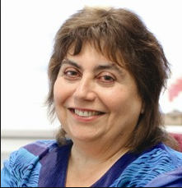
Professor Nira Yuval-Davis is a Director of the Research Centre on Migration, Refugees and Belonging (CMRB) at the University of East London. She has been the President of the Research Committee 05 (on Racism, Nationalism and Ethnic Relations) of the International Sociological Association, a founder member of Women Against Fundamentalism and the international research network of Women In Militarized Conflict Zones. She has been a member of the UK 2008 RAE (Research Assessment Exercise) and the 2014 REF (Research Excellence Framework) Sociology sub-panels. She has acted as a consultant to various NGOs and Human Rights organizations such as the UNDP, the UN Special Rapporteur on Violence Against Women, Amnesty International, AWID and the international Investigative Women’s Delegation ‘Justice in the Gujarat’. She is an editor of the book series The Politics of Intersectionality of Palgrave MacMilan.

Nira has written extensively on theoretical and empirical aspects of intersected nationalisms, racisms, fundamentalisms, citizenships, identities, belonging/s and gender relations in Britain & Europe, Israel and other Settler Societies. In her major ESRC research project she used participatory theatre techniques as a research methodology working with refugees in East London. She was a partner in the recently concluded major EU research project on ‘Borderscapes’, where she led an international team, examining everyday bordering in metropolitan cities and different European border zones from an intersectional situated gaze perspective.

Among her written and edited books are Woman-Nation-State, 1989, Racialized Boundaries, 1992, Unsettling Settler Societies, 1995, Gender and Nation, 1997, Warning Signs of Fundamentalisms, 2004, The Politics of Belonging, 2011, Women Against Fundamentalism, 2014 and the forthcoming Bordering (2017). Her works have been translated to more than ten languages.

PhD Students & Post-doctoral Researchers
Esther Afari-Mensah The challenges of migrant workers and detainees and their access to healthcare with its effect on the spread of infectious disease
Dr Ali Ali Choice and constraint: narratives of Iraqi refugees in Jordan
Dr Celine Centat Politics of exclusion and the making of migrant identities in Europe
Dr Frances Cetti Terror and the figure of the refugee
Dr Mastoureh Fathi Class narratives of Iranian Women Migrants in Britain
Dr Rumana Hashem Gender and armed conflict: the case of Chittagong Hill Tracts, Bangladesh
Dr Jamie Hakim Affect and Cultural Change: The Rise of Popular Zionism in the British Jewish Community after the ‘Six Day War’ (1967)
Helen Margaret Leadbitter Meeting the health care and support needs of refugee and asylum seeking families with particular reference to the impact of illness and disability on the young people within the family unit
Lynn Mhlanga Presumption of guilt: criminalisation and marginalisation of migrant communities in the global war on terror
Alice Mukaka Performing and Counter-Performing the Borders: Stories of Feminist Organizing for Migrant rights
Dr Nicola Samson Narratives of Belonging: Life Histories of Women in East London post Second World War
Dayjour Sefre Refugee experiences in education: A comparative study of Iranian and Afghani pupils in London’s secondary schools.
Mary Sutton From solidarity to sanctuary: refugees’ experiences with church communities
Dr Helen Taylor Landscapes of Belonging: the Meaning of Home for Cypriot Refugees in London
Steve Thorpe Inter-generational Dynamics in Protracted Urban Exile: Southern Sudanese Refugees in Cairo
Dr Diana Yeh Beyond (British) – Chineseness: The Politics and Poetics of Art and Migration in Multi-ethnic Contexts
Dr Tahir Zaman The Noble Sanctuary: Islamic traditions and Iraqi refugees in Syria

