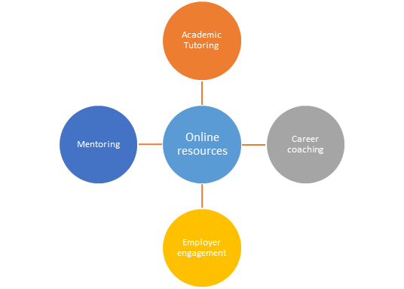
Centre for Student Success

CfSS is made up of a range of teams all designed to enhance and add value throughout the student lifecycle. We work in close collaboration with academic schools and students in order to ensure that we are providing services which meet the needs of our students.

Academic Tutors (English and Maths)
- Drop-In sessions/ one to ones and workshops to support students to further develop academic writing, maths and study skills.
- Online resources available 24/7 in English, Maths and general study skills including Study Skills Moodle and Studiosity
Career Coaches
- Information and advice on careers, jobs vacancies, CVs, applications and interview preparation
- Workshops and face to face appointments
- Help with developing employability skills and confidence,
- Help with sign posting to volunteering opportunities, work experience, paid work and internships
- Online resources including UEL Career centre and Employability Moodle
Mentoring
- Opportunities to be a mentor/ mentee
- Professional Mentoring Scheme
- Peer Mentoring Scheme
Employer Engagement
- Hosted Employer Events: Employer Insight Events, Networking Events, Workshops annual Careers Fair
- Promoting opportunities to students and graduates: Graduate Level Roles, PT flexible work, Paid Internships, Placements
- Employment Hub - online access to employer jobs and managed vacancies

