Performing the Archive
In front of a very receptive, supportive and intimate audience of about 60, Monday night saw the culmination of several months hard work on the part of University of East London (UEL) second year undergraduate performing arts students in their showcase entitled: ‘Performing the Archive: Living Narratives and the Politics of Performance’, which included a range of diverse and interested performance pieces.
As part of a year-long module investigating themes associated with the Politics of Memory and Performance, the students were tasked in the second half of the course to develop their own performance pieces on the theme of ‘Performing the Archive.’ The concept being that the students would be able to explore archival collections and be encouraged to discover the breadth and range of narratives held within these collections and then create their own pieces of performance theatre based upon the narratives they had discovered.
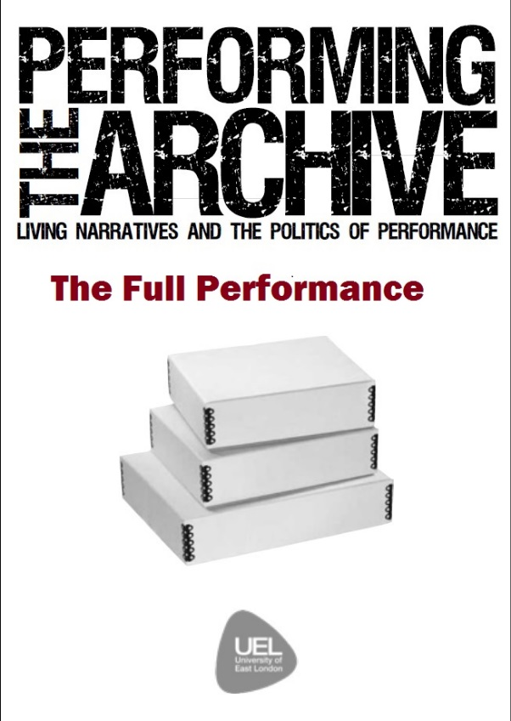
With a successful civic engagement funding application in place, we were able to work, in conjunction with Tom Drayton (Director of Pregnant Fish Theatre) and Dr. Eve Katsouraki (Senior Lecturer at UEL), with our second year performing arts students to start formulating their performance pieces. We decided that we would encourage the students to make use of possible narratives from all our archive collections: including the British Olympic Association Archive; the East London People’s Archive of East London oral histories; the Hackney Empire Theatre Archive; and the Refugee Council Archive. Students were given two weeks of inductions at both of our archive stores, at both the Docklands and Stratford Campuses. We were very fortunate to be able to employ Tom Drayton, Director of Pregnant Fish Theatre, as a theatre director to help guide and direct the students, and in Tom’s reflective piece for the programme, he states:
“Getting second year students excited about an archive, was the challenge Eve (Katsouraki) and myself thought would be the first hurdle. Yet, when we let loose with the multitude of boxes available at UEL I found the students immersed themselves for hours on end in the narratives that appeared throughout the archives.”
It was great as an Archivist to be able to see students actively engaging with our archival collections in such a positive way and be genuinely excited about the narratives they were discovering, right from the inductions, considering how these narratives could be interpreted and adapted into a performance. As an archivist, it can sometimes be a challenge to try and find different ways of encouraging students to engage with archival materials and to reflect on the many and varied narratives contained within. With the seemingly instant knowledge now available at a click of a button or increasingly a swipe of a finger on laptops, tablets and smart phones, trying to highlight the benefits of a bunch of old documents sitting on a shelf can prevent its own challenges. As Tom poetically reflects:
“The process of taking something static, something safely and securely put away, catalogued, labelled and put on shelves; tucked amongst other boxes, hundreds and hundreds of its brother nestled amongst each other, hidden and sheltered, and moulding it into something theatrical, breathing, kinetic and alive – that is what our students have been faced with.”
Following the inductions, we encouraged the students to continue to make use of the archives as and when needed, which we were very pleased that they did, and entrusted them to Tom and Eve to start the journey of development from printed document and oral history, to pieces of performance theatre. In addition to being able to employ Tom as a theatre director, the civic engagement funding that we received also enabled us to be able to encourage the students through the opportunity to be able to present the work publicly at the end of the module, and also facilitate the purchasing of additional props as required, as well as enabling the final showcase to be filmed and recorded professionally.
All this work over several weeks finally resulted in the official showcase of the student performances on Monday 18th April in a showcase we entitled “Performing the Archive: Living Narratives and the Politics of Performance.”

