e-Submission of Coursework
Guidance for External Examiners

Introduction
As part of an ongoing project to increase the use of electronic submission, marking and feedback of coursework, External Examiners may be required to access Moodle (the University of East London’s Virtual Learning Environment) to moderate student work from directly within Turnitin (a plagiarism detection and online submission system used by the majority of UK Higher Education Institutions).
Turnitin, and its marking facility Feedback Studio, are being used to facilitate the widespread implementation of online submission of coursework at UEL. This guide will provide information on how to access Moodle, locate the appropriate Turnitin link and view assignments using Turnitin Feedback Studio.

Logging into Moodle and Accessing Turnitin
In order to access Moodle, you will need to be provided with a username and password by your external examiner contact. For details of external examiner contacts within each School see ‘Appendix: External Examiner Contacts within Schools’.
Note: As a security measure, passwords are set to expire after a period of 90 days therefore we recommend that you register with the Password Recovery System, which enable you to reset your password online when required. To set up Password Recovery please open a web browser and browse to https://prs.uel.ac.uk and follow the instructions on screen.
If you need your password to be re-set, contact IT Services on 020 8223 2468.
- We recommend using Google Chrome or Microsoft Edge for use with Moodle and Turnitin.To access Moodle in your web browser, either:
- Log in directly to Moodle:
  - Go to https://moodle.uel.ac.uk/login, select the ‘Log in’ button, the Office 365 portal will prompt you to enter your UEL network Username and Password.
You will enter as username@uel.ac.uk.

- The Moodle Home page: Access the modules select the Dashboard link located on the black bar.

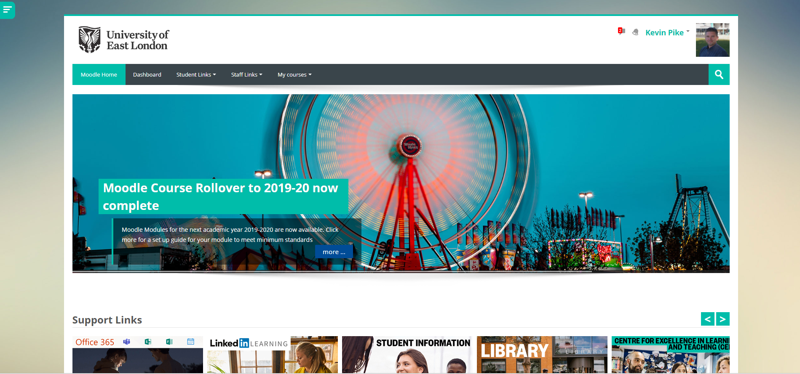

- Listing all the courses you are enrolled on in the Course overview section. To enter a course, click a course title under the Course overview section.

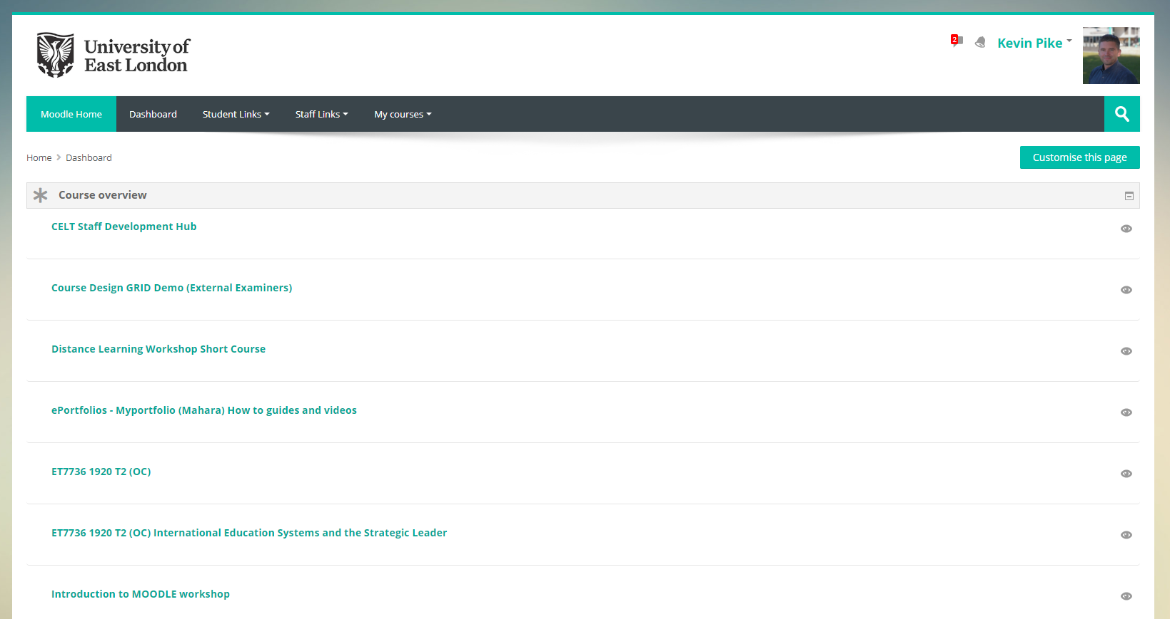

- Within a Moodle module course, you will need to navigate to the appropriate Turnitin link to access the students’ scripts. As a general rule, any Turnitin links should appear under the Assessment heading, but may be placed at any location within the Moodle course.

Note: A Turnitin assignment link is denoted by this icon

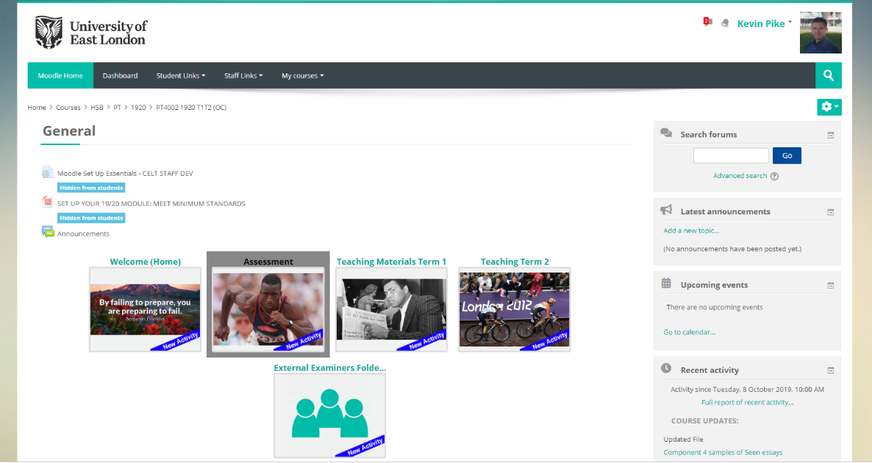

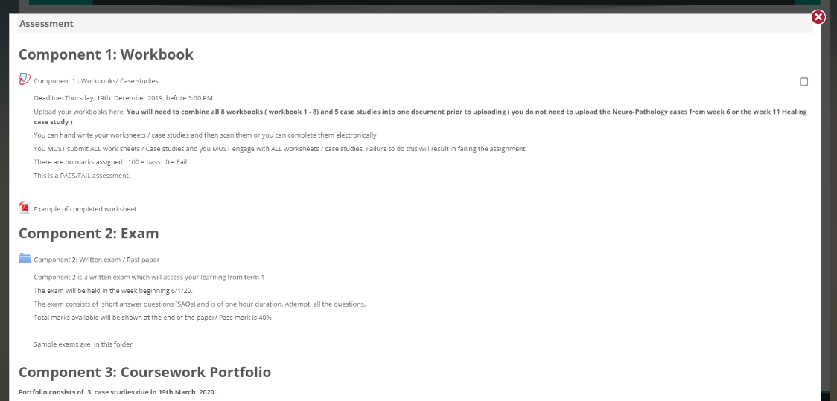

- Click the Turnitin link to access the Submission Inbox. A list of student submissions, their percentage similarities and provisional grade will be displayed.

- Click the Grade of the required submission to open a new window containing the student submission and any feedback provided.

Student Name
Student Name
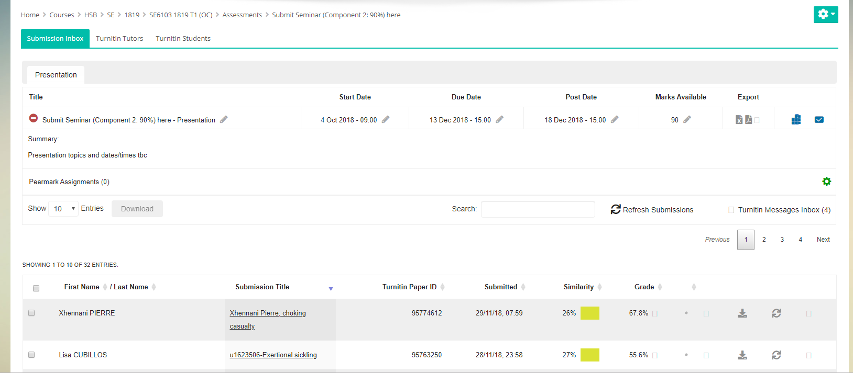

- The Turnitin Document Viewer will be displayed. Within the Turnitin Document Viewer you will be able to view any specific comments and feedback the marker has added for the student submission.

Reviewing/Moderating Feedback on Turnitin Submissions
Within the Turnitin Document Viewer, feedback will have been provided on the submission in a variety of ways. Below is an overview of the types of feedback that may have been used on a student submission.
QuickMark Comments
- Turnitin provides the ability to add comments directly onto the student submission, providing annotations on the submitted work. These comments can be individual comments, common comments (used on multiple submissions) or a mixture of both.
- QuickMark comments will appear as blue bubble comments within the submission. Hovering over a comment will expand it to provide the details.

General Comments
- General comments may be available on the right of screen. These comments are text based and can provide a narrative on overall submission.
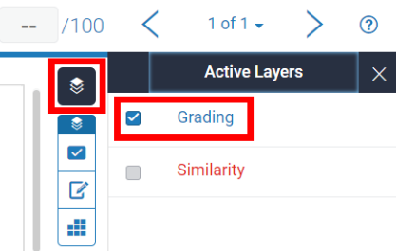
- To view any general comments click the General Comments
tab from the bottom right of the screen.

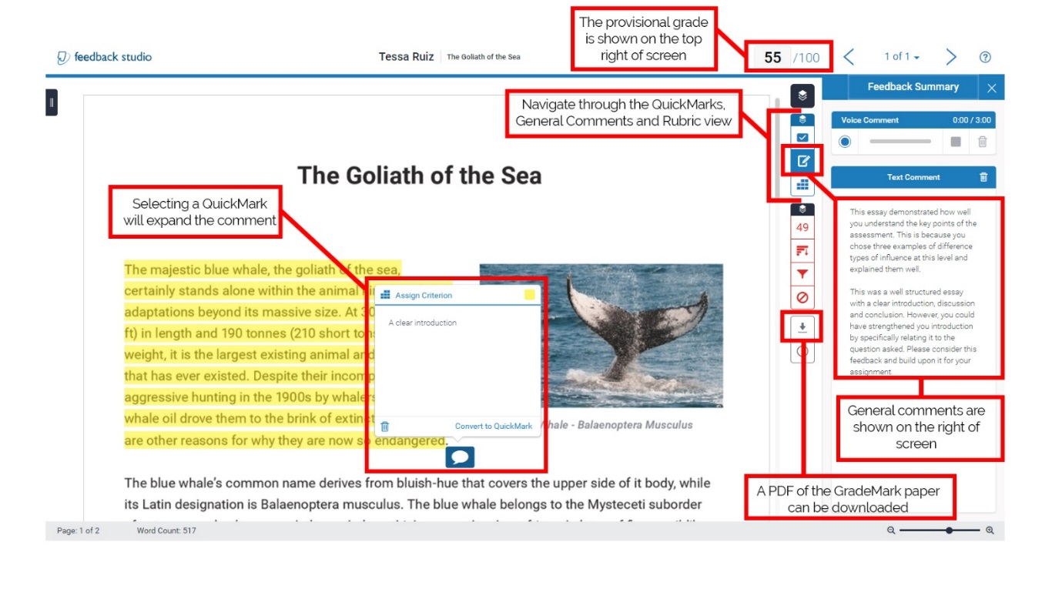

Rubric Based Feedback
- Rubrics can be used to provide feedback on standard marking criteria, providing for students an indication on the level at which their assignment met specific criteria or learning outcomes.
- If a rubric has been used on the assignment, it can be accessed by selecting the Rubric tab from the bottom right of the screen.
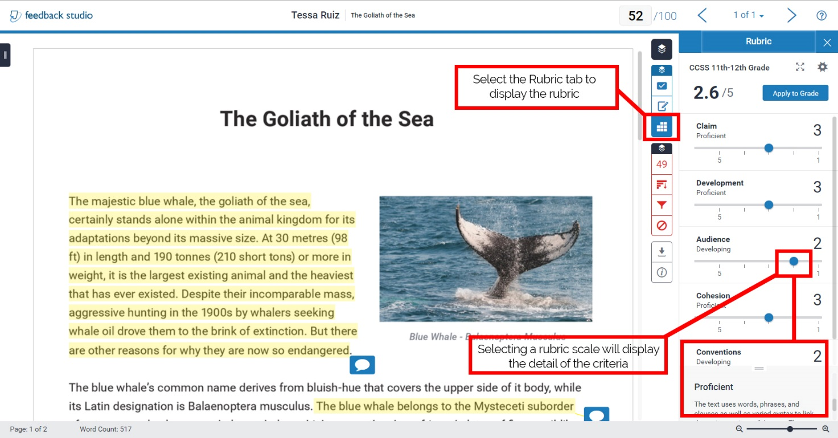
View Rubric

An example of an expanded Rubric is provided below. The highlighted boxes indicate the scale and points awarded for each specific criterion (Note, this example differs from above).
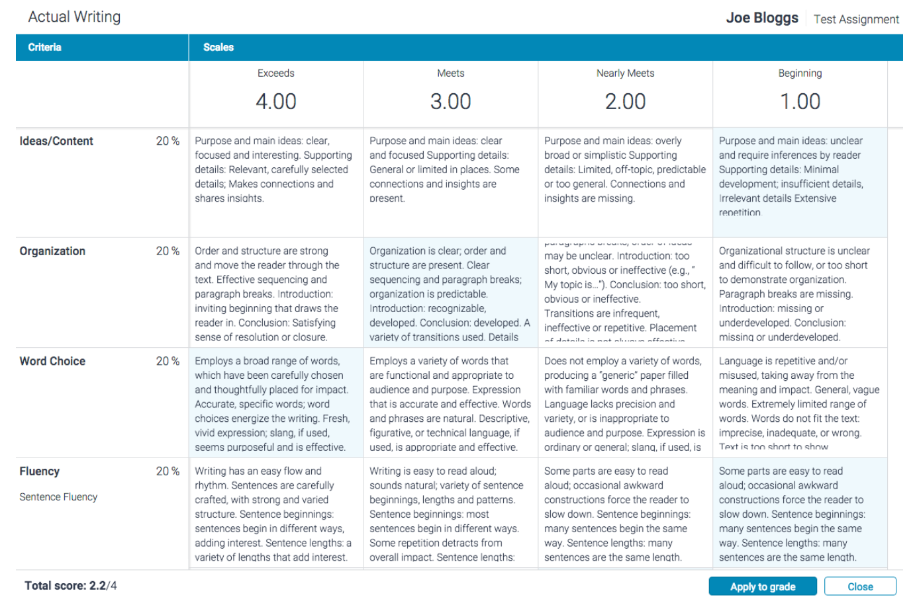

Identifying Second Marker Comments
Turnitin Feedback Studio allows second marking to be undertaken in a variety of ways. As an External Examiner, you will need to be aware of the type of method used. If in any doubt, you should liaise with the Module or Programme Leader to identify the method used within a specific submission or module. Examples of how a second marker’s comments may be added include:
- Adding second marker’s comments to the General Comments section.

- Adding a ‘Second Marker Comments’ QuickMark to the student’s work
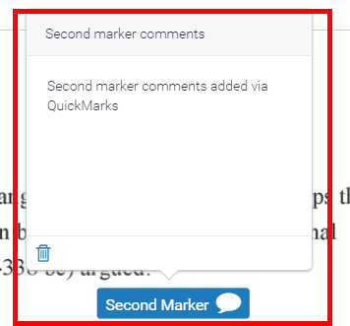

- Prefixing individual comments with ‘2M’ to indicate a second marker’s comment

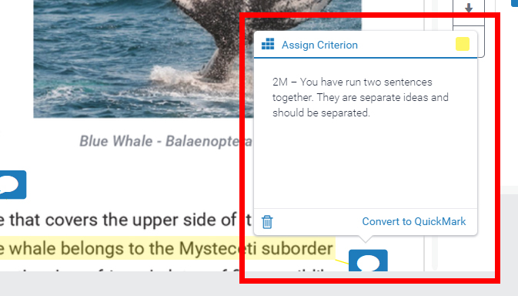

Online resources are located here:

CELT – Feedback Studio Course (Moodle) and Feedback Studio video tutorial Playlist (YouTube)

Feedback studio manuals and guides

e-Submission of Coursework
Guidance for External Examiners

APPENDIX: External Examiner Contacts within Schools
School | Contact | Telephone | E-mail
School of Business & Law | Eda Sefik | 0208 223 2132 | e.sefik@uel.ac.uk
Cass School of Education & Communities | Sabiha Daria | 0208 223 3400 | s.daria@uel.ac.uk
School of Architecture, Computing and Engineering | Jane Hodgson | 020 8223 2066 | s.j.hodgson@uel.ac.uk
School of Arts and Digital Industries | Nicole Hay | 020 8223 2389 | n.hay@uel.ac.uk
School of Health, Sports & Biosciences | Will Munday | 020 8223 4540 | w.p.munday@uel.ac.uk
School of Psychology | Susy Ajith | 020 8223 4480 | s.ajith@uel.ac.uk

