Digital Accessibility Centre

Accessibility Audit Report for
University of East London

Company | UEL
Date | 28th June 2021
DAC Ref. | 000846
Version | v1.0
Standard | WCAG 2.1

© 2021 Digital Accessibility Centre Limited, All Rights Reserved
Disclosure
Pursuant to item 7 in our terms and conditions, this report and its findings are intended for the client organization. Any other use of this material that is attributed to Digital Accessibility Centre, including delivery of excerpts, paraphrases, or edited versions to anyone not employed by the client organization must be approved by us in writing.

Document Control

Site/product/app name: | UEL Website
Client: | University of East London
Project lead: | Dan Jolley
User Testing Support: | Matthew Morgan
Technical Auditing Report Author: | Dan Jolley
Quality checked by: | Georgina Williams
Address: | Digital Accessibility Centre  Stephen Lloyd Suite (Unit 18)  Darcy Business Park  Llandarcy  Neath  SA10 6FG
Contact details: | Gavin.evans@digitalaccessibilitycentre.org  079366 85804  Cam.nicholl@digitalaccessibilitycentre.org  07597 690358
Phone: | 01792 815267
Date of audit: | 28th June 2021
Date Report Issued: | 9th July 2021

Contents

Digital Accessibility Centre 1
Accessibility Audit Report for University of East London 1
Document Control 2
Contents 3
Executive Summary 7
Audit Summary 9
Scope 10
Tasks 10
Browser matrix and Assistive Technology (AT) combinations 11
Summary Graphs 12
Analyst Feedback 12
WCAG 2.1 Breakdown 13
Audit Results 14
High Priority – WCAG A 15
Images 15
Issue ID: DAC_Images_01 15
CSS Icons 17
Issue ID: DAC_CSS_Icons_01 17
Issue ID: DAC_Images_02 19
Issue ID: DAC_Images_03 20
Issue ID: DAC_Images_04 21
Video – Media Alternative 22
Issue ID: DAC_Video_Alternative_01 22
Video - Captions 23
Issue ID: DAC_Video_Captions_01 23
Mouse Dependency 24
Issue ID: DAC_Keyboard_01 24
Issue ID: DAC_Keyboard_02 26
Expanding Content 27
Issue ID: DAC_Aria_03 27
Issue ID: DAC_Expanding_01 29
Heading Structure 30
Issue ID: DAC_Headings_01 30
Issue ID: DAC_Headings_02 32
Issue ID: DAC_Headings_03 34
Lists 35
Issue ID: DAC_Lists_01 35
Emphasised Text 36
Issue ID: DAC_Blockquote_01 36
Tables 38
Issue ID: DAC_Tables_01 38
Form Controls – Visible Label 40
Issue ID: DAC_Forms_02 40
Form Controls - Grouped 41
Issue ID: DAC_Forms_04 41
Incorrect Tags - PDF 43
Issue ID: DAC_PDF_Tags_01 43
Required Fields 45
Issue ID: DAC_Forms_01 45
Search Filters 47
Issue ID: DAC_Role_02 47
Moving Content 50
Issue ID: DAC_Moving_Content_01 50
Issue ID: DAC_Moving_Content_02 52
Issue ID: DAC_Moving_Content_03 54
Flashing Content 55
Issue ID: DAC_Flashing_01 55
Skip Link 56
Issue ID: DAC_Skip_Link_01 56
Issue ID: DAC_Skip_Link_02 57
Issue ID: DAC_Skip_Link_03 58
Error Summary 59
Issue ID: DAC_Error_Summary_01 59
Document Title - PDF 60
Issue ID: DAC_PDF_Title_01 60
Focus Order 61
Issue ID: DAC_Focus_Order_01 61
Issue ID: DAC_Focus_Order_02 63
Issue ID: DAC_Focus_Order_03 64
Issue ID: DAC_Focus_Order_04 66
Issue ID: DAC_Focus_Order_05 68
Issue ID: DAC_Focus_Order_06 69
Issue ID: DAC_Focus_Order_07 71
Issue ID: DAC_Focus_Order_09 73
Autofocus 74
Issue ID: DAC_Focus_Order_08 74
Empty Link 75
Issue ID: DAC_Links_01 75
Issue ID: DAC_Links_08 77
Issue ID: DAC_Links_09 78
Non-Descriptive Links 79
Issue ID: DAC_Links_02 79
Issue ID: DAC_Links_03 81
Issue ID: DAC_Links_04 82
Accordion 84
Issue ID: DAC_Accordion_01 84
Role 86
Issue ID: DAC_Role_01 86
Custom Elements 87
Issue ID: DAC_Listboxes_01 87
Incorrect use of Aria 90
Issue ID: DAC_Aria_01 90
Issue ID: DAC_Aria_02 91
Issue ID: DAC_Aria_04 92
Buttons – Accessible Name 94
Issue ID: DAC_Buttons_01 94
Issue ID: DAC_Buttons_04 96
iFrame – Accessible Name 97
Issue ID: DAC_iFrame_01 97
Carousel Controls 99
Issue ID: DAC_Carousel_Controls_01 99
Tabs 101
Issue ID: DAC_Tabs_01 101
Medium Priority – WCAG AA 103
Text Contrast 103
Issue ID: DAC_Text_Contrast_01 103
Issue ID: DAC_Text_Contrast_02 105
Non-Text Contrast 107
Issue ID: DAC_Non_Text_01 107
Non-Text Contrast - Focus 109
Issue ID: DAC_Focus_State_01 109
Issue ID: DAC_Focus_State_02 110
Buttons – Ambiguous Text 111
Issue ID: DAC_Buttons_02 111
Issue ID: DAC_Buttons_04 112
Focus Visible 113
Issue ID: DAC_Focus_State_03 113
Status Message 114
Issue ID: DAC_Status_Message_01 114
Low Priority – WCAG AAA 115
Non-Descriptive Links (Out of Context) 115
Issue ID: DAC_Links_05 115
Issue ID: DAC_Links_06 117
Issue ID: DAC_Links_07 119
Usability Issues 120
Reflow 120
Issue ID: DAC_Reflow_01 120
Article use 121
Issue ID: DAC_Articles_01 121
Duplicated Landmarks 123
Issue ID: DAC_Landmarks_01 123
Input Wrapped in Label 124
Issue ID: DAC_Forms_03 124
Bypass Blocks 126
Issue ID: DAC_Bypass_Blocks_01 126
Radio Buttons 127
Issue ID: DAC_Radio_Buttons_01 127
End of Report 128
Appendix I 129
Journeys 129
Appendix II 131
Classification of Accessibility Issues 131
Appendix III 152
The Process 152
CRITERIA 153
DAC Testing Procedure 154

Executive Summary

An accessibility audit for The UEL Website was carried out by the Digital Accessibility Centre (DAC) user/ technical team on 28th June 2021.

The website was assessed against the Web Content Accessibility Guidelines WCAG 2.1.

This document incorporates the findings regarding any accessibility barriers identified during the testing process.
The issues reported are examples of any assistive technology barriers which were encountered during accessibility testing, and information has been provided detailing how to resolve them.
Please note: additional instances of these barriers may exist in other pages of the site; wherever these barriers are present, they will also need to be resolved.

There were a significant number of issues identified during the audit process which would present a barrier to accessibility for multiple user groups.

Screen reader users had difficult interacting with content across the site. The heading structure of all pages was not logical, there were headings which were not descriptive and sections which did not have a heading. Screen reader users utilise heading to quickly understand the content of the page and skip through the content. It is essential that the heading structure is logical, hierarchical and descriptive.

Images across the site were found to have alternative text, which was not appropriate, all images should be checked, decorative images should have a null alt to allow screen reading software to ignore the images.

There are several elements which do not have an appropriate name or role including links, buttons and tabs. This can be confusing for users who rely on audio feedback. Some buttons have text which users may find ambiguous.

There are empty links present on several pages and other links which do not have descriptive text for screen reader users browsing in context or out of context using the links list.

There are multiple carousels which are not structured correctly and will be confusing for users.

Keyboard only users identified issues with the tab order of several pages. There are non-interactive components which have been included in the tab order and the focus order of some components is confusing. Some pages have elements which receive focus automatically, which can be confusing.
There are skip links which do not function as expected and elements which are mouse dependent.

Users with limited vision or colour perception issues may have difficulty with some of the colour combinations which have been used.

The issues have been listed in order of the relevant WCAG success criteria, with high priority issues listed first and low priority WCAG AAA issues and usability issues towards the end of the report.

Audit Summary
In order for the website to be eligible for a Digital Accessibility Centre certification, and fall in line with WCAG 2.1 requirements, improvements need to be made in the following areas.
A
Images
CSS Icons
Video – Media Alternative
Video - Captions
Mouse Dependency
Expanding Content
Heading Structure
Lists
Emphasised Text
Tables
Form Controls – Visible Label
Form Controls - Grouped
Incorrect Tags - PDF
Required Fields
Search Filters
Moving Content
Flashing Content
Skip Link
Error Summary
Document Title - PDF
Focus Order
Autofocus
Empty Link
Non-Descriptive Links
Accordion
Role
Custom Elements
Incorrect use of Aria
Buttons – Accessible Name
iFrame – Accessible Name
Carousel Controls
Tabs
AA
Text Contrast
Non-Text Contrast
Non-Text Contrast - Focus
Buttons – Ambiguous Text
Focus Visible
Status Message
AAA
Non-Descriptive Links (Out of Context)

Scope

Tasks

Brief Task and/ or URLs are listed below along with the specific browser and AT set.
URL: https://univeastlond.prod.acquia-sites.com/

See Appendix I for a full list of tasks and instructions.

Browser matrix and Assistive Technology (AT) combinations

Desktop
User type | Operating System (OS) | Browser | Assistive Technology
Blind | Windows | Chrome | JAWS 18 and 2019
 |  | Firefox | NVDA
 | MAC | Safari | VoiceOver
Mobility | Windows | IE11 | Dragon Voice Activation v15
Mobility | Windows | Chrome | Keyboard
 |  | Edge | Keyboard
Deaf | Windows | Chrome | -
Colour Blind/ Dyslexia | Windows | Chrome | -
Low Vision | Windows | Chrome | Screen Magnification,  Reflow *, Text Spacing †
 |  | Edge | System inverted colours
Cognitive Impaired/ Asperger’s/ Anxiety | Windows | Chrome | -

* Reflow tests with screen size of 1280 x 1024px, at 400% browser magnification
† Text Spacing tests with larger Line height, and larger Paragraph, Word and Letter spacing.

Mobile/ Tablet
User type | Operating System (OS) | Browser | Assistive Technology
Blind | iOS | Safari | VoiceOver
 | Android | Chrome | TalkBack/ Voice Assistant
Mobility | iOS | Safari | -
 | Android | Chrome | -
Deaf | iOS | Safari | -
Colour Blind/ Dyslexia | Android/ iOS | Chrome/ Safari | -
Low Vision | Android | Chrome | Magnification
 | iOS | Safari | System inverted colours

Summary Graphs

Analyst Feedback

Our analysts provided their overall feedback on the website.
This was rated from 0 – could not complete to 3 – Completed independently, no issues.

Key:
0 | Could not complete on my own
1 | Completed independently but with major issues
2 | Completed independently but with minor issues
3 | Completed independently, no issues

WCAG 2.1 Breakdown

The graphs below detail the number of checkpoints that passed, failed or were not applicable to the website.
Please refer to the Classification of Accessibility Issues for more information.

A
Priority Level | Number | Percentage: High Priority Results
Number of checkpoints ‘Passed’ | 10 (33%)
Number of checkpoints ‘Failed’ | 15 (50%)
Number of checkpoints ‘Not Applicable (N/A)’ | 5 (17%)

AA
Priority Level | Number | Percentage: Medium Priority Results
Number of checkpoints ‘Passed’ | 9 (45%)
Number of checkpoints ‘Failed’ | 5 (25%)
Number of checkpoints ‘Not Applicable (N/A)’ | 6 (30%)

AAA
Priority Level | Number | Percentage: Low Priority Results
Number of checkpoints ‘Passed’ | 4 (14%)
Number of checkpoints ‘Failed’ | 5 (18%)
Number of checkpoints ‘Not Applicable (N/A)’ | 19 (68%)

Audit Results

These are the results of the Digital Accessibility Centre accessibility audit by section.

Each area contains a reference to the WCAG success criteria, a brief overview of the issue encountered, a description of issues found along with user testing commentaries and solutions.

High Priority – WCAG A

Images
There are images present which do not have appropriate alternative text for screen reader users.

WCAG Reference:
1.1.1 Non-text Content
Understanding Non-text Content |How to Meet Non-text Content
(Level A)

Issue ID: DAC_Images_01

URL: https://univeastlond.prod.acquia-sites.com/
Page title: Homepage | UEL
Journey: 1 step 1

Screenshot:

There is an image which does not have an alt attribute which may be confusing for some screen reader users as some software will attempt to read the file path to users.

All images should have an alt attribute.

Current Code Ref(s):
<img class="coh-image coh-ce-cpt_homepage_hero_image-3731cf07 coh-image-responsive-xs" src="https://assetbank.uel.ac.uk/assetbank-uel/servlet/display?file=836585996934f6a3cedc.jpg">
Screen reader comments:
“When navigating through the graphics out of context on the home page I found multiple graphics that had clear alt texts. If these are decorative; however, I would expect these graphics to be hidden from screen reader users.”

Solution:
Ensure all images have an alt attribute, in this instance the alt attribute should be null to allow screen reading software to ignore the image.

Example
<img class="coh-image coh-ce-cpt_homepage_hero_image-3731cf07 coh-image-responsive-xs" src="https://assetbank.uel.ac.uk/assetbank-uel/servlet/display?file=836585996934f6a3cedc.jpg" alt="">

CSS Icons
There are CSS icons which are creating blank swipes for screen reader users

WCAG Reference:
1.1.1 Non-text Content
Understanding Non-text Content |How to Meet Non-text Content
(Level A)

Issue ID: DAC_CSS_Icons_01

URL: https://univeastlond.prod.acquia-sites.com/
Page title: Homepage | UEL
Journey: 1 step 1

Screenshot:

The CSS icons are being picked up by mobile screen readers and result in blank link which may be confusing and time consuming for screen reader users.

This applies to all CSS icons across the site.

Current Code Ref(s):
<a href=”/” data-coh-settings=”{ &quot;xs&quot;:{&quot;link_interaction&quot;:&quot;no-interaction&quot;} }” class=”coh-link mega-menu-trigger coh-ce-cc96a4a7 js-coh-menu-item-link”>Study</a>

.coh-ce-cc96a4a7:after {
line-height: 1.0;
font-weight: normal;
text-transform: none;
speak: none;
font-variant: normal;
-webkit-font-smoothing: antialiased;
-moz-osx-font-smoothing: grayscale;
content: “\E810”;
font-family: “fontello”;
margin-left: auto;
position: absolute;
top: -webkit-calc(50% - 10px);
top: calc(50% - 10px);
right: 0;
}

Screen reader user comments:
“After each link there appears to be a blank link. A member of the support team advised me that it was an icon which was being picked up by VoiceOver.”

Solution:
Ensure that the icons are hidden and not read by screen reading software.

Issue ID: DAC_Images_02

URL: https://univeastlond.prod.acquia-sites.com/
Page title: Homepage | UEL
Journey: 1 step 1

Screenshot:

There is an image which has alternative text of "Student smiling at the camera" which is not descriptive of the image. Decorative images should have a null alt attribute unless they convey useful information to users.

Current Code Ref(s):
<img class="coh-image coh-ce-cpt_two_column_coloured_banner-8061cfbe coh-image-responsive-xs" src="/sites/default/files/9588.jpg" alt="Student smiling at the camera">

Solution:
Ensure all decorative images have a null alt attribute.

Example
<img class="coh-image coh-ce-cpt_two_column_coloured_banner-8061cfbe coh-image-responsive-xs" src="/sites/default/files/9588.jpg" alt="">

Issue ID: DAC_Images_03

URL: https://univeastlond.prod.acquia-sites.com/
Page title: Homepage | UEL
Journey: 1 step 1

Screenshot:

There is a decorative image which has an alt attribute of "Docklands campus library external shot" which may be frustrating and time consuming for screen reader users to read as it provides no useful information.

Current Code Ref(s):
<img class="coh-image coh-ce-cpt_two_column_coloured_banner-8061cfbe coh-image-responsive-xs" src="/sites/default/files/2629.jpg" alt="Docklands campus library external shot">

Solution:
Ensure all decorative images have a null alt attribute.

Example
<img class="coh-image coh-ce-cpt_two_column_coloured_banner-8061cfbe coh-image-responsive-xs" src="/sites/default/files/2629.jpg" alt="">

Issue ID: DAC_Images_04

URL: https://univeastlond.prod.acquia-sites.com/study/undergraduate/why-uel
Page title: Why UEL? | UEL
Journey: 1 Step 3

Screenshot:

There are decorative images that have descriptive alt attributes which can be frustrating for screen reader users. One of the alt attributes has a spelling mistake which can also be confusing.

Current Code Ref(s):
<img class="coh-image coh-image-responsive-xs" src="/sites/default/files/3379.jpg" alt="Three students in lab coats wear safety googles">

Solution:
Ensure all decorative images have a null alt attribute (alt="").

Video – Media Alternative
The video has no transcript available for users who may require alternative formats.

WCAG Reference:
1.2.1 Audio-only and Video-only (Pre-recorded)
Understanding Audio-only and Video-only (Pre-recorded) |How to Meet Audio-only and Video-only (Pre-recorded)
(Level A)

1.2.3 Audio Description or Media Alternative (Pre-recorded)
Understanding Audio Description or Media Alternative (Pre-recorded) |How to Meet Audio Description or Media Alternative (Pre-recorded)
(Level A)

Issue ID: DAC_Video_Alternative_01

URL: https://univeastlond.prod.acquia-sites.com/about/alumni-supporters
Page title: Alumni and supporters | UEL
Journey: 1 Step 2

Screenshot:

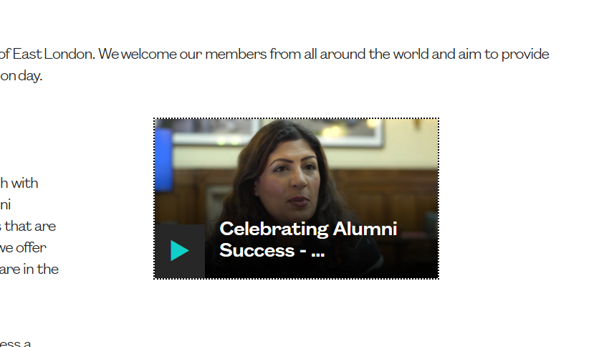

There is no transcript available for users who may require an alternative format. All video content should have a transcript or audio description which presents equivalent information.

Solution:
Ensure that all time based media has an alternative; such as an audio description or transcript for people which have difficulty perceiving visual content.

Video - Captions
Automatically generated captions have been used which are not accurate.

WCAG Reference:
1.2.2 Captions (Pre-recorded)
Understanding Captions (Pre-recorded) |How to Meet Captions (Pre-recorded)
(Level A)

Issue ID: DAC_Video_Captions_01

URL: https://univeastlond.prod.acquia-sites.com/about/alumni-supporters
Page title: Alumni and supporters | UEL
Journey: 1 Step 2

Screenshot:

The captions for the video content have been auto generated and do not accurately represent the spoken content.

Solution:
Ensure that the captions are accurate for all video content. If auto generated captions are used, then they should be checked for accuracy and any mistakes edited.

Mouse Dependency
There are elements which cannot be accessed using a keyboard only.

WCAG Reference:
1.3.1 Info and Relationships
Understanding Info and Relationships |How to Meet Info and Relationships
(Level A)

2.1.1 Keyboard
Understanding Keyboard |How to Meet Keyboard
(Level A)

2.1.3 Keyboard (No Exception)
Understanding Keyboard (No Exception) |How to Meet Keyboard (No Exception)
(Level AAA)

4.1.2 Name, Role, Value
Understanding Name, Role, Value |How to Meet Name, Role, Value
(Level A)

Issue ID: DAC_Keyboard_01

URL: https://univeastlond.prod.acquia-sites.com/undergraduate/courses/bsc-hons-accounting-finance
Page title: BSc (Hons) Accounting and Finance | UEL
Journey: 1 step 5

Screenshot:

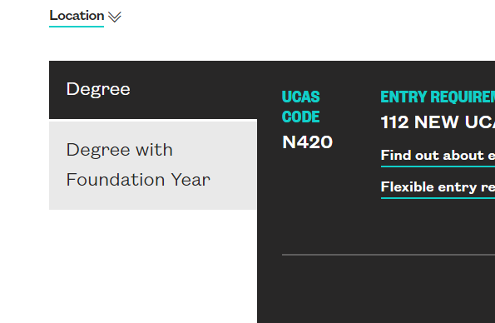

The element to show ‘Degree with Foundation Year’ is not accessible to users who cannot use a mouse. The element is a non-interactive component which relies on JavaScript for functionality. The whole component should be structured as tabs to allow all users to interact with the content.

Current Code Ref(s):
<span class="coh-inline-element course-name coh-ce-a0ac4b61">Degree with Foundation Year</span>

Keyboard only user comments:
“I was not able to get focus onto the ‘degree’ and ‘degree with foundation year’ tabs. This meant that I was not able to access them.”

Solution:
Ensure all interactive components are accessible using a keyboard only. This component should be structured as tabs to allow users to understand the purpose of the component.

See Tabs from the UK Government Design system for an example of tabs which display tables.

Issue ID: DAC_Keyboard_02

URL: https://univeastlond.prod.acquia-sites.com/undergraduate/courses/bsc-hons-accounting-finance
Page title: BSc (Hons) Accounting and Finance | UEL
Journey: 1 step 5

Screenshot:

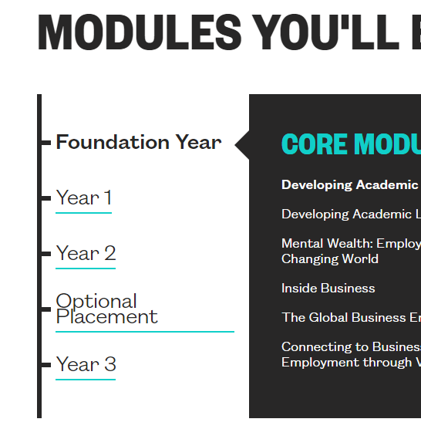

The links on the left-hand side of the modules section can be reached with a keyboard only, but cannot be activated. The links have no href attribute and rely on JavaScript for functionality. Keyboard only users will not be able to interact with the content.

Current Code Ref(s):
<a class="coh-style-inline-link" id="module-year-year1" tabindex="0">Year 1</a>

Keyboard only user comments:
“I was able to get focus onto the tabs under ‘modules you’ll be studying’ but I was not able to select them. This meant that when I pressed space or enter nothing happened.”

Solution:
Either ensure all links have an href attribute or an equivalent keyboard event handler.

Expanding Content
There is nested content which expands but does not inform screen reader users. The links are not accessible to users who cannot use a mouse.

WCAG Reference:
1.3.1 Info and Relationships
Understanding Info and Relationships |How to Meet Info and Relationships
(Level A)

2.1.1 Keyboard
Understanding Keyboard |How to Meet Keyboard
(Level A)

2.1.3 Keyboard (No Exception)
Understanding Keyboard (No Exception) |How to Meet Keyboard (No Exception)
(Level AAA)

4.1.2 Name, Role, Value
Understanding Name, Role, Value |How to Meet Name, Role, Value
(Level A)

Issue ID: DAC_Aria_03

URL: https://univeastlond.prod.acquia-sites.com/undergraduate/courses/bsc-hons-accounting-finance
Page title: BSc (Hons) Accounting and Finance | UEL
Journey: 1 step 5

Screenshot:

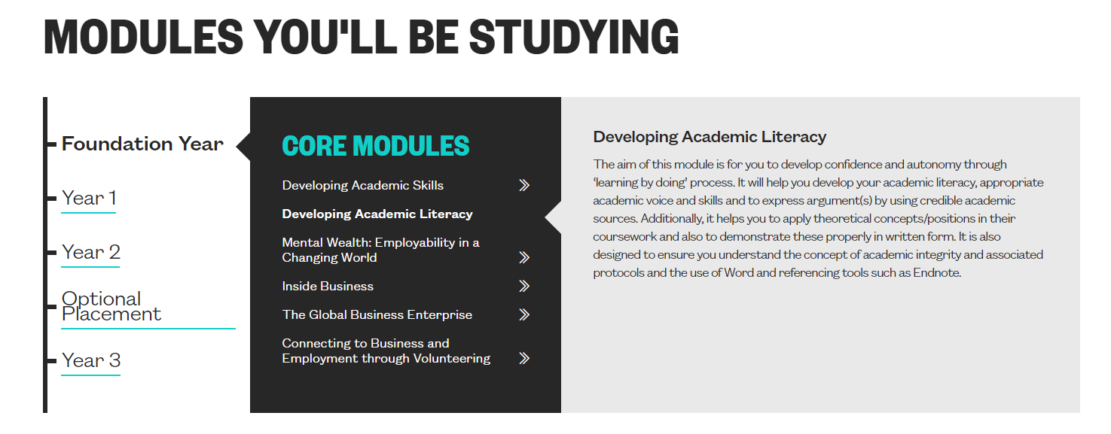

The ‘Modules you’ll be studying section’ will be difficult for screen reader users to understand. The links have no href attribute meaning that the role will not be announced by screen reading software and do not announce that they are expandable.

Current Code Ref(s):
<div class="coh-container coh-style-margin-top-and-bottom-large coh-container-boxed"> <h2 class="coh-heading coh-style-heading-2-uppercase" id="tab-id-6"> MODULES YOU'LL BE STUDYING </h2> <div class="coh-container module-browser-container" style="height: 420px;"> <div class="coh-container module-year-menu-container coh-ce-4e20a56c"> <div class="coh-container module-year-menu coh-ce-4e20a56c"> </div> </div> <ul class="coh-list-container coh-unordered-list module-browser-list"> <li class="coh-list-item"> <div class="paragraph paragraph--type--module-browser paragraph--view-mode--default">

<div class="module-year is-active"><a class="coh-style-inline-link" id="module-year-foundationyear" tabindex="0">Foundation Year</a></div>
<div class="module-group-container is-open">
<div class="paragraph paragraph--type--module-group paragraph--view-mode--default">
<a class="module-group-name">Core Modules</a>
<div class="module-group-content"> <article role="article" about="/developing-academic-skills"> <a href="javascript:void(0)" class="coh-link module-name coh-ce-366679c2"> Developing Academic Skills </a> <div class="coh-container module-details"> <a href="javascript:void(0)" class="coh-link module-close coh-ce-31e7a6da">Close</a> <h4 class="coh-heading coh-style-header-4 coh-ce-b14be452"> Developing Academic Skills </h4>
<div><div class="rich-txt-custom"><p class="coh-style-body">The main aim of this module is to equip you and develop the academic skills necessary to study at an HEI. This includes an introduction to the structure of higher education and also the learning and study skills necessary to produce quality pieces of work.</p>
</div></div>
</div> </article>

Solution:
Ensure that the links have a valid href attribute to allow screen reader users to understand that the element is selectable. Aria-expanded=true/false should be used on the link to inform users of the state.

Example
<a href="javascript:void(0)" aria-expanded="true" class="coh-style-inline-link" id="module-year-foundationyear" tabindex="0">Foundation Year</a>

Issue ID: DAC_Expanding_01

URL: https://univeastlond.prod.acquia-sites.com/
Page title: Homepage | UEL
Journey: 1 step 1

Screenshot:

The link to expand or collapse the menu does not announce as expanded or collapsed for screen reader users. This may be confusing as the state of the link is not clear.

Current Code Ref(s):
<a href="javascript:void(0)" class="coh-container menu-toggle coh-ce-cpt_header-e0a8f379 coh-interaction is-active" title="Menu" data-interaction-modifiers="[{&quot;modifierType&quot;:&quot;&quot;}]" rel="nofollow" data-coh-settings="{ &quot;xs&quot;:{&quot;linkAnimation&quot;:[{&quot;animationType&quot;:&quot;none&quot;}]} }"> </a>

Solution:
Use aria-expanded=true/false to announce the state of the link to screen reader users.

Heading Structure
The heading structure of some pages is not a logical hierarchy.

WCAG Reference:
1.3.1 Info and Relationships
Understanding Info and Relationships |How to Meet Info and Relationships
(Level A)

2.4.6 Headings and Labels
Understanding Headings and Labels |How to Meet Headings and Labels
(Level AA)

Issue ID: DAC_Headings_01

URL: https://univeastlond.prod.acquia-sites.com/
Page title: Homepage | UEL
Journey: 1 step 1

Screenshot:
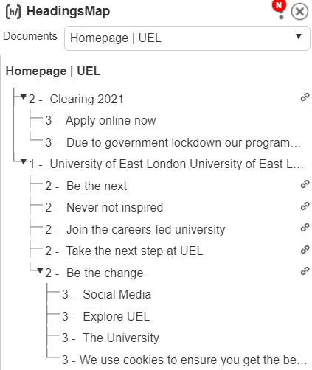

The heading structure of the page is not a logical hierarchy. The level 1 heading is not at the start of the page content and the footer links appear to be subordinate to the ‘Be the change’ level 2 heading.

Current Code Ref(s):
<h2 class="coh-heading coh-style-heading-2-uppercase coh-ce-cpt_homepage_image_video_row-4d8a031a" id="tab-id-5" style="display: block;" data-element-id="headingsMap-16"> Be the change </h2>

Screen reader comments:
“When navigating through the headings on the home page I discovered that they jump from a H3 to a H1. A logical hierarchical heading structure where the headings move in a consecutive order would be beneficial as this allows blind users to better understand the content on the page.”

Solution:
Ensure that the heading structure of each page is logical and hierarchical, each page should have a level 1 heading to introduce the content followed by subheadings at level 2 to level 6. The heading structure should reflect the relationships of the content on the page. The headings in the footer should be at level 2 or there should be a level 2 heading to introduce them.

Issue ID: DAC_Headings_02

URL: https://univeastlond.prod.acquia-sites.com/about/alumni-supporters
Page title: Alumni and supporters | UEL
Journey: 1 Step 2

Screenshot:

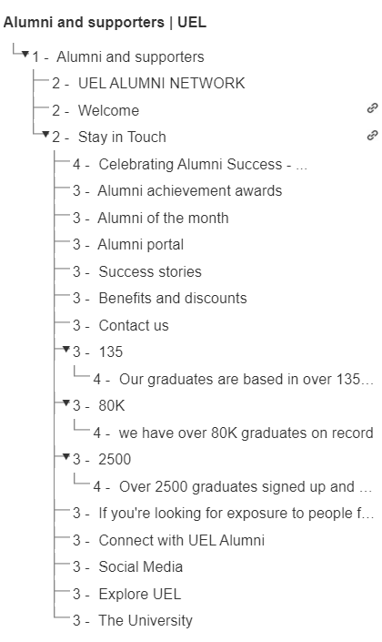
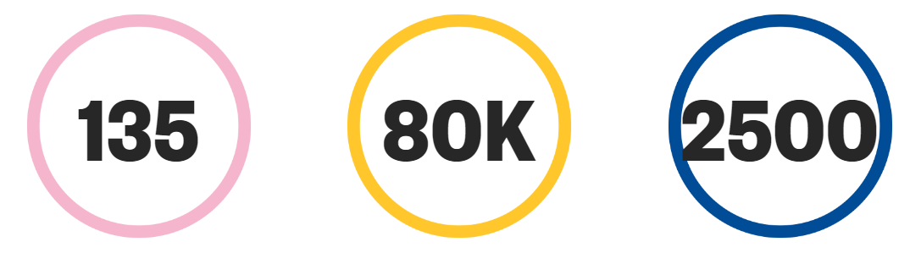

The heading structure on the alumni page is not logical. All of the content below ‘Stay in touch’ appears to be subordinate of that heading for screen reader users including the headings in the page footer. There is a blockquote which is marked as a heading which is not correct and there are numbers marked as headings which will be confusing for screen reader users.

This issue appears to be consistent across the site. Heading structures on all pages should be checked.

Current Code Ref(s):
<h2 class="coh-heading coh-component coh-component-instance-57590755-d295-48a8-9f07-092c32916610 contextual-component coh-style-header-2 coh-ce-cpt_headings-3de6d520" id="tab-id-1"> Stay in Touch </h2>

<div class="coh-container stat-item coh-ce-cpt_dynamic_stat_item-33f41896"> <h3 class="coh-heading coh-style-header-1-medium coh-instance-1623450274 coh-ce-cpt_dynamic_stat_item-e8ebf630"> 135 </h3> <h4 class="coh-heading coh-style-heading-3 coh-ce-cpt_dynamic_stat_item-6ca62319"> Our graduates are based in over 135 countries </h4> </div>

<h3 class="coh-heading coh-ce-f50d7750"> If you're looking for exposure to people from different countries, people who bring a different outlook to your own, people who bring a sense of maturity, UEL is the place for you, it's a fantastic place to study. </h3>

Screen reader comments:
“When navigating through the headings out of context on the Alumni and supporters page I discovered headings that contain a numerical value. These headings would benefit from additional text being added to the heading so that users are able to understand related content both in and out of context.”

Solution:
Ensure that the heading structure of all pages is logical and hierarchical. The heading structure should define the structure of the page and each section. Semantic HTML heading tags should not be used on content that does not introduce further text and headings should be descriptive.

Issue ID: DAC_Headings_03

URL: https://univeastlond.prod.acquia-sites.com/study/undergraduate/why-uel
Page title: Why UEL? | UEL
Journey: 1 Step 3

Screenshot:

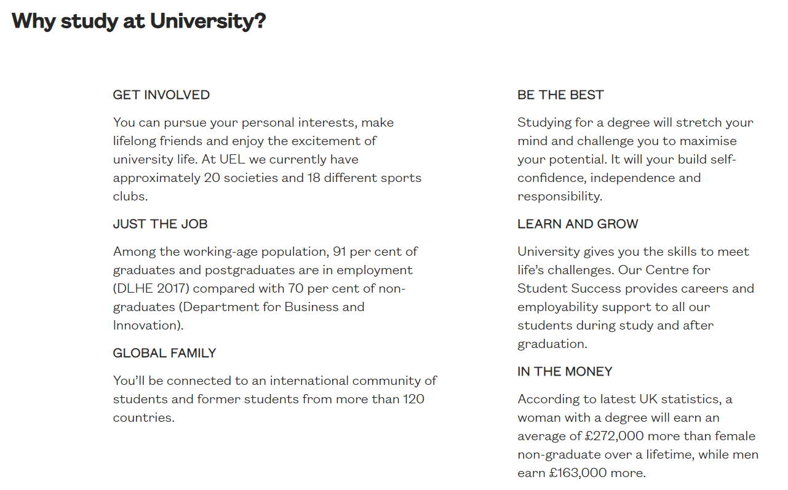

There are visible headings present which do not have appropriate semantic HTML mark up to allow screen reader users to recognise the text as headings. Screen reader users can use headings as short cuts to navigate through the page content, so it is important that headings are marked and structured correctly.

Current Code Ref(s):
<p><strong>GET INVOLVED</strong></p>

<p><strong>JUST THE JOB</strong></p>

<p><strong>GLOBAL FAMILY</strong></p>

<p><strong>BE THE BEST</strong></p>

<p><strong>LEARN AND GROW</strong></p>

<p><strong>IN THE MONEY</strong></p>

Solution:
Ensure that all content which appears visually as a heading is marked appropriately with a semantic HTML heading tag. These headings should be set as <h3>

Example
<h3><strong>GET INVOLVED</strong></h3>

Lists
There are lists which are not structured correctly that may confuse users who rely on audio feedback.

WCAG Reference:
1.3.1 Info and Relationships
Understanding Info and Relationships |How to Meet Info and Relationships
(Level A)

Issue ID: DAC_Lists_01

URL: https://univeastlond.prod.acquia-sites.com/study/undergraduate/why-uel
Page title: Why UEL? | UEL
Journey: 1 Step 3

Screenshot:

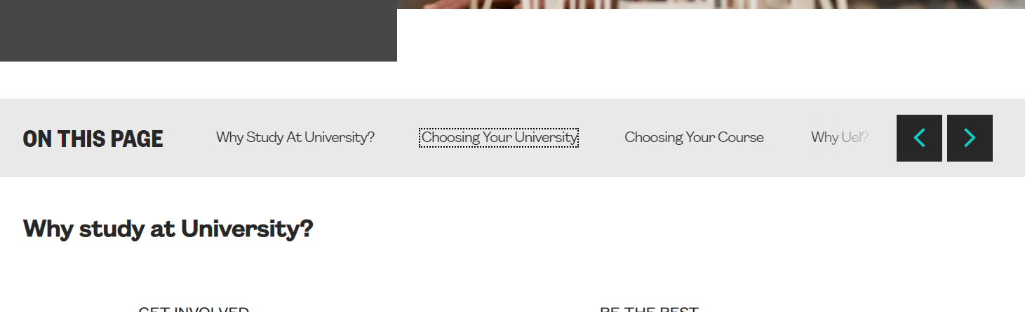

The ‘on this page’ carousel is not structured correctly and may be confusing for screen reader users. An unordered list should only contain list items to allow screen reading software to read the list correctly.

Current Code Ref(s):
<ul class="coh-list-container coh-unordered-list on-this-page-list coh-ce-cpt_on_this_page-2fce1d61 slick-initialized slick-slider">
<div class="slick-list">
<div class="slick-track" style="opacity: 1; width: 50000px; transform: translate3d(0px, 0px, 0px);">
<div class="slick-slide slick-current slick-active" data-slick-index="0" aria-hidden="false" tabindex="0">
<div>
<li style="width: 100%; display: inline-block;"><a class="coh-style-inline-link" href="#tab-id-0" data-target-id="tab-id-0" tabindex="0">Why Study At University?</a></li>
</div>
[…]
</ul>

Solution:
Ensure that the <ul> only contains <li> elements. See Carousel Structure from W3C for more information.

Emphasised Text
There is text which is emphasised that does not have the appropriate semantic mark up to allow screen reader users to recognise the emphasis.

WCAG Reference:
1.3.1 Info and Relationships
Understanding Info and Relationships |How to Meet Info and Relationships
(Level A)

Issue ID: DAC_Blockquote_01

URL: https://univeastlond.prod.acquia-sites.com/about/alumni-supporters
Page title: Alumni and supporters | UEL
Journey: 1 Step 2

Screenshot:

There is a blockquote on the page which is not marked appropriately. Screen reader users may not be aware of the context of the text as the emphasis is provided by CSS and heading tags.

This issue is consistent wherever blockquotes have been used.

Current Code Ref(s):
<div class="coh-container"> <h3 class="coh-heading coh-ce-f50d7750"> If you're looking for exposure to people from different countries, people who bring a different outlook to your own, people who bring a sense of maturity, UEL is the place for you, it's a fantastic place to study. </h3> <p class="coh-paragraph coh-ce-357397eb">Firoz Patel</p> <p class="coh-paragraph coh-ce-dbd9ed74">BA International Development with NGO Management, 2006</p> </div>

Solution:
Ensure any emphasised text has appropriate semantic mark up to allow screen reader users to understand the context of the text.
Example
<blockquote class="coh-heading coh-ce-f50d7750"> If you're looking for exposure to people from different countries, people who bring a different outlook to your own, people who bring a sense of maturity, UEL is the place for you, it's a fantastic place to study. </blockquote>

See Using semantic markup to mark emphasized or special text for more information.

Tables
There is content which is displayed as a table that does not have appropriate semantic mark up for screen reader users.

WCAG Reference:
1.3.1 Info and Relationships
Understanding Info and Relationships |How to Meet Info and Relationships
(Level A)

Issue ID: DAC_Tables_01

URL: https://univeastlond.prod.acquia-sites.com/undergraduate/courses/bsc-hons-accounting-finance
Page title: BSc (Hons) Accounting and Finance | UEL
Journey: 1 step 5

Screenshot:

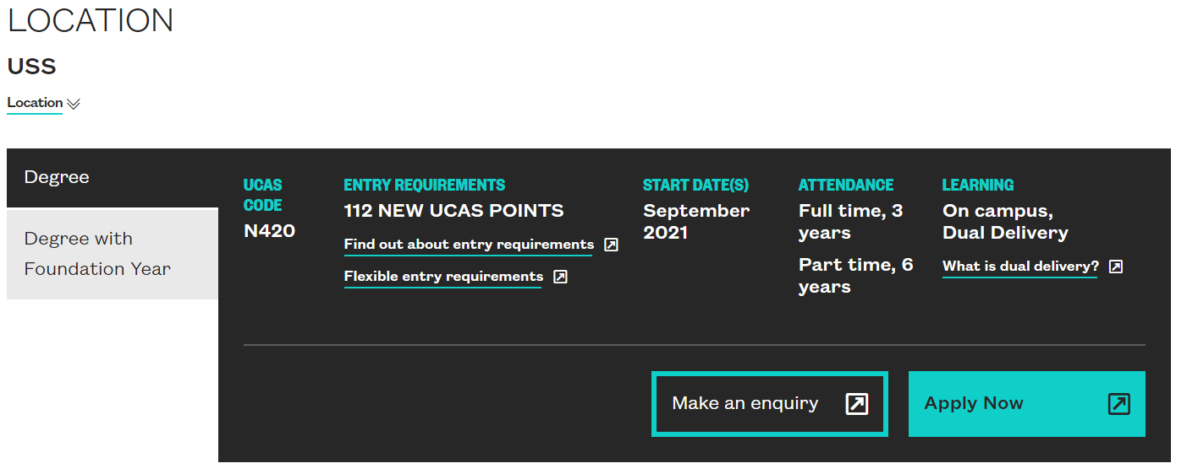

There is content which is displayed in a tabular format which does not have appropriate semantic HTML mark up to allow screen reader users to interact with the content in a meaningful way.

Current Code Ref(s):
<div class="coh-container study-options-accordion__content__columns"> <div class="coh-container study-options-accordion__content__column"> <h4 class="coh-heading"> UCAS CODE </h4> <div class="coh-container column-body"> <p class="coh-paragraph ucas-code coh-ce-4d7c449f">N420</p> </div> </div> <div class="coh-container study-options-accordion__content__column"> <h4 class="coh-heading"> ENTRY REQUIREMENTS </h4> <div class="coh-container column-body coh-ce-9d417938"> <p class="coh-paragraph ucas-points-container"> <span class="coh-inline-element ucas-points">112</span> <span class="coh-inline-element">NEW UCAS POINTS</span> </p> <p class="coh-paragraph ucas-points-error-msg coh-ce-14b445f0">UCAS points will be updated soon</p> <div class="coh-container coh-ce-dd72d4af"> <div class="coh-container coh-component coh-component-instance-e2eabd4b-9a60-44bb-8e62-14558de2583e contextual-component cta-inline-link progressive-trigger coh-instance-494294546 coh-ce-cpt_progressive_reveal_cta_link-bd819071" data-modal-open="progressive-reveal-0" role="button" id="progressive-trigger-0" tabindex="0"> <span class="coh-inline-element link-text coh-ce-cpt_progressive_reveal_cta_link-9763f6ad">Find out about entry requirements</span> </div>
</div> <div class="coh-container coh-component coh-component-instance-9899d42b-b096-4926-b920-21e05bc9bcdd contextual-component cta-inline-link progressive-trigger coh-instance-2244708755 coh-ce-cpt_progressive_reveal_cta_link-bd819071" data-modal-open="progressive-reveal-1" role="button" id="progressive-trigger-1" tabindex="0"> <span class="coh-inline-element link-text coh-ce-cpt_progressive_reveal_cta_link-9763f6ad">Flexible entry requirements</span> </div>
</div> </div> <div class="coh-container study-options-accordion__content__column"> <h4 class="coh-heading">Start Date(s)</h4> <div class="coh-container column-body"> <div about="/taxonomy/term/391">

<div>
<div>September 2021</div>
</div>

</div>
</div> </div> <div class="coh-container study-options-accordion__content__column"> <h4 class="coh-heading">Attendance</h4> <div class="coh-container column-body"> <ul class="coh-list-container coh-unordered-list coh-ce-ebc52bd"> <li class="coh-list-item coh-ce-78109ac8"> <article about="/taxonomy/term/291"> <h4 class="coh-heading coh-ce-fb89dca7"> Full time, 3 years </h4> </article>
</li> <li class="coh-list-item coh-ce-78109ac8"> <article about="/taxonomy/term/491"> <h4 class="coh-heading coh-ce-fb89dca7"> Part time, 6 years </h4> </article>
</li> </ul> </div> </div> <div class="coh-container study-options-accordion__content__column"> <h4 class="coh-heading">Learning</h4> <div class="coh-container column-body coh-ce-505647e"> <ul class="coh-list-container coh-unordered-list coh-ce-ebc52bd"> <li class="coh-list-item coh-ce-fb9d5b0d"> <article about="/taxonomy/term/66"> <h4 class="coh-heading coh-ce-fb89dca7"> On campus, Dual Delivery </h4> </article>
</li> </ul> <div class="coh-container coh-component coh-component-instance-a25b4771-ebe0-430a-9e94-0f756330bc1e contextual-component cta-inline-link progressive-trigger coh-instance-4130944222 coh-ce-cpt_progressive_reveal_cta_link-bd819071" data-modal-open="progressive-reveal-2" role="button" id="progressive-trigger-2" tabindex="0"> <span class="coh-inline-element link-text coh-ce-cpt_progressive_reveal_cta_link-9763f6ad">What is dual delivery?</span> </div>
</div> </div> </div>

Solution:
Ensure that content presented as a table has the appropriate mark up to allow screen reader users to read and understand the content.
See Tables with one header for more information or alternatively a description list could be used to present the relationships in the content to screen reader users.

Form Controls – Visible Label
There are form controls which rely on placeholder text as a visible label.

WCAG Reference:
1.3.1 Info and Relationships
Understanding Info and Relationships |How to Meet Info and Relationships
(Level A)

3.3.2 Labels or Instructions
Understanding Labels or Instructions |How to Meet Labels or Instructions
(Level A)

Issue ID: DAC_Forms_02

URL: https://univeastlond.prod.acquia-sites.com/elaines-accessibility-page
Page title: Elaine's Accessibility page | UEL
Journey: 1 step 13

Screenshot:

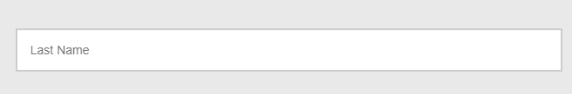

The input for last name relies on placeholder text as a visible label which may cause issues for users with cognitive impairments.

Current Code Ref(s):
<input aria-label="Full Name (Last name)" class="form-control ng-pristine ng-valid" type="text" placeholder="Last Name" style="width: 49%;" ng-model="values[field.id]['last_name']" autocomplete="family-name">

Solution:
Ensure all form controls have a visible label.

Form Controls - Grouped
There are grouped form controls which do not have a shared or common label.

WCAG Reference:
1.3.1 Info and Relationships
Understanding Info and Relationships |How to Meet Info and Relationships
(Level A)

3.3.2 Labels or Instructions
Understanding Labels or Instructions |How to Meet Labels or Instructions
(Level A)

Issue ID: DAC_Forms_04

URL: https://univeastlondstg.prod.acquia-sites.com/undergraduate/courses/bsc-hons-biomedical-science
Page title: BSc (Hons) Biomedical Science | UEL
Journey: 2 step 6

Screenshot:

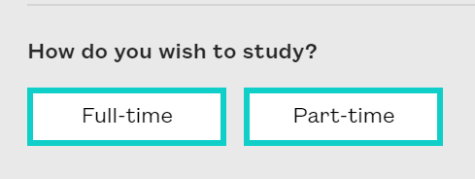
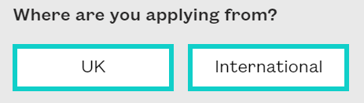

The buttons for full-time or part-time and ‘where are you applying from?’ do not have a shared label to give context to the buttons. All grouped inputs should have a shared or common label.

Current Code Ref(s):
<div class="question-row current" data-rowid="1">
<h2 class="question-title">How do you wish to study?</h2>

<div class="answers">
<button class="answer" data-relatedrow="2">Full-time</button>
<button class="answer" data-relatedrow="12">Part-time</button>
<button class="close" data-relatedrow="1">close</button>
</div>
</div>

Solution:
Ensure that all grouped form controls have a shared or common label to allow screen reader users to fully understand the context of the question.

Example
<fieldset class="question-row current" data-rowid="1">
<legend>
<h2 class="question-title">How do you wish to study?</h2>
</legend>
<div class="answers">
<button class="answer" data-relatedrow="2">Full-time</button>
<button class="answer" data-relatedrow="12">Part-time</button>
<button class="close" data-relatedrow="1">close</button>
</div>
</fieldset>

Incorrect Tags - PDF
There are elements in the pdf document which have been tagged incorrectly.

WCAG Reference:
1.3.1 Info and Relationships
Understanding Info and Relationships |How to Meet Info and Relationships
(Level A)

Issue ID: DAC_PDF_Tags_01

URL: https://univeastlond.prod.acquia-sites.com/sites/default/files/6727.pdf
Page title: 6727.pdf
Journey: 1 step 6

Screenshot:

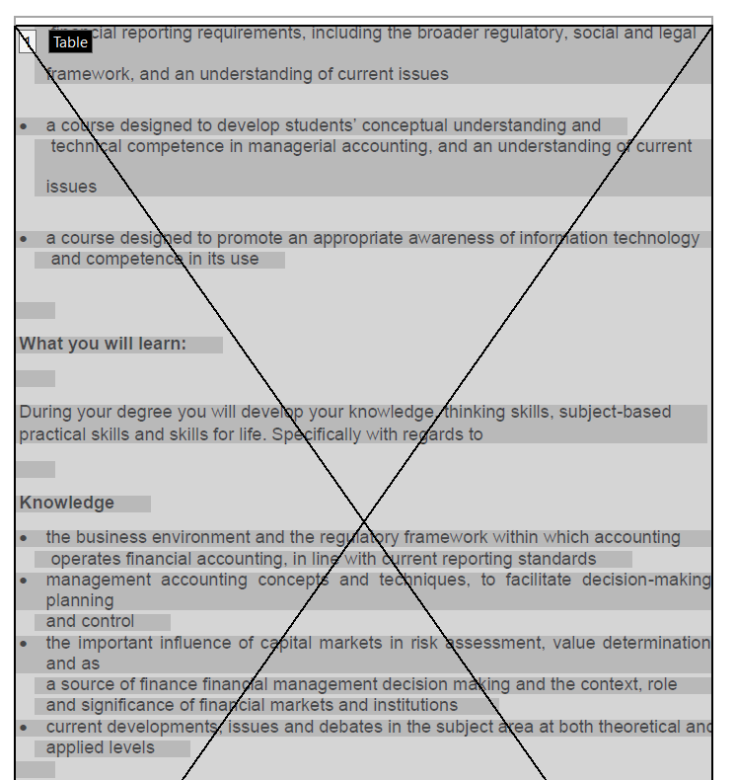

Content throughout the document has been tagged as tables which will be confusing for screen reader users. The content should be tagged as paragraphs or lists. There are visible headings which are not tagged appropriately and tables which do not have table headers.

Screen reader comments:
“When testing the BSC accounting course specifications pdf using JAWS in Chrome, I found that there were no headings on the page. Headings are important as they enable screen reader users the ability to locate the information they require in an easy manner. A heading at level 1 indicates main content on the PDF. I would expect to find a H1 on the PDF but would prefer more than one heading to be present to enable me to navigate through the pdf more efficiently.
When testing the pdf in adobe with JAWS, I located a heading at level 1. Additional headings would be helpful for the reasons stated above.”
Solution:
Ensure all content within the pdf is tagged appropriately. Content which is not a table should not be tagged as a table. Headings should be tagged with an appropriate level and table headers should be tagged accordingly.

See PDF accessibility overview from Adobe for more information.

Required Fields
There are form fields with required input which are not marked correctly.

WCAG Reference:
1.3.1 Info and Relationships
Understanding Info and Relationships |How to Meet Info and Relationships
(Level A)

3.3.2 Labels or Instructions
Understanding Labels or Instructions |How to Meet Labels or Instructions
(Level A)

Issue ID: DAC_Forms_01

URL: https://univeastlond.prod.acquia-sites.com/elaines-accessibility-page
Page title: Elaine's Accessibility page | UEL
Journey: 1 step 13

Screenshot:

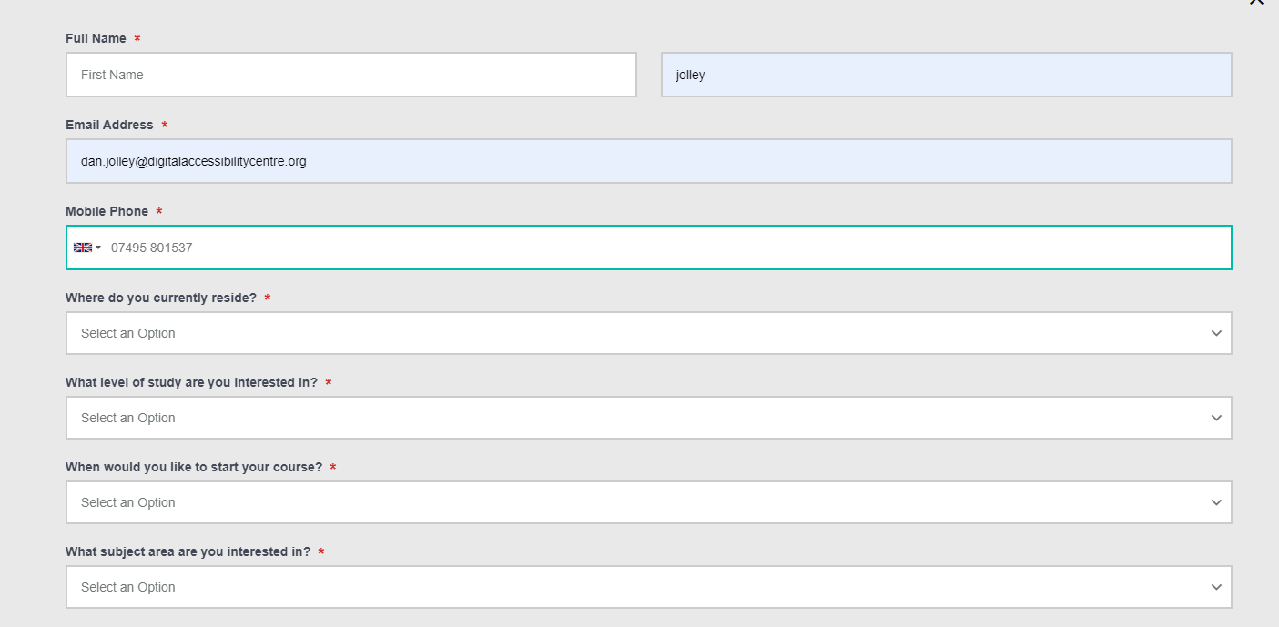

The required fields are marked with an asterisk to inform sighted users that the field is required; however, there is no key to inform users that the asterisk marks a required form and screen reader user will not be aware that the field is required as the aria labels on the input fields does not include the asterisk.

Current Code Ref(s):
<label id="form_5592_label" for="form_5592" ng-show="showFieldLabel(field, form)" class="ng-binding">
Full Name <!-- ngIf: field.required == 1 --><span class="required ng-scope" ng-if="field.required == 1">*</span><!-- end ngIf: field.required == 1 -->
</label>

<input id="form_5592" aria-label="Full Name (First name)" class="form-control pull-left ng-pristine ng-valid" type="text" placeholder="First Name" style="width: 49%; margin-right: 2%;" ng-model="values[field.id]['first_name']" autocomplete="given-name">

Solution:
Ensure that there is text at the start of the form to inform all users that fields marked with an asterisk are required.

Remove the aria label from the inputs as there are visual labels present which are already programmatically associated with each input. Mark required inputs with ‘required’.

<span>Fields marked with a * are required</span>

<input id="form_5592" class="form-control pull-left ng-pristine ng-valid" type="text" placeholder="First Name" style="width: 49%; margin-right: 2%;" ng-model="values[field.id]['first_name']" autocomplete="given-name" required="">

Search Filters
The search filters will be confusing for multiple users groups.

WCAG Reference:
1.3.1 Info and Relationships
Understanding Info and Relationships |How to Meet Info and Relationships
(Level A)

1.3.3 Sensory Characteristics
Understanding Sensory Characteristics |How to Meet Sensory Characteristics
(Level A)

4.1.2 Name, Role, Value
Understanding Name, Role, Value |How to Meet Name, Role, Value
(Level A)

Issue ID: DAC_Role_02

URL: https://univeastlondstg.prod.acquia-sites.com/study/undergraduate/andrew-test-page-do-not-edit/clearing-search
Page title: Clearing Search | UEL
Journey: 1 step 11

Screenshot:

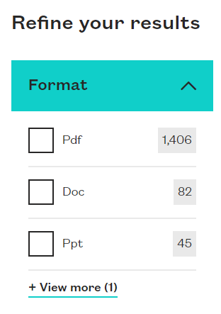

The links to select a document format may be confusing for multiple user groups. The links are styled as checkboxes which will be confusing for Voice Activation users. The links are contained in a list which has a role=menu which will override the role of link meaning users may not know that the elements are selectable.

When a link is selected, there is a tick shown next to the link to show it is selected. The tick will not be announced to screen reader users. The page title is not updated to inform users that the page content has changed and the message which shows the number of results is not announced to screen reader users.

Current Code Ref(s):
<ul class="module-filter__facets-list" role="menu">
<li class="module-filter__facets-item" role="menuitem">
<!-- Checkbox facets -->
<a href="?f.Format%7Cpdf=pdf&amp;collection=uel-meta" style="text-transform:capitalize" class="module-filter__facets-link square ">
pdf
<span>
1,406
</span>
</a>
</li>
<li class="module-filter__facets-item" role="menuitem">
<!-- Checkbox facets -->
<a href="?collection=uel-meta&amp;f.Format%7Cdoc=doc" style="text-transform:capitalize" class="module-filter__facets-link square ">
doc
<span>
82
</span>
</a>
</li>
<li class="module-filter__facets-item" role="menuitem">
<!-- Checkbox facets -->
<a href="?f.Format%7Cppt=ppt&amp;collection=uel-meta" style="text-transform:capitalize" class="module-filter__facets-link square ">
ppt
<span>
45
</span>
</a>
</li>
<li class="module-filter__facets-item" role="menuitem" style="display: none;">
<!-- Checkbox facets -->
<a href="?f.Format%7Cpptx=pptx&amp;collection=uel-meta" style="text-transform:capitalize" class="module-filter__facets-link square ">
pptx
<span>
20
</span>
</a>
</li>
</ul>

Screen reader comments:
“I located a form field that was announced to me by JAWS as ‘navigation tab menu checked not checked sub men’. This form label I ambiguous as it does not provide clear information to indicate the purpose of the field. This also applies to the second menu in a
The list which contains various document types and the ‘+view more 1’ button.”

“I located document types both in and out of context. These documents do not contain clear file names. This means that prior to opening the files, screen reader users do not know what the files relate too.”

Solution:
We would recommend that the elements should be structured as a group of checkboxes to allow users to interact with the components in the expected manner Checkboxes will announce as selected to users where links will not.

The elements should have a shared or common label of ‘Document format’.

See Grouping Controls from W3C for more information.

If this is not possible, then further text should be added to the link to inform users that the document type has been selected. Role=menu and menuitem should be removed from the elements and text should be added to the links to inform screen reader users which links are selected.

Moving Content
There is content which moves for more than 5 seconds that does not have an accessible pause feature.

WCAG Reference:
2.2.2 Pause, Stop, Hide
Understanding Pause, Stop, Hide |How to Meet Pause, Stop, Hide
(Level A)

Issue ID: DAC_Moving_Content_01

URL: https://univeastlond.prod.acquia-sites.com/
Page title: Homepage | UEL
Journey: 1 step 1

Screenshot:

There is moving content present which does not have an accessible pause feature to allow users to stop the content. This can be distracting for some users.

Current Code Ref(s):
<iframe frameborder="0" allow="autoplay; mute" src="https://www.youtube.com/embed/M9NVMJLYJbQ?enablejsapi=1&amp;disablekb=1&amp;controls=0&amp;rel=0&amp;iv_load_policy=3&amp;cc_load_policy=0&amp;playsinline=1&amp;showinfo=0&amp;modestbranding=1&amp;fs=0&amp;origin=https://univeastlond.prod.acquia-sites.com&amp;mute=1&amp;autoplay=1&amp;loop=1" id="M9NVMJLYJbQ-9682" style="top: 50%; left: 50%; transform: translateX(-50%) translateY(-50%); position: absolute; opacity: 1; width: 1952px; height: 1098px;" nuan_newframe="true"></iframe>

Keyboard only user comments:
“The carousel at the top of the page changes every five seconds. There are arrows present for it but there is no pause button. This meant that I was not able to stop it from moving to read the information.”

Solution:
For any moving, blinking or scrolling information that (1) starts automatically, (2) lasts more than five seconds, and (3) is presented in parallel with other content, there is a mechanism for the user to pause, stop, or hide it unless the movement, blinking, or scrolling is part of an activity where it is essential

Issue ID: DAC_Moving_Content_02

URL: https://univeastlond.prod.acquia-sites.com/student-life/sport/sportsdock
Page title: SportsDock | UEL
Journey: 1 Step 4

Screenshot:

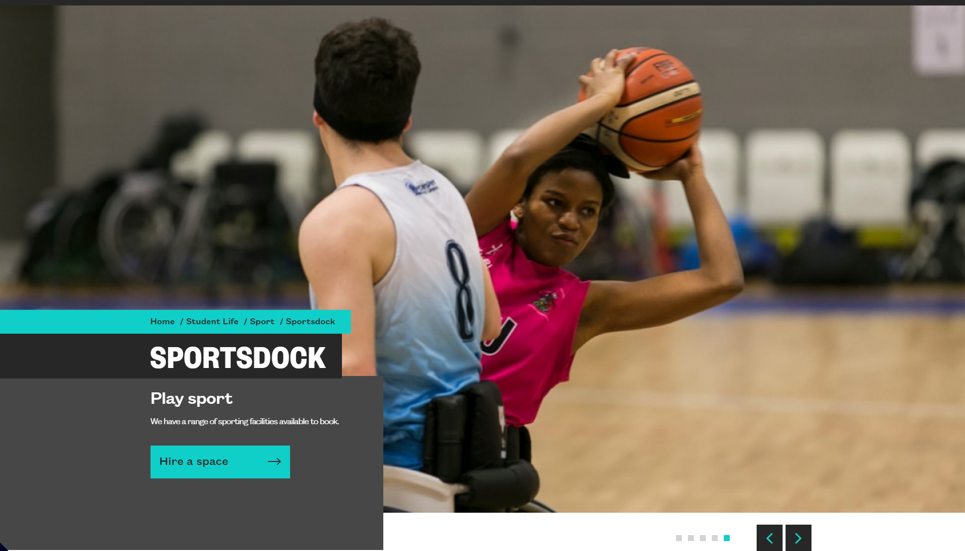

The moving carousel has no accessible pause feature and may be distracting for users.

Current Code Ref(s):
<div class="coh-slider-container-inner slick-initialized slick-slider slick-dotted" data-coh-slider="{ &quot;accessibility&quot; : true, &quot;arrows&quot; : false, &quot;counter&quot; : false, &quot;counterClass&quot; : &quot;coh-slide-count &quot;, &quot;dots&quot; : false, &quot;dotsClass&quot; : &quot;slick-dots coh-style-carousel-pagination&quot;, &quot;dotsNumbers&quot; : false, &quot;draggable&quot; : true, &quot;edgeFriction&quot; : 0.15, &quot;mobileFirst&quot; : false, &quot;pauseOnFocus&quot; : false, &quot;pauseOnHover&quot; : false, &quot;respondTo&quot; : &quot;window&quot;, &quot;responsive&quot; : {&quot;xs&quot;:{&quot;adaptiveHeight&quot;:false,&quot;matchHeights&quot;:{&quot;target&quot;:&quot;none&quot;},&quot;arrows&quot;:false,&quot;dots&quot;:true,&quot;appendDots&quot;:&quot;.coh-slider-nav-bottom&quot;,&quot;draggable&quot;:true,&quot;swipe&quot;:true,&quot;fade&quot;:false,&quot;vertical&quot;:false,&quot;infinite&quot;:true,&quot;speed&quot;:700,&quot;cssEase&quot;:&quot;ease&quot;,&quot;pauseOnHover&quot;:false,&quot;pauseOnDotsHover&quot;:true,&quot;autoplay&quot;:true,&quot;autoplaySpeed&quot;:5000,&quot;rows&quot;:0},&quot;md&quot;:{&quot;arrows&quot;:true,&quot;prevArrow&quot;:&quot;<button type=\&quot;button\&quot; class=\&quot;slick-prev coh-style-carousel-prev-button\&quot;>Previous</button>&quot;,&quot;nextArrow&quot;:&quot;<button type=\&quot;button\&quot; class=\&quot;slick-next coh-style-carousel-next-button\&quot;>Next</button>&quot;,&quot;appendArrows&quot;:&quot;.coh-slider-nav-bottom&quot;,&quot;dots&quot;:true,&quot;appendDots&quot;:&quot;.coh-slider-nav-bottom&quot;,&quot;rows&quot;:0}}, &quot;rows&quot; : 0, &quot;slide&quot; : &quot;.coh-slider-item&quot;, &quot;slidesPerRow&quot; : 0, &quot;touchMove&quot; : true, &quot;touchThreshold&quot; : 5, &quot;useCSS&quot; : true, &quot;useTransform&quot; : true, &quot;centerPadding&quot;:&quot;0px&quot;, &quot;infinite&quot; : false }">

Screen reader comments:
“When navigating through the page in context I located ‘next’ and ‘back’ buttons. A member of the support team advised me that there is a carousel with moving content in the background. There is no pause button to stop the content from scrolling. It would be helpful to provide a pause button for all carousels.”

Solution:
Ensure all content which moves for more than 5 seconds has an accessible pause feature.

Issue ID: DAC_Moving_Content_03

URL: https://univeastlond.prod.acquia-sites.com/undergraduate/courses/bsc-hons-accounting-finance
Page title: BSc (Hons) Accounting and Finance | UEL
Journey: 1 step 5

Screenshot:

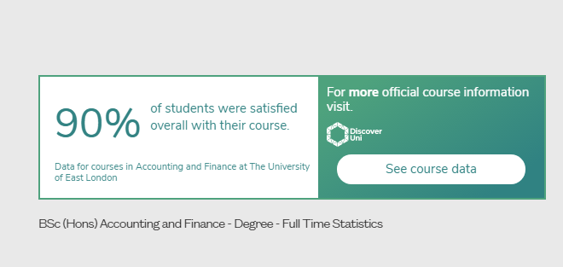

The content in the statistics section is constantly changing which may be difficult for users with cognitive impairments and screen reader users to read.

Current Code Ref(s):
<iframe class="coh-iframe coh-ce-cpt_discover_uni_carousal-f96bd7fe" nuan_newframe="true" src="https://discoveruni.gov.uk/widget/10007144/SD2030/responsive/small/en-GB" title=" BSc (Hons) Accounting and Finance - Degree - Full Time Statistics"> </iframe>

Keyboard only user comments:
“The first item in the carousel above the ‘related courses’ section refreshes every few seconds. There is no way for me to control this as there is no pause button on it. As a result, I don’t have enough time to read the information.”

Solution:
Ensure that any content which moves for more than five seconds has an accessible pause feature.

Flashing Content
There is content which flashes more than 3 times in one second which may trigger photosensitive seizures.

WCAG Reference:
2.3.1 Three Flashes or Below Threshold
Understanding Three Flashes or Below Threshold |How to Meet Three Flashes or Below Threshold
(Level A)

2.3.2 Three Flashes
Understanding Three Flashes |How to Meet Three Flashes
(Level AAA)

Issue ID: DAC_Flashing_01

URL: https://univeastlond.prod.acquia-sites.com/
Page title: Homepage | UEL
Journey: 1 step 1

Screenshot:

The video content has several sections which flash more than three times in one second which may trigger photosensitive epileptic seizures.

Current Code Ref(s):
<div class="coh-container homepage-static-image__content home-banner-content coh-style-margin-top-and-bottom-large coh-container-boxed animate-slide-down">

Solution:
Ensure that no content flashes more than three times in one second. Use the PEAT Tool to analyse any content.

Skip Link
The skip to content link is not the first focusable link on the page.

WCAG Reference:
2.4.1 Bypass Blocks
Understanding Bypass Blocks |How to Meet Bypass Blocks
(Level A)

Issue ID: DAC_Skip_Link_01

URL: https://univeastlond.prod.acquia-sites.com/
Page title: Homepage | UEL
Journey: 1 step 1

Screenshot:

The skip to content link appears after the navigation link which means users who cannot use a mouse will have to navigate past repetitive content on each page. The skip to content link should be the first link to receive focus.

Current Code Ref(s):
<a href="#main-content" class="coh-link visually-hidden focusable skip-link" target="_self">Skip to main content</a>

Screen reader comments:
“When using the cursor keys to navigate through the home page, I found that the skip link is on the page beneath various links. The purpose of the skip link is to take focus from the top of the page, past these links, to the H1 which is the main content heading.”

Keyboard only user comments:
“Focus goes onto the skip link after the main navigation. I found this confusing as the link is for moving your focus passed the main navigation and into the content, but the link to do it is passed the main navigation.”

Solution:
Ensure that the skip link receives keyboard focus first when tabbing through the page content.

Issue ID: DAC_Skip_Link_02

URL: https://univeastlond.prod.acquia-sites.com/study/undergraduate/why-uel
Page title: Why UEL? | UEL
Journey: 1 step 3

Screenshot:

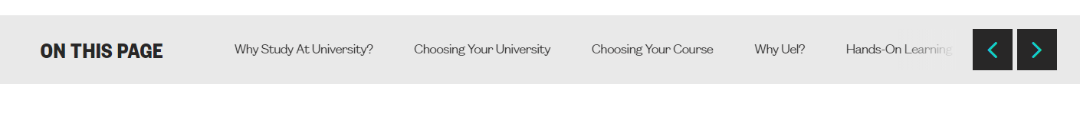

The ‘on this page’ skip links move focus visibly to the section but keyboard focus is not placed on the section meaning that when keyboard only users press tab, focus will move back to the next link in the on this page navigation section.

Current Code Ref(s):
<a class="coh-style-inline-link" href="#tab-id-0" data-target-id="tab-id-0" tabindex="0">Why Study At University?</a>

Keyboard only user comments:
“The skip links in the ‘on this page’ more the visual focus of the page but not the keyboard focus. This meant that after I selected a link the page would move down but on the next keypress the page jumps back up to where I was.”

Solution:
The skip links rely on JavaScript to scroll visible focus to the section, but focus is not programmatically set to the section. Either use JavaScript to set focus to the correct section or remove the event handler from the links to allow the skip link to act in the expected manner.

Issue ID: DAC_Skip_Link_03

URL: https://univeastlond.prod.acquia-sites.com/
Page title: Homepage | UEL
Journey: 1 step 1

Screenshot:

The back to top button moves focus visibly but does not anchor the focus to the top of the page meaning that keyboard only users will return to the next link when they press the tab key. Focus should be programmatically set to an element at the top of the page.

Current Code Ref(s):
<button class="coh-button coh-ce-79e6d5dc coh-js-scroll-top" data-coh-settings="{ &quot;xs&quot;:[] }" type="button">Back to top</button>

Solution:
We would recommend that focus is programmatically set to an element at the top of the page to allow keyboard only users to use the back to top button.

Error Summary
The error summary is not accessible.

WCAG Reference:
2.1.1 Keyboard
Understanding Keyboard |How to Meet Keyboard
(Level A)

2.4.1 Bypass Blocks
Understanding Bypass Blocks |How to Meet Bypass Blocks
(Level A)

Issue ID: DAC_Error_Summary_01

URL: https://univeastlond.prod.acquia-sites.com/elaines-accessibility-page
Page title: Elaine's Accessibility page | UEL
Journey: 1 step 13

Screenshot:
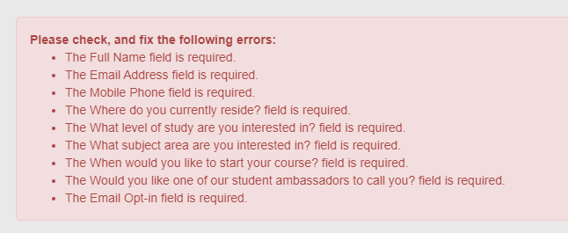

The links in the error summary are not accessible to users who cannot use a mouse. The links do not take users to the field where the error has been committed.

Please note that the colour contrast of the text is exactly 4.5:1 which is the minimum required ratio, but may still be difficult for some users to see clearly.

Current Code Ref(s):
<li ng-repeat="error in errorMessages track by $index" ng-click="ctrl.scrollFn(fieldId)" ng-bind-html="error" class="ng-binding ng-scope">The Full Name field is required.</li>

Solution:
Ensure that the skip links in the error summary are accessible to users who navigate with a keyboard only and take users to the field where the error has been committed.

Document Title - PDF
The document title has not been specified on a PDF Document.

WCAG Reference:
2.4.2 Page Titled
Understanding Page Titled |How to Meet Page Titled
(Level A)

Issue ID: DAC_PDF_Title_01

URL: https://univeastlond.prod.acquia-sites.com/sites/default/files/6727.pdf
Page title: 6727.pdf
Journey: 1 step 6

Screenshot:

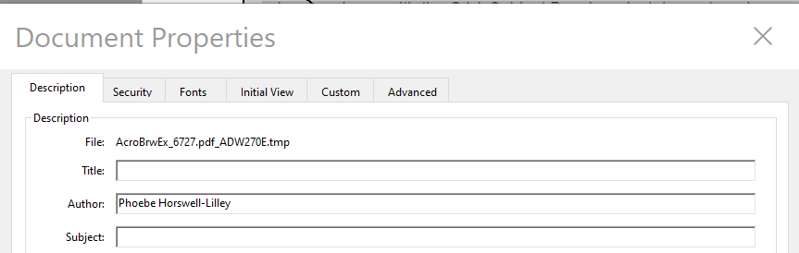

The document title has not been set when the document was created which will mean the file path is used as a title. This will be confusing for screen reader users.

Current Code Ref(s):
n/a

Solution:
Ensure that all pdf documents have the title set when the document is created to allow screen reader users to understand the purpose of the document.

Focus Order
The focus order of some pages and components may be confusing for users who navigate with a keyboard only.

WCAG Reference:
2.4.3 Focus Order
Understanding Focus Order |How to Meet Focus Order
(Level A)

Issue ID: DAC_Focus_Order_01

URL: https://univeastlond.prod.acquia-sites.com/study/undergraduate/why-uel
Page title: Why UEL? | UEL
Journey: 1 Step 3

Screenshot:

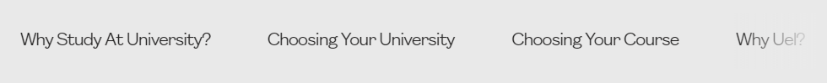

There are elements in the carousel which are set to receive focus incorrectly. The <div> containing the link has tabindex=0 set which means the element will receive focus. The <div> has no focus state indicator meaning focus will disappear from the page until the user presses tab and focus is placed on the link within the div. This may be confusing and disorientating for keyboard only users.

Current Code Ref(s):
<div class="slick-slide slick-current slick-active" data-slick-index="0" aria-hidden="false" tabindex="0">
<div>
<li style="width: 100%; display: inline-block;"><a class="coh-style-inline-link" href="#tab-id-0" data-target-id="tab-id-0" tabindex="0">Why Study At University?</a></li>
</div>
</div>

Keyboard only user comments:
“There is a missing tab between each of the links in the ‘on this page’ section. At this point I did not know where my focus had gone.”

Solution:
Remove the tabindex=0 from the containing div.

Example
<div class="slick-slide slick-current slick-active" data-slick-index="0" aria-hidden="false" tabindex="0">
<div>
<li style="width: 100%; display: inline-block;"><a class="coh-style-inline-link" href="#tab-id-0" data-target-id="tab-id-0" tabindex="0">Why Study At University?</a></li>
</div>
</div>

Issue ID: DAC_Focus_Order_02

URL: https://univeastlond.prod.acquia-sites.com/study/undergraduate/why-uel
Page title: Why UEL? | UEL
Journey: 1 Step 3

Screenshot:
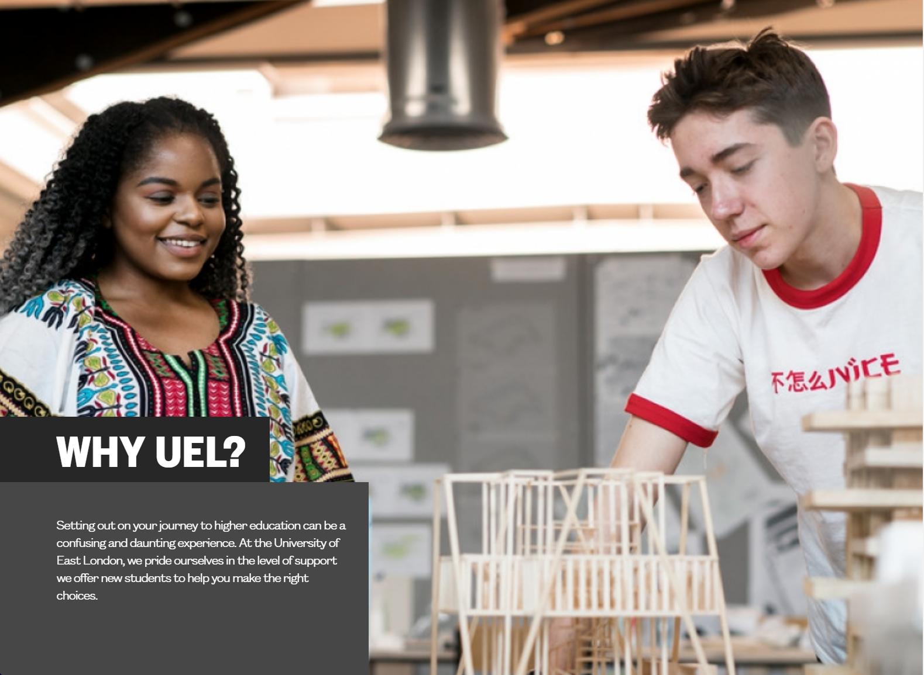

There is an image which has been included in the tab order of the page using a tabindex value of 0. This may be confusing for keyboard only users as focus disappears from screen.

The image appears to have markup consistent with a carousel but there is no carousel present.

This issue is consistent on other pages such as the Alumni and supporters page.

Current Code Ref(s):
<div class="coh-slider-item coh-ce-cpt_hero_carousel-b182bfd9 slick-slide slick-current slick-active" style="width: 1295.2px;" data-slick-index="0" aria-hidden="false" tabindex="0">

Keyboard only user comments:
“There is a missing tab between the ‘home’ link and the ‘update your details now’ button. At this point I did not know where my focus had gone.”

Solution:
Non-interactive elements should not be included in the tab order of the page. Remove the tabindex=0 value from the element.

Issue ID: DAC_Focus_Order_03

URL: https://univeastlond.prod.acquia-sites.com/undergraduate/courses/bsc-hons-accounting-finance
Page title: BSc (Hons) Accounting and Finance | UEL
Journey: 1 step 5

Screenshot:

Keyboard focus goes to the ‘Apply Now’ button, then to the ‘Make an enquiry’ button which can be confusing for keyboard only users. The keyboard focus should follow a logical path from top to bottom and left to right to prevent users becoming disorientated.

This issue also applies to the carousel buttons on the page.

All pages should be checked with a keyboard to ensure a logical focus order.

Current Code Ref(s):
<div class="coh-container apply-now-container ug-show-1 pg-show-0 coh-ce-2b9a6622"> <div class="coh-container coh-component coh-component-instance-76b2822e-52c1-4917-80fb-4fb73dc860a2 contextual-component cta-inline-button cta-primary bg-teal-black progressive-trigger apply-now-cta coh-instance-2017465218 coh-ce-cpt_progressive_reveal_cta_link-bd819071" data-modal-open="progressive-reveal-3" role="button" id="progressive-trigger-3" tabindex="0"> <span class="coh-inline-element link-text coh-ce-cpt_progressive_reveal_cta_link-9763f6ad">Apply Now</span> </div>
<div class="coh-container coh-component coh-component-instance-a192fed4-9d35-4924-9feb-a78804b49a56 contextual-component cta-inline-button cta-secondary bg-teal progressive-trigger enquiry-gecko-cta coh-style-margin-right-small coh-instance-462528938 coh-ce-cpt_progressive_reveal_cta_link-bd819071" data-modal-open="progressive-reveal-4" role="button" id="progressive-trigger-4" tabindex="0"> <span class="coh-inline-element link-text coh-ce-cpt_progressive_reveal_cta_link-9763f6ad">Make an enquiry</span> </div>
</div>

Keyboard only user comments:
“Focus goes to the ‘apply now’ button before the ‘make an enquiry’ button. I found this a little confusing as I expected them to receive focus the other way around.”

“Focus goes to the arrows then the pagination for the carousel. I found this a little confusing as the pagination is on the left, so I expected focus to go to them first.”

Solution:
Ensure that the keyboard focus order of all pages follows a logical path through all UI components.

Issue ID: DAC_Focus_Order_04

URL: https://univeastlond.prod.acquia-sites.com/undergraduate/courses/bsc-hons-accounting-finance
Page title: BSc (Hons) Accounting and Finance | UEL
Journey: 1 step 5

Screenshot:

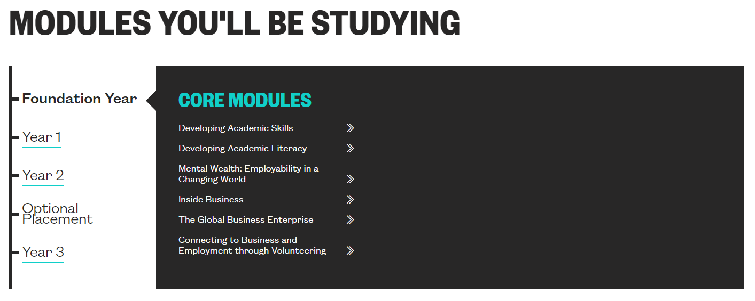

There is content contained within the modules section which is not visible but will still receive keyboard focus which will be confusing and disorientating for keyboard only users.

The hidden links have a tabindex value of 0, which will mean they remain focusable.

Current Code Ref(s):
<li class="coh-list-item"> <div class="paragraph paragraph--type--module-browser paragraph--view-mode--default">

<div class="module-year"><a class="coh-style-inline-link" id="module-year-year1" tabindex="0">Year 1</a></div>
<div class="module-group-container">
<div class="paragraph paragraph--type--module-group paragraph--view-mode--default">
<a class="module-group-name">Core Modules</a>
<div class="module-group-content"> <article role="article" about="/mental-wealth-1-academic-digital-proficiency"> <a href="javascript:void(0)" class="coh-link module-name coh-ce-366679c2"> Mental Wealth 1: Academic and Digital Proficiency </a> <div class="coh-container module-details"> <a href="javascript:void(0)" class="coh-link module-close coh-ce-31e7a6da">Close</a> <h4 class="coh-heading coh-style-header-4 coh-ce-b14be452"> Mental Wealth 1: Academic and Digital Proficiency </h4>
[…]
</li>

Keyboard only user comments:
“There are a number of missing tabs between each of the tabs under the ‘modules you’ll be studying’ section. After some investigation I found that focus was going to the elements that are in each of the tabs when they are not visible.”

Solution:
Ensure content which is not visible on screen is not included in the tab order or readable with a screen reader. Use aria-hidden=true and tabindex=-1 until the content is revealed.

Issue ID: DAC_Focus_Order_05

URL: https://univeastlond.prod.acquia-sites.com/undergraduate/courses/bsc-hons-accounting-finance
Page title: BSc (Hons) Accounting and Finance | UEL
Journey: 1 step 5

Screenshot:
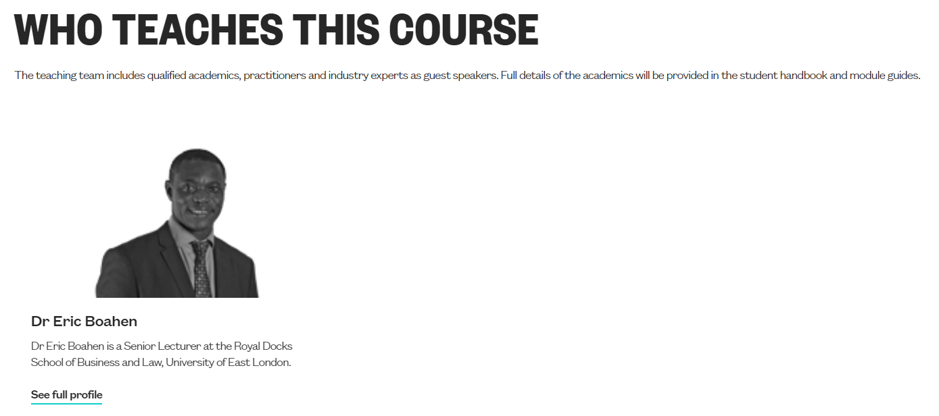

The container for the image has been included in the tab order of the page with tabindex=0. This will mean that focus will disappear when keyboard only users tab through the page. Non-interactive components should not be included in the tab order.

This is consistent where this carousel component has been used.

Current Code Ref(s):
<div class="coh-slider-item slick-slide slick-current slick-active" style="width: 466.429px;" data-slick-index="0" aria-hidden="false" tabindex="0"> <article role="article" about="/about-uel/staff/eric-boahen"> <div class="coh-container coh-instance-796525229 coh-ce-5dd3cae1"> <img class="coh-image coh-ce-51a54600 coh-image-responsive-xs" src="https://univeastlond.prod.acquia-sites.com/sites/default/files/8972.png" alt=""> </div> <div class="coh-container"> <h4 class="coh-heading coh-style-header-4 coh-ce-fb89dca7"> Dr Eric Boahen </h4> <p class="coh-paragraph coh-style-body coh-ce-9bb5cc8f">Dr Eric Boahen is a Senior Lecturer at the Royal Docks School of Business and Law, University of East London.</p> <a href="https://univeastlond.prod.acquia-sites.com/about-uel/staff/eric-boahen" class="coh-link coh-style-inline-link coh-ce-82ffdfa5" target="_self" tabindex="0"> See full profile </a> </div> </article>
</div>

Keyboard only user comments:
“There is a missing tab before the ‘see full profile’ link. At this point I did not know where my focus had gone at this point.”

Solution:
Remove the tabindex=0 attribute from the containing div within this carousel component. The links will receive keyboard focus allowing users to interact with the content.

Issue ID: DAC_Focus_Order_06

URL: https://univeastlond.prod.acquia-sites.com/study/undergraduate/why-uel
Page title: Why UEL? | UEL
Journey: 1 Step 3

Screenshot:

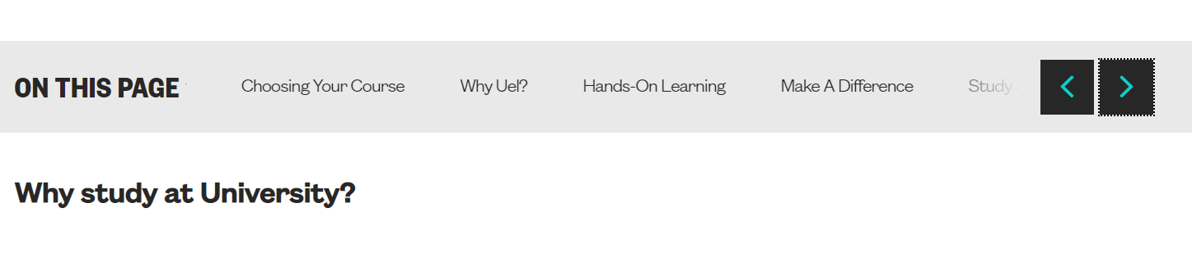

The ‘on this page’ carousel may be difficult for users who navigate with a keyboard or other alternate input devices to navigate. Users tab through the visible link to the scroll buttons at the end and use the forward scroll to reveal further link. Users will then have to navigate backwards to reach the links which can be frustrating.

Screen reader users may become confused as the buttons scroll the content but there is no audible notification that anything has changed. Users may not be aware that the content is behind the scroll buttons.

Current Code Ref(s):
<ul class="coh-list-container coh-unordered-list on-this-page-list coh-ce-cpt_on_this_page-2fce1d61 slick-initialized slick-slider">
<div class="slick-list">
<div class="slick-track" style="opacity: 1; width: 50000px; transform: translate3d(0px, 0px, 0px);">
<div class="slick-slide slick-current slick-active" data-slick-index="0" aria-hidden="false" tabindex="0">
<div>
<li style="width: 100%; display: inline-block;"><a class="coh-style-inline-link" href="#tab-id-0" data-target-id="tab-id-0" tabindex="0">Why Study At University?</a></li>
</div>
[…]
</ul>

Screen reader comments:
“A member of the support team advised me that there are multiple links within the carousel. When clicking next or back my focus does not change which means that non-visually there is no indication that there is a carousel on the page, or, that focus has moved visually to another slide with a different set of links.”

Keyboard only user comments:
“To be able to access all of the links in the ‘on this page’ section I can tab onto the first three links then I have to use the arrow buttons to move it then tab backwards, pressing shift + tab, to get onto the new links. This made it very time consuming for me to get through all of the links in the section.”

Solution:
Consider allowing users to tab through all the links, revealing the links as focus is placed on each link that is hidden. This will be an easier method of navigating for users with limited mobility and screen reader users.

Issue ID: DAC_Focus_Order_07

URL: https://univeastlond.prod.acquia-sites.com/undergraduate/courses/bsc-hons-accounting-finance
Page title: BSc (Hons) Accounting and Finance | UEL
Journey: 1 step 5

Screenshot:

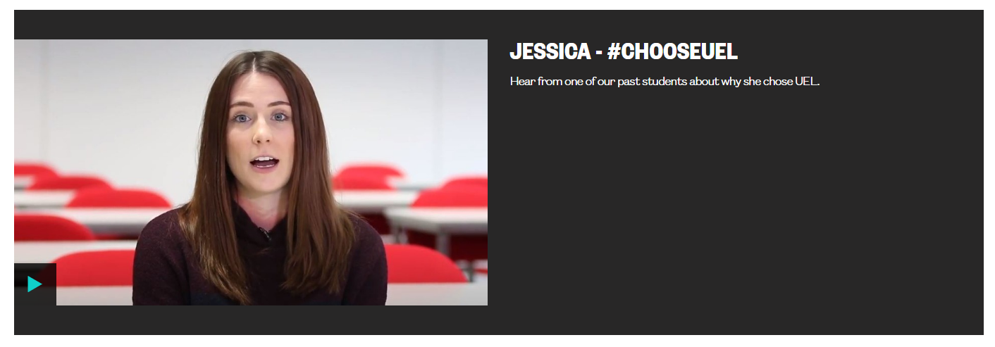

The video section may be confusing for users who navigate with a keyboard only. The controls for the video are visibly hidden but will still receive keyboard focus resulting in focus disappearing from the screen. This can be confusing and disorientating for users.

This issue is consistent with other pages including: -
https://univeastlond.prod.acquia-sites.com/about-uel/staff/rachel-tribe
https://univeastlond.prod.acquia-sites.com/study/clearing
https://univeastlond.prod.acquia-sites.com/elaines-accessibility-page

Current Code Ref(s):
<div id="mep_0" class="mejs__container coh-video-inner mejs__video" tabindex="0" role="application" aria-label="Video Player" style="background: transparent; width: 672px; height: 378px; min-width: 0px;">
<div class="mejs__inner">
<div class="mejs__mediaelement">
<mediaelementwrapper id="mejs_07544457713185793">
<div id="mejs_07544457713185793-iframe-overlay" class="mejs__iframe-overlay"></div>
<iframe id="mejs_07544457713185793_youtube_iframe" frameborder="0" allowfullscreen="1" allow="accelerometer; autoplay; clipboard-write; encrypted-media; gyroscope; picture-in-picture" title="YouTube video player" src="https://www.youtube.com/embed/AnGMeoE1wmo?controls=1&amp;rel=0&amp;disablekb=1&amp;showinfo=0&amp;modestbranding=0&amp;html5=1&amp;iv_load_policy=3&amp;playsinline=1&amp;enablejsapi=1&amp;origin=https%3A%2F%2Funiveastlond.prod.acquia-sites.com&amp;widgetid=1" nuan_newframe="true" width="672" height="378"></iframe>
<video class="coh-video-inner" playsinline="" tabindex="0" poster="" preload="none" src="https://www.youtube.com/watch?v=AnGMeoE1wmo&amp;ab_channel=UniversityofEastLondon" data-coh-video="{&quot;stretching&quot;:&quot;responsive&quot;,&quot;autoRewind&quot;:true,&quot;clickToPlayPause&quot;:true,&quot;showPlayCenter&quot;:true,&quot;alwaysShowControls&quot;:false,&quot;hideVideoControlsOnLoad&quot;:false,&quot;hideVideoControlsOnPause&quot;:false,&quot;pauseOtherPlayers&quot;:true,&quot;playOnHover&quot;:false,&quot;features&quot;:[&quot;playpause&quot;,&quot;current&quot;,&quot;progress&quot;,&quot;duration&quot;,&quot;volume&quot;,&quot;fullscreen&quot;]}" id="mejs_07544457713185793_from_mejs" style="width: 100%; height: 100%; display: none;"></video>
</mediaelementwrapper>
</div>
<div class="mejs__layers">
<div class="mejs__poster mejs__layer" style="display: none; width: 100%; height: 100%;"></div>
<div class="mejs__overlay mejs__layer" style="width: 100%; height: 100%; display: none;">
<div class="mejs__overlay-loading"><span class="mejs__overlay-loading-bg-img"></span></div>
</div>
<div class="mejs__overlay mejs__layer" style="display: none; width: 100%; height: 100%;">
<div class="mejs__overlay-error"></div>
</div>
<div class="mejs__overlay mejs__layer mejs__overlay-play" style="display: none; width: 100%; height: 100%;">
<div class="mejs__overlay-button" role="button" tabindex="0" aria-label="Play" aria-pressed="false"></div>
</div>
</div>
<div class="mejs__controls" style="display: none;"></div>
</div>
</div>

Keyboard only user comments:
“There are nine missing tabs before the play button on the video. At this point I did not know where my focus had gone.”

Solution:
Ensure that controls which are not visible on the screen are not included in the tab order of the page.

Issue ID: DAC_Focus_Order_09

URL: https://univeastlond.prod.acquia-sites.com/international/regions/africa
Page title: Africa | UEL
Journey: 2 step 3

Screenshot:

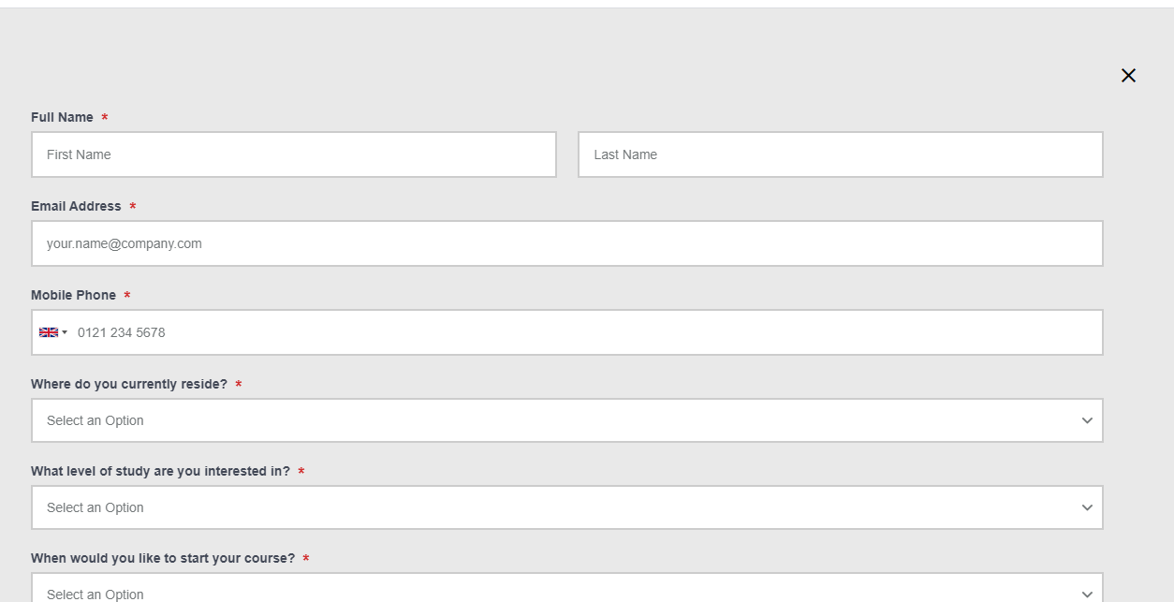

Focus has been set to the close button using autofocus as the button is at the end of the dom. The div containing the modal has been included in the tab order of the page using tabindex=0. This will result in a confusing tab order for users who navigate with a keyboard only.

Current Code Ref(s):
<div class="coh-modal-inner js-first-focus is-open" data-modal-document="" tabindex="0" style="" role="document">

<div class="coh-modal-close-wrapper"> <button aria-label="Close" class="coh-modal-close-button js-last-focus" data-autofocus="" data-modal-close-btn="">Close</button> </div>

Screen reader comments:
“There is a missing tab between the close button and the ‘first name’ field. At this point I did not know where my focus had gone.”

Solution:
We would recommend placing the close button at the top of the document and removing tabindex=0 from the containing div to preserve a logical tab order.

Autofocus
There are elements which receive keyboard focus automatically which may confuse keyboard only users.

WCAG Reference:
2.4.3 Focus Order
Understanding Focus Order |How to Meet Focus Order
(Level A)

Issue ID: DAC_Focus_Order_08

URL: https://univeastlondstg.prod.acquia-sites.com/study/undergraduate/andrew-test-page-do-not-edit/clearing-search
Page title: Clearing Search | UEL
Journey: 1 step 11

Screenshot:
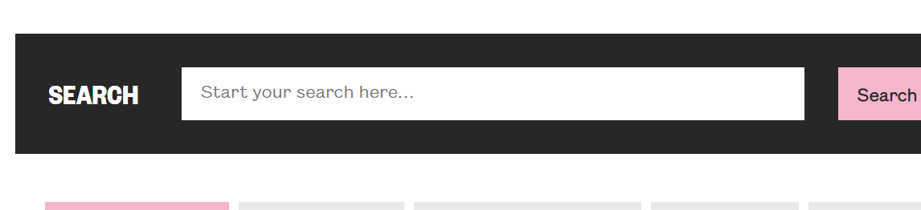

Focus has been set to the search input page meaning that when the page loads, focus is placed directly within the input. This may be confusing for screen reader users and keyboard only users.

Current Code Ref(s):
<input required="" name="query" id="funnelback-query" type="Search query" autofocus="" class="module-search__query tt-input" autocomplete="off" placeholder="Start your search here…" value="" spellcheck="false" dir="auto" aria-labelledby="fb-query" aria-required="true" style="position: relative; vertical-align: top;">

Keyboard only user comments:
“When this page loaded my focus started at the top of the content. I found this confusing as I expect my focus to always start at the top of the page.”

Solution:
Remove the autofocus attribute from the input to allow the expected tab order of the page.

Empty Link
There is an empty link present on the page which may be confusing for screen reader users.

WCAG Reference:
2.4.3 Focus Order
Understanding Focus Order |How to Meet Focus Order
(Level A)

2.4.4 Link Purpose (In Context)
Understanding Link Purpose (In Context) |How to Meet Link Purpose (In Context)
(Level A)

2.4.9 Link Purpose (Link Only)
Understanding Link Purpose (Link Only) |How to Meet Link Purpose (Link Only)
(Level AAA)

4.1.2 Name, Role, Value
Understanding Name, Role, Value |How to Meet Name, Role, Value
(Level A)

Issue ID: DAC_Links_01

URL: https://univeastlond.prod.acquia-sites.com/
Page title: Homepage | UEL
Journey: 1 step 1

Screenshot:

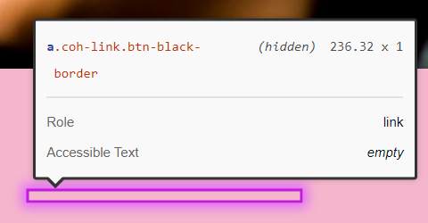

There is an empty link on the page which may be read by screen reading software and will receive focus for keyboard only users.

Current Code Ref(s):
<a href="" class="coh-link btn-black-border" target="_self"> </a>

Keyboard only user comments:
“When I moved my focus off the chevrons it went to an invisible element. At this point I did not know what I had focus on.”

Solution:
If the link has a purpose, then it should have text to describe its purpose to screen reader users. If the link has no purpose is should be removed or hidden with display: none

Issue ID: DAC_Links_08

URL: https://univeastlond.prod.acquia-sites.com/elaines-accessibility-page
Page title: Elaine's Accessibility page | UEL
Journey: 1 step 11

Screenshot:

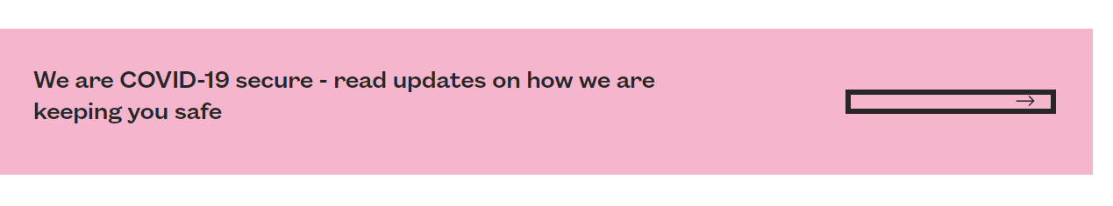

There is a link which has no text to allow screen reader users to understand the purpose or destination of the link.

Current Code Ref(s):
<a href="" class="coh-link btn-black-border" target="_self"> </a>

Solution:
Ensure all links have appropriate text to allow screen reader users to understand the purpose or destination of the link.

Issue ID: DAC_Links_09

URL: https://univeastlond.prod.acquia-sites.com/elaines-accessibility-page
Page title: Elaine's Accessibility page | UEL
Journey: 1 step 11

Screenshot:

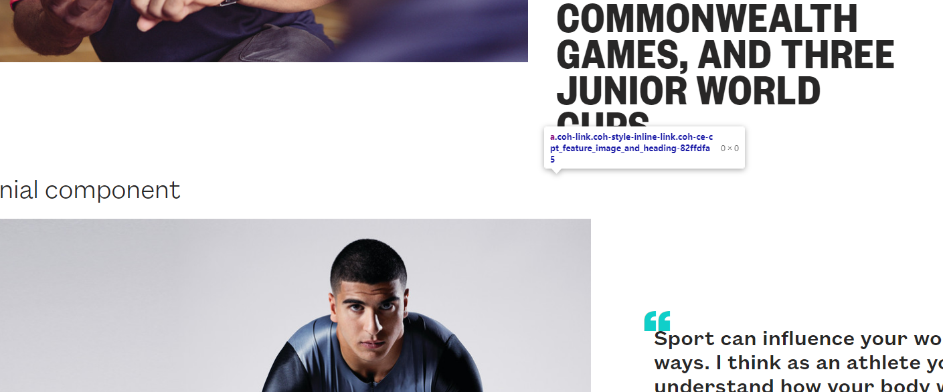

There is an empty link on the page, which will be confusing for screen reader and keyboard only users.

Current Code Ref(s):
<a href="" class="coh-link coh-style-inline-link coh-ce-cpt_feature_image_and_heading-82ffdfa5" target="_self"> </a>

Keyboard only user comments:
“There is an invisible element above the ‘testimonial component’ section that my keyboard focus goes onto. I found this confusing as there is no clickable element visible there.”

Solution:
If the link has a purpose, then ensure there is visible text present to allow users to understand the purpose of the link. If the link has no purpose then it should be removed or hidden.

Non-Descriptive Links
There are links which are not descriptive and may be confusing for screen reader users.

WCAG Reference:
2.4.4 Link Purpose (In Context)
Understanding Link Purpose (In Context) |How to Meet Link Purpose (In Context)
(Level A)

2.4.9 Link Purpose (Link Only)
Understanding Link Purpose (Link Only) |How to Meet Link Purpose (Link Only)
(Level AAA)

2.4.10 Section Headings
Understanding Section Headings |How to Meet Section Headings
(Level AAA)

Issue ID: DAC_Links_02

URL: https://univeastlond.prod.acquia-sites.com/
Page title: Homepage | UEL
Journey: 1 step 1

Screenshot:

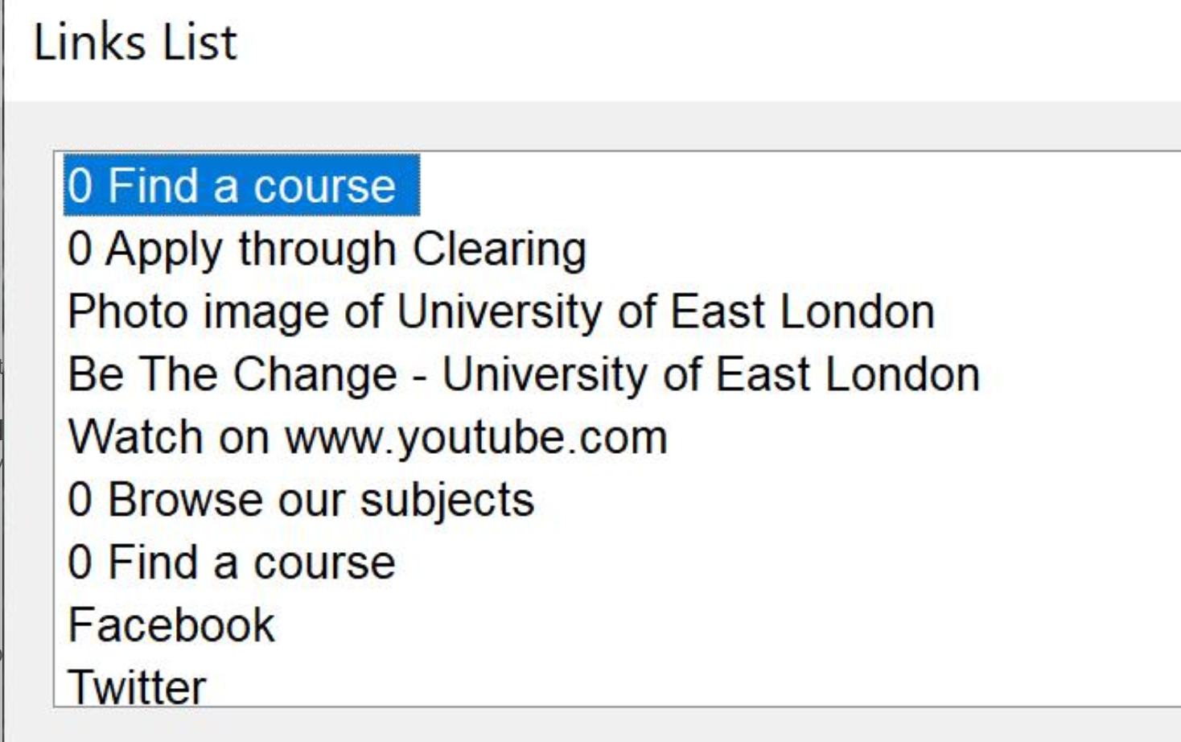

The animated underline used on links on the page contains a ‘0’ in the pseudo element which is announced as part of the link text to screen reader users. This means that users will not be able to find the link easily using the first letter of the link in the shortcuts list.

This issues is consistent across all pages where the animated link hover is present.

Current Code Ref(s):
<a href="/study/subjects" class="coh-link coh-style-inline-link coh-ce-cpt_homepage_static_image_row-2e788a491 coh-ce-cpt_homepage_static_image_row-2e788a49" target="_self" style="display: inline;"> Find a course </a>

.coh-style-inline-link-bold:before, .coh-style-inline-link:before {
content: "0";
background-color: #10cfc9;
width: 100%;
position: absolute;
bottom: -0.125rem;
font-size: 0;
height: 0.125rem;
-webkit-transition: all 400ms ease-in-out;
-o-transition: all 400ms ease-in-out;
transition: all 400ms ease-in-out;
overflow: hidden;
}

Screen reader comments:
“When navigating through the page using the cursor keys I encountered ‘0 link’. A member of the support team advised me that these represent arrows and/or underlines at various points throughout the page. Upon further investigation I discovered that 0 is present within links that contain clear link text also and are not only used in the place of punctuation. It would be helpful if these could be hidden or be provided a clear link text. This would allow screen reader users to better understand these links throughout.”

Solution:
Ensure link text is read correctly for all links. Remove the ‘0’ from the ::before pseudo element.

Issue ID: DAC_Links_03

URL: https://univeastlond.prod.acquia-sites.com/about/alumni-supporters
Page title: Alumni and supporters | UEL
Journey: 1 Step 2

Screenshot:

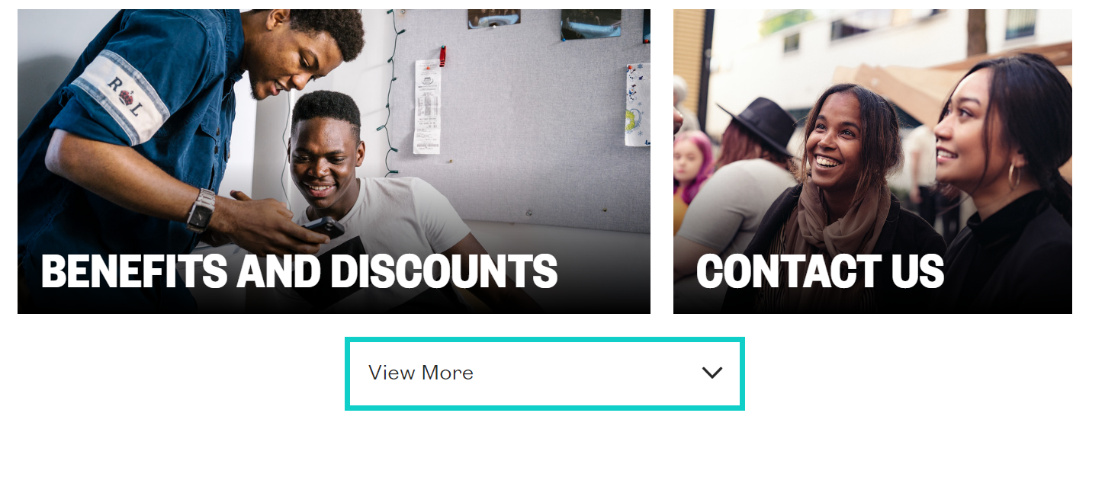

There is a link to ‘View More’ which will be confusing for screen reader users as it is not clear what will be viewed. The section above is a series of articles but there is no heading to introduce the section. Users may not be aware that the ‘View more’ link displays more articles until after the link has been selected.

Current Code Ref(s):
<a href="/" class="coh-container coh-component coh-component-instance-110e255c-d9ba-4844-8247-bf49fddd2ea1 contextual-component cta-secondary bg-teal-black coh-style-margin-bottom-small coh-ce-cpt_cta_link-646131ff" target="_self"> <span class="coh-inline-element link-text coh-instance-1163928241 coh-ce-cpt_cta_link-4c0777d4">View More</span> </a>

Solution:
Consider adding more text to the link to make the purpose of the link clear to screen reader users. The text can be hidden with CSS if required.

Example
<a href="/" class="coh-container coh-component coh-component-instance-110e255c-d9ba-4844-8247-bf49fddd2ea1 contextual-component cta-secondary bg-teal-black coh-style-margin-bottom-small coh-ce-cpt_cta_link-646131ff" target="_self"> <span class="coh-inline-element link-text coh-instance-928682816 coh-ce-cpt_cta_link-4c0777d4">View More<span class="visually-hidden">&nbsp;Articles</span></span> </a>

A heading to introduce the section would also add context to the link.

Issue ID: DAC_Links_04

URL: https://univeastlond.prod.acquia-sites.com/student-life/sport/sportsdock
Page title: SportsDock | UEL
Journey: 1 Step 4

Screenshot:

There are links to download documents which are not descriptive for screen reader users. The links do not inform users that the links will download non-html documents. Assistive technology users may require specialist software to interact with certain document types, the file type should be included in the link text.

Current Code Ref(s):
<div class="coh-container coh-ce-d69ceab2"> <h3 class="coh-heading coh-style-heading-3 coh-ce-424b21d1"> <a href="https://univeastlond.prod.acquia-sites.com/sites/default/files/6587.docx" class="coh-link coh-style-inline-link coh-ce-3a201833" target="_self"> SportsDock Terms and Conditions </a> </h3> <p class="coh-paragraph coh-style-body"> <span class="coh-inline-element coh-ce-2bcf30b4">docx,</span> <span class="coh-inline-element">75.34 KB</span> </p> </div>

<div class="coh-container coh-ce-d69ceab2"> <h3 class="coh-heading coh-style-heading-3 coh-ce-424b21d1"> <a href="https://univeastlond.prod.acquia-sites.com/sites/default/files/6586.docx" class="coh-link coh-style-inline-link coh-ce-3a201833" target="_self"> SportsDock Fair Processing Notice </a> </h3> <p class="coh-paragraph coh-style-body"> <span class="coh-inline-element coh-ce-2bcf30b4">docx,</span> <span class="coh-inline-element">63.52 KB</span> </p> </div>

Screen reader comments:
“The accounting and finance course specification does contain file type or size information, but it is separated from the link text by a blank line. It would be helpful if this information could be included within the link text.”

Solution:
The link purpose and file type should be clearly described within the link text to allow screen reader users to understand that the link will download a non-html document prior to selection.

Example
<div class="coh-container coh-ce-d69ceab2">
<h3 class="coh-heading coh-style-heading-3 coh-ce-424b21d1"> <a aria-label="Download SportsDock Terms and Conditions docx 75.34kb" href="https://univeastlond.prod.acquia-sites.com/sites/default/files/6587.docx" class="coh-link coh-style-inline-link coh-ce-3a201833" target="_self"> SportsDock Terms and Conditions </a> </h3>
<p aria-hidden="true" class="coh-paragraph coh-style-body"> <span class="coh-inline-element coh-ce-2bcf30b4">docx,</span> <span class="coh-inline-element">75.34 KB</span> </p>
</div>

Accordion
There is an accordion with expanding content which will be confusing for users who rely on audio feedback.

WCAG Reference:
2.4.4 Link Purpose (In Context)
Understanding Link Purpose (In Context) |How to Meet Link Purpose (In Context)
(Level A)

4.1.2 Name, Role, Value
Understanding Name, Role, Value |How to Meet Name, Role, Value
(Level A)

Issue ID: DAC_Accordion_01

URL: https://univeastlond.prod.acquia-sites.com/study/undergraduate/why-uel
Page title: Why UEL? | UEL
Journey: 1 Step 3

Screenshot:

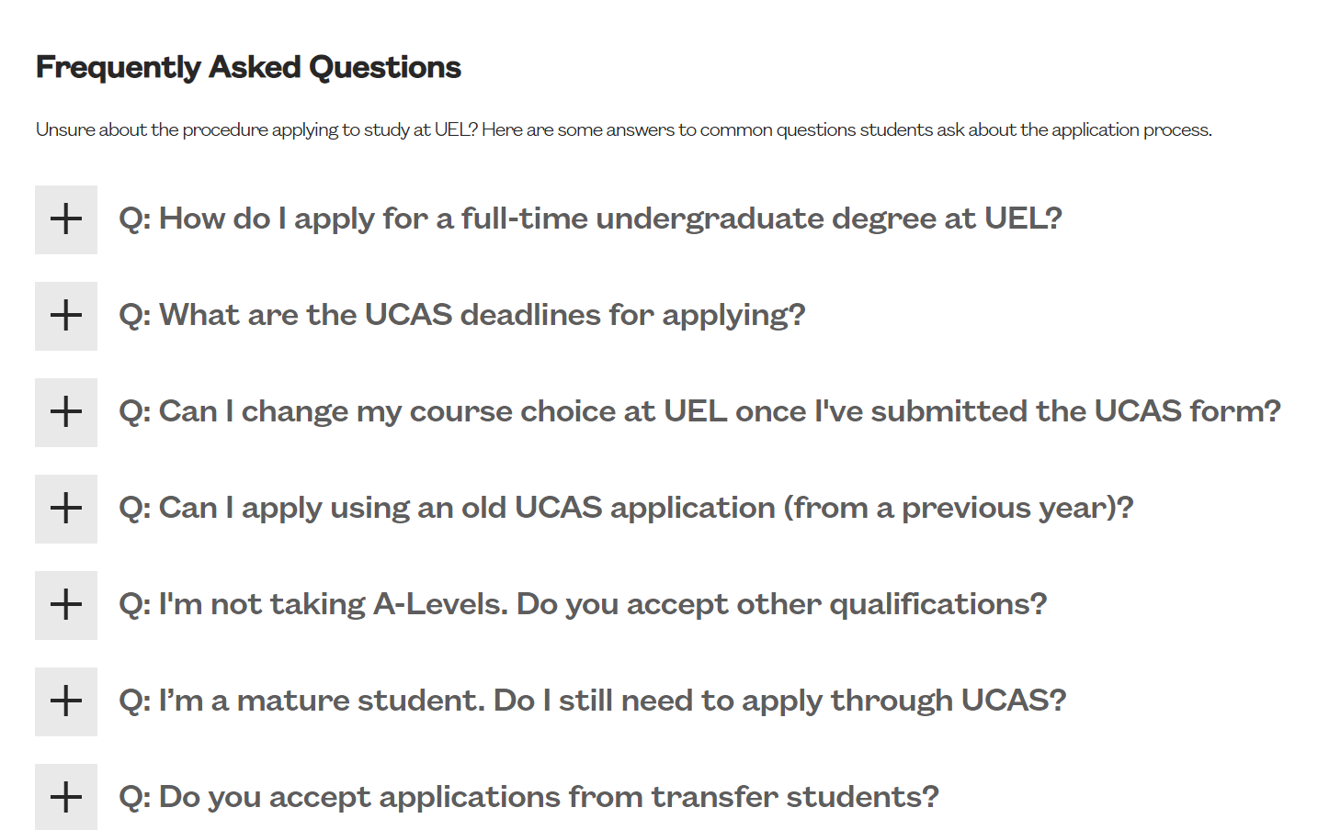

The FAQ Accordion will be confusing for screen reader users. The links to expand the content all read as ‘Accordion Open/Close’ and do not inform users of the state of the link, whether expanded or collapsed.

This issue is consistent wherever this component is used.

Current Code Ref(s):
<div class="coh-container coh-component coh-component-instance-60aa7984-a7a8-4122-ae3c-767a20b194a2 contextual-component accordion-item coh-ce-cpt_accordion_item_faq-c7d717b8 active" itemscope="" itemtype="https://schema.org/Question" itemprop="mainEntity"> <div class="coh-container accordion-button-color coh-ce-cpt_accordion_item_faq-a2297871"> <a href="javascript:void(0)" class="coh-container coh-ce-cpt_accordion_item_faq-787f7316 coh-interaction link-active" data-interaction-modifiers="[{&quot;modifierType&quot;:&quot;toggle-modifier&quot;,&quot;interactionScope&quot;:&quot;parent&quot;,&quot;modifierName&quot;:&quot;active&quot;,&quot;interactionParent&quot;:&quot;.accordion-item&quot;,&quot;interactionTarget&quot;:&quot;.accordion-item&quot;},{&quot;modifierType&quot;:&quot;toggle-modifier&quot;,&quot;interactionScope&quot;:&quot;this&quot;,&quot;interactionTarget&quot;:&quot;a&quot;,&quot;modifierName&quot;:&quot;link-active&quot;}]" rel="nofollow" data-coh-settings="{ &quot;xs&quot;:{&quot;linkAnimation&quot;:[{&quot;animationType&quot;:&quot;slide&quot;,&quot;animationScope&quot;:&quot;component&quot;,&quot;animationDirection&quot;:&quot;up&quot;,&quot;animationEasing&quot;:&quot;easeInOutQuad&quot;,&quot;animationDuration&quot;:200,&quot;animationTarget&quot;:&quot;.accordion-body&quot;}]} }"> <span class="coh-inline-element .accordion-toggle-text coh-ce-cpt_accordion_item_faq-3bdfd7">Accordion close</span> </a> </div> <h3 class="coh-heading coh-style-heading-3 coh-ce-cpt_accordion_item_faq-4fe52ff5" itemprop="name"> Q: How do I apply for a full-time undergraduate degree at UEL? </h3> <div class="coh-container accordion-body coh-ce-cpt_accordion_item_faq-e22c7f39" itemscope="" itemtype="https://schema.org/Answer" itemprop="acceptedAnswer" style="display: block;"> <div class="coh-wysiwyg" itemprop="text"> <div class="rich-txt-custom"><p>A: You can apply by going to the&nbsp;<a href="https://www.ucas.com/" target="_self">UCAS</a>&nbsp;website and clicking on Apply. Once you begin your application there are ‘help’ sections to support you as you complete the form. If you’re applying directly from school or college, you may want to ask a member of staff to help guide you through the process.</p>
</div> </div> </div> </div>

Screen reader comments:
“The accordions on the staff profile page do not contain a clear link text. I would also expect information that indicates the state of the accordion.”

Solution:
Ensure accordions are structured correctly to enable screen reader users to interact with the content. The question should be the trigger to expand the accordion and should be a <button> which uses aria-expanded=true/false to inform users of the state of the component.

See Accordion from the UK Government Design System for a good example.

Role
There are user interface components which do not have a specified role to allow screen reader users to understand the purpose of the component.

WCAG Reference:
4.1.1 Parsing
Understanding Parsing |How to Meet Parsing
(Level A)

4.1.2 Name, Role, Value
Understanding Name, Role, Value |How to Meet Name, Role, Value
(Level A)

Issue ID: DAC_Role_01

URL: https://univeastlondstg.prod.acquia-sites.com/study/undergraduate/andrew-test-page-do-not-edit/clearing-search
Page title: Clearing Search | UEL
Journey: 1 step 11

Screenshot:

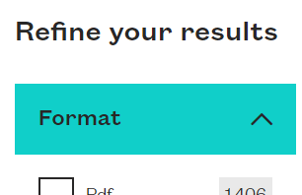

The element to expand the filter section is a span which has aria-expanded and aria-haspopup set. There is no role announced to screen reader users to allow them to know that the element is an interactive component.

Current Code Ref(s):
<span class="module-filter__item-title open" aria-haspopup="true" aria-expanded="true" tabindex="0">Format</span>

Solution:
Either use an html <button> or role=button on the element to allow screen reader users to understand the purpose of the component. Aria-haspopup is not necessary for this component as it is not a menu button.

Example
<span role="button" class="module-filter__item-title open" aria-expanded="true" tabindex="0">Format</span>

Custom Elements
There are custom dropdown listboxes, which are not accessible to screen reader users.

WCAG Reference:
4.1.1 Parsing
Understanding Parsing |How to Meet Parsing
(Level A)

4.1.2 Name, Role, Value
Understanding Name, Role, Value |How to Meet Name, Role, Value
(Level A)

Issue ID: DAC_Listboxes_01

URL: https://univeastlondstg.prod.acquia-sites.com/study/undergraduate/andrew-test-page-do-not-edit/clearing-search
Page title: Clearing Search | UEL
Journey: 1 step 11

Screenshot:
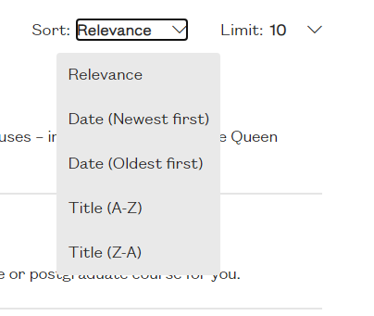

When users interact with the dropdown listboxes, focus is not given to the first element in the listbox and remains on the button. This will be confusing for screen reader users as they will have to press tab to reach the first element in the list which is not the normal navigation for screen reader users.

The listbox contains nested active elements as the <li> elements with role=option contain a link which will also be confusing for screen reader users.

This issue applies to both dropdown elements on the page.

Current Code Ref(s):
<section class="dropdown-list fb-sort-dropdown">
<span id="fb-sort-dropdown" class="sr-only">
Sort results by
</span>
Sort:
<button class="dropdown-list__link js-dropdown-list__link opened" aria-haspopup="listbox" aria-expanded="true">
<span>Relevance</span>
</button>
<ul class="dropdown-list__list" role="listbox" tabindex="-1" aria-labelledby="fb-sort-dropdown" style="display: block;">
<li role="option" aria-selected="false">
<a class="dropdown-list__list-link" title="Sort by Relevance" href="?collection=uel-meta&amp;sort=">
Relevance
</a>
</li>
<li role="option" aria-selected="false">
<a class="dropdown-list__list-link" title="Sort by Date (Newest first)" href="?collection=uel-meta&amp;sort=date">
Date (Newest first)
</a>
</li>
<li role="option" aria-selected="false">
<a class="dropdown-list__list-link" title="Sort by Date (Oldest first)" href="?collection=uel-meta&amp;sort=adate">
Date (Oldest first)
</a>
</li>
<li role="option" aria-selected="false">
<a class="dropdown-list__list-link" title="Sort by Title (A-Z)" href="?collection=uel-meta&amp;sort=title">
Title (A-Z)
</a>
</li>
<li role="option" aria-selected="false">
<a class="dropdown-list__list-link" title="Sort by Title (Z-A)" href="?collection=uel-meta&amp;sort=dtitle">
Title (Z-A)
</a>
</li>
</ul>
</section>

Screen reader comments:
“When clicking on the ‘relevance’ filters, JAWS enters forms mode which is indicated via an audible clicking sound. I used the cursor keys to navigate through the filters, but JAWS remained silent. I would expect JAWS to read the different options available to me within this filter rather than remaining silent.”

“When testing the forms on the ‘clearing search: page I found a ‘10’ button. This may indicate how many results are present on the page and if this is the case, including this information in the form label will help users to understand the purpose of this form element out of context.”

Solution:
Ensure focus is given to the listbox when it is presented. See Collapsible Dropdown Listbox Example for more information and an accessible example.

Incorrect use of Aria
There are elements that use aria incorrectly which may cause issues for users of assistive technology.

WCAG Reference:
4.1.2 Name, Role, Value
Understanding Name, Role, Value |How to Meet Name, Role, Value
(Level A)

Issue ID: DAC_Aria_01

URL: https://univeastlond.prod.acquia-sites.com/
Page title: Homepage | UEL
Journey: 1 step 1

Screenshot:

An aria role of ‘header’ has been set on the page header which is not correct. ‘Header’ is not a valid role.

Current Code Ref(s):
<header class="coh-container coh-component coh-component-instance-916a7dbe-672b-4cf6-a84b-e2f226ee17f6 contextual-component site-header header-bg-color-black coh-ce-cpt_header-d5e715d" role="header">

Solution:
Ensure that where aria attributes are used, they are valid attributes.

See Using ARIA landmarks to identify regions of a page for more information.

Issue ID: DAC_Aria_02

URL: https://univeastlond.prod.acquia-sites.com/undergraduate/courses/bsc-hons-accounting-finance
Page title: BSc (Hons) Accounting and Finance | UEL
Journey: 1 step 5

Screenshot:

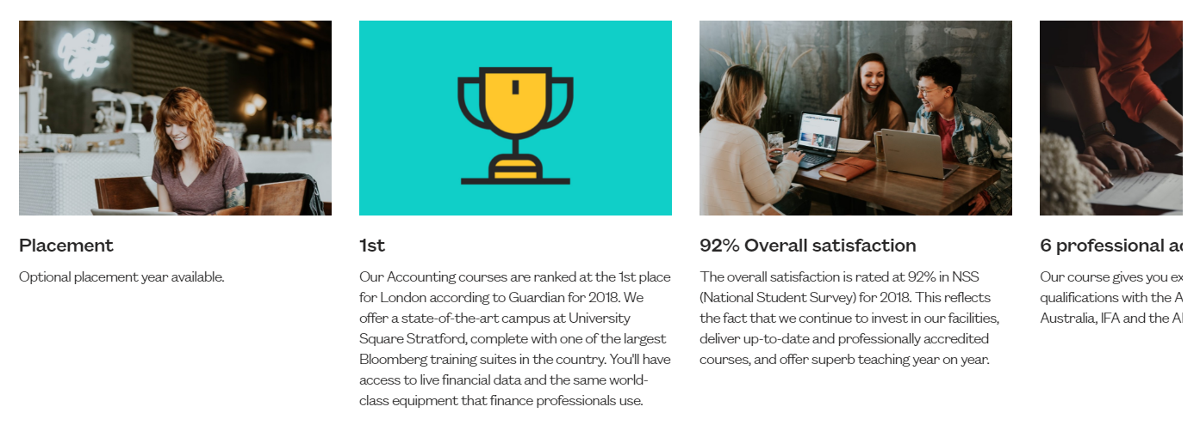

There is a carousel which has role=tabpanel set which is not correct. This may be confusing for screen reader users. The images in the carousel also have an alt attribute of ‘img’ which is being masked by the role=tabpanel.

Current Code Ref(s):
<div class="coh-slider-item coh-component coh-component-instance-543ff71c-9e3d-41cc-a536-d1596efa6bca contextual-component coh-ce-cpt_image_pod-d30da076 slick-slide slick-current slick-active" style="width: 395.143px;" data-slick-index="0" aria-hidden="false" role="tabpanel" id="slick-slide00" aria-describedby="slick-slide-control00" tabindex="0"> <div class="coh-container coh-instance-273580283 coh-ce-cpt_image_pod-56dfe2cf"> <img class="coh-image coh-ce-cpt_image_pod-51a54600 coh-image-responsive-xs" src="/sites/default/files/9570.jpg" alt="img"></div> <div class="coh-container"> <h4 class="coh-heading coh-style-header-4 coh-ce-cpt_image_pod-fb89dca7"> Placement </h4> <p class="coh-paragraph coh-style-body coh-ce-cpt_image_pod-9bb5cc8f">Optional placement year available.</p> </div> </div>

Solution:
Remove role=tabpanel from the carousel elements. The images should have a null alt attribute.

Issue ID: DAC_Aria_04

URL: https://univeastlondstg.prod.acquia-sites.com/study/undergraduate/andrew-test-page-do-not-edit/clearing-search
Page title: Clearing Search | UEL
Journey: 1 step 11

Screenshot:

The links to filter the results have role=none applied to the containing list item which will override the natural role of link. Screen reader users will not know that the links are selectable. The containing list has a role=menu which is also incorrect.

Current Code Ref(s):
<ul class="tabs__list" role="menu" aria-label="Tab navigation">
<li class="tabs__item" role="none">
<a href="?collection=uel-meta" class="tabs__link tabs__link--icon active">
<span class="fal fa-globe"></span>
All results
<span class="search-facet-count">(4,728)</span>
</a>
</li>
<li class="tabs__item" role="none">
<a href="?f.Tabs%7Cuel-courses=Courses&amp;collection=uel-meta" class="tabs__link tabs__link--icon ">
<span class="fal fa-graduation-cap"></span>
Courses
<span class="search-facet-count">(248)</span>
</a>
</li>
<li class="tabs__item" role="none">
<a href="?collection=uel-meta&amp;f.Tabs%7CcourseClearing=clearing" class="tabs__link tabs__link--icon ">
<span class="fal fa-graduation-cap"></span>
Courses in Clearing
<span class="search-facet-count">(2)</span>
</a>
</li>
<li class="tabs__item" role="none">
<a href="?f.Tabs%7Cuel-people=People&amp;collection=uel-meta" class="tabs__link tabs__link--icon ">
<span class="fal fa-user"></span>
People
<span class="search-facet-count">(437)</span>
</a>
</li>
<li class="tabs__item" role="none">
<a href="?f.Tabs%7Cuel-events=Events&amp;collection=uel-meta" class="tabs__link tabs__link--icon ">
<span class="fal fa-calendar-alt"></span>
Events
<span class="search-facet-count">(3)</span>
</a>
</li>
<li class="tabs__item" role="none">
<a href="?f.Tabs%7Cuel-news=News&amp;collection=uel-meta" class="tabs__link tabs__link--icon ">
<span class="fal fa-newspaper"></span>
News
<span class="search-facet-count">(3)</span>
</a>
</li>
<li class="tabs__item" role="none">
<a href="?f.Tabs%7Cuel-documents=Documents&amp;collection=uel-meta" class="tabs__link tabs__link--icon ">
<span class="fal fa-file-alt"></span>
Documents
<span class="search-facet-count">(1,533)</span>
</a>
</li>
</ul>

Screen reader comments:
“When navigating through the clearing search page using the tab key, I discovered that JAWS announces ‘tab navigation’ several times. This changes when screen reader users move to the document formats. It would be helpful if this information could be announced only once and that the other information receiving focus with the tab key is clearly described.”

Solution:
Remove the roles from the <ul> and <li> elements. A heading should be added before the section to ensure the links can be understood when navigating in context.

Buttons – Accessible Name
There is a button which has no text to describe its purpose to screen reader users.

WCAG Reference:
4.1.2 Name, Role, Value
Understanding Name, Role, Value |How to Meet Name, Role, Value
(Level A)

Issue ID: DAC_Buttons_01

URL: https://univeastlond.prod.acquia-sites.com/
Page title: Homepage | UEL
Journey: 1 step 1

Screenshot:

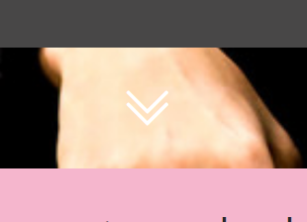

There is a button to scroll down the page which has no accessible text to describe its purpose to screen reader users. The button will announce as ‘Button’ which will be confusing for users who rely on audio feedback.

Current Code Ref(s):
<button class="coh-button homepage-hero__arrow coh-ce-cpt_homepage_hero_image-9548a1ed coh-interaction homepage-hero__arrow--visible" data-interaction-modifiers="[{&quot;modifierType&quot;:&quot;&quot;,&quot;interactionScope&quot;:&quot;document&quot;}]" data-coh-settings="{ &quot;xs&quot;:{&quot;buttonAnimation&quot;:[{&quot;animationType&quot;:&quot;none&quot;}]} }" type="button"> </button>

Screen reader comments:
“When navigating through the home page using the forms list out of context, I located multiple buttons that do not contain a label. It would be helpful if all buttons could be clearly labelled so that all users are able to understand the purpose of all form fields.”

Solution:
Ensure all buttons have text which describes their purpose and provides an accessible name which can be read by screen reading software.
Aria-label can be used, but this will not be translated for users who speak other languages. A visually hidden span is the most reliable method of adding text.

Example
<button class="coh-button homepage-hero__arrow coh-ce-cpt_homepage_hero_image-9548a1ed coh-interaction homepage-hero__arrow--visible" data-interaction-modifiers="[{&quot;modifierType&quot;:&quot;&quot;,&quot;interactionScope&quot;:&quot;document&quot;}]" data-coh-settings="{ &quot;xs&quot;:{&quot;buttonAnimation&quot;:[{&quot;animationType&quot;:&quot;none&quot;}]} }" type="button"> <span class="visually-hidden">Scroll Down</span></button>

Issue ID: DAC_Buttons_04

URL: https://univeastlond.prod.acquia-sites.com/
Page title: Homepage | UEL
Journey: 1 step 1

Screenshot:

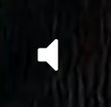

The mute button has no text which is accessible to screen reader users to describe its purpose. The element will just announce as ‘Button’.

Current Code Ref(s):
<button class="coh-button homepage-hero__mute coh-ce-6c57edd1 coh-interaction" data-interaction-modifiers="[{&quot;modifierType&quot;:&quot;&quot;,&quot;interactionScope&quot;:&quot;document&quot;}]" data-coh-settings="{ &quot;xs&quot;:{&quot;buttonAnimation&quot;:[{&quot;animationType&quot;:&quot;none&quot;}]} }" type="button"> </button>

Solution:
Ensure that all buttons have text which describes their purpose to screen reader users.

iFrame – Accessible Name
There are iFrames present which do not have a title attribute to describe their content to screen reader users.

WCAG Reference:
4.1.2 Name, Role, Value
Understanding Name, Role, Value |How to Meet Name, Role, Value
(Level A)

Issue ID: DAC_iFrame_01

URL: https://univeastlond.prod.acquia-sites.com/
Page title: Homepage | UEL
Journey: 1 step 1

Screenshot:

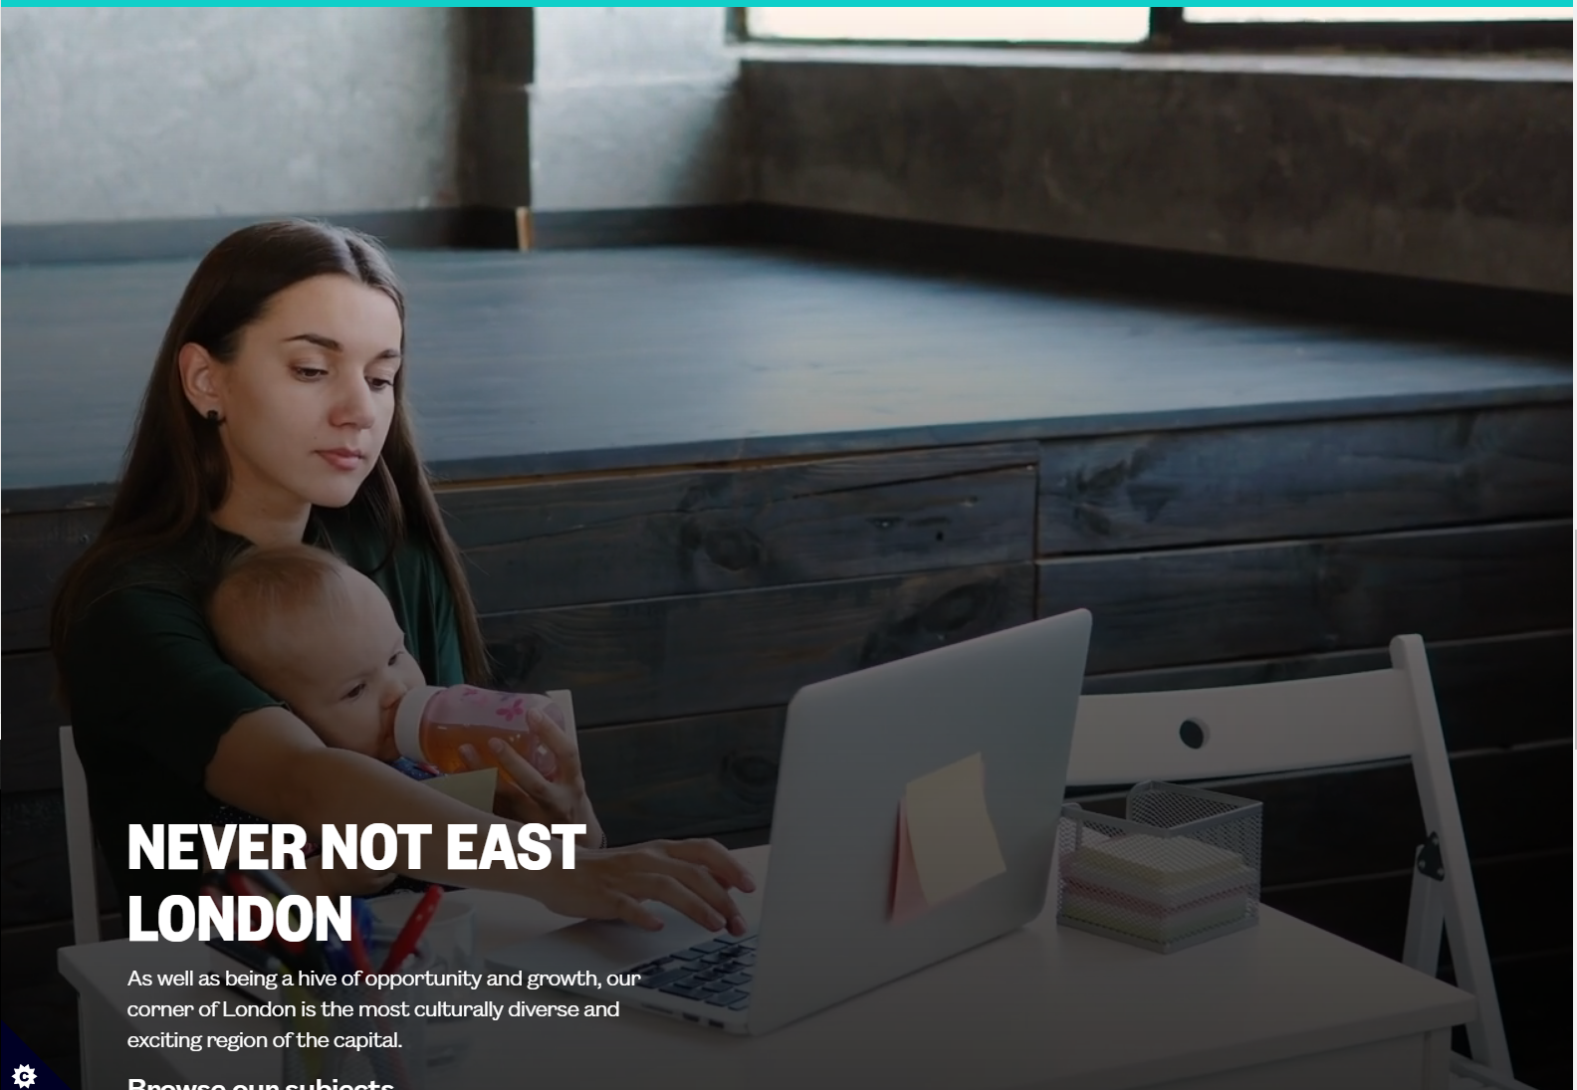

There are iframes present on the page which do not have a title attribute to describe the content to screen reader users.

Current Code Ref(s):
<iframe frameborder="0" allow="autoplay; mute" src="https://www.youtube.com/embed/M9NVMJLYJbQ?enablejsapi=1&amp;disablekb=1&amp;controls=0&amp;rel=0&amp;iv_load_policy=3&amp;cc_load_policy=0&amp;playsinline=1&amp;showinfo=0&amp;modestbranding=1&amp;fs=0&amp;origin=https://univeastlond.prod.acquia-sites.com&amp;mute=1&amp;autoplay=1&amp;loop=1" id="M9NVMJLYJbQ-9682" style="top: 50%; left: 50%; transform: translateX(-50%) translateY(-50%); position: absolute; opacity: 1; width: 1952px; height: 1098px;" nuan_newframe="true"></iframe>

Solution:
Ensure all frames and iframes have a title attribute.
Example
<iframe title="descriptive frame title" frameborder="0" allow="autoplay; mute" src="https://www.youtube.com/embed/M9NVMJLYJbQ?enablejsapi=1&amp;disablekb=1&amp;controls=0&amp;rel=0&amp;iv_load_policy=3&amp;cc_load_policy=0&amp;playsinline=1&amp;showinfo=0&amp;modestbranding=1&amp;fs=0&amp;origin=https://univeastlond.prod.acquia-sites.com&amp;mute=1&amp;autoplay=1&amp;loop=1" id="M9NVMJLYJbQ-9682" style="top: 50%; left: 50%; transform: translateX(-50%) translateY(-50%); position: absolute; opacity: 1; width: 2400px; height: 1350px;" nuan_newframe="true"></iframe>

Carousel Controls
There are controls for a scrolling carousel which may be confusing for screen reader users.

WCAG Reference:
4.1.2 Name, Role, Value
Understanding Name, Role, Value |How to Meet Name, Role, Value
(Level A)

Issue ID: DAC_Carousel_Controls_01

URL: https://univeastlond.prod.acquia-sites.com/student-life/sport/sportsdock
Page title: SportsDock | UEL
Journey: 1 Step 4

Screenshot:

The buttons to control the carousel are set as tabs and the text for the buttons is not fully descriptive. Tabs are a specific component, and the role of tab should not be used on a carousel.

Current Code Ref(s):
<ul class="slick-dots coh-style-carousel-pagination" role="tablist" style="">
<li class="" role="presentation"><button type="button" role="tab" id="slick-slide-control00" aria-controls="slick-slide00" aria-label="1 of 5" tabindex="0"></button></li>
<li role="presentation" class=""><button type="button" role="tab" id="slick-slide-control01" aria-controls="slick-slide01" aria-label="2 of 5" tabindex="0"></button></li>
<li role="presentation" class="slick-active"><button type="button" role="tab" id="slick-slide-control02" aria-controls="slick-slide02" aria-label="3 of 5" tabindex="0" aria-selected="true"></button></li>
<li role="presentation" class=""><button type="button" role="tab" id="slick-slide-control03" aria-controls="slick-slide03" aria-label="4 of 5" tabindex="0"></button></li>
<li role="presentation" class=""><button type="button" role="tab" id="slick-slide-control04" aria-controls="slick-slide04" aria-label="5 of 5" tabindex="0"></button></li>
</ul>

Screen reader comments:
“When navigating through the page I located ‘next’ and ‘back’ buttons out of context. A member of the support team advised me that these enable service users to move through the links on a carousel. It would be helpful to add ‘next slide’ or ‘go back to the previous slide’, as this will make the purpose of these button simpler to understand both in and out of context.”

“When testing the sports dock page out of context I noticed multiple tabs. These tabs are not clearly labelled and do not work as expected with JAWS. When I click on the tabs and then press enter and then tab, I expected to be able to read the content but there did not appear to be content within the tab.”

Solution:
Ensure that the labels for the slide controls are fully descriptive of the purpose of the control. Remove role=tab from the buttons. Live regions should be used to announce the current slide to users.

See Carousels – Functionality from W3C for more information.

Tabs
There are tabs present which do not have the appropriate semantic HTML to allow screen reader users to interact with the content in a meaningful way.

WCAG Reference:
4.1.2 Name, Role, Value
Understanding Name, Role, Value |How to Meet Name, Role, Value
(Level A)

Issue ID: DAC_Tabs_01

URL: https://univeastlond.prod.acquia-sites.com/study/undergraduate/why-uel
Page title: Why UEL? | UEL
Journey: 1 Step 3

Screenshot:

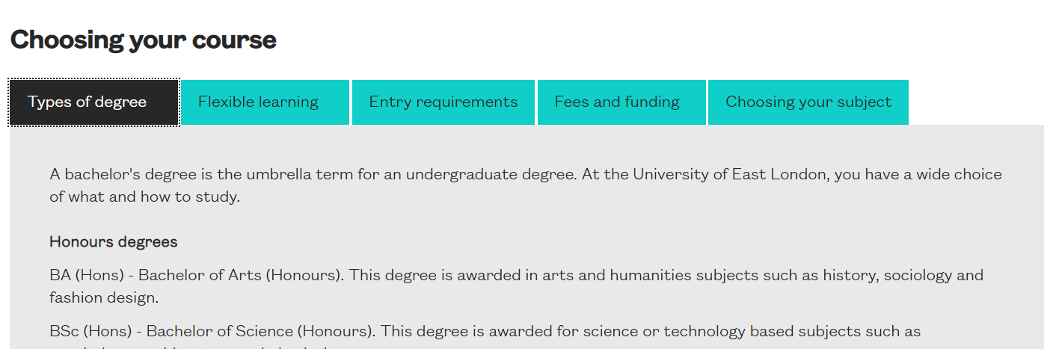

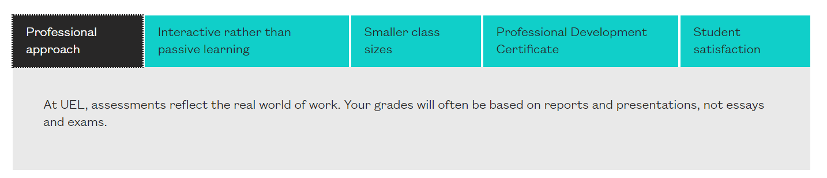

The visible tabs on the page do not have the appropriate semantic markup to allow screen reader users to recognise the content as tabs and interact with them in the manner they would expect. The elements will announce as links, when a link is selected and the content is displayed, screen reader users will not be aware that the page content has changed.

Tabs should be marked up correctly to enable screen reader users to interact with the content of each tab and hear which tab is selected. The links should be buttons and have a role of tab, an associated tabpanel and use aria-selected to inform users of the state of the tab.

Current Code Ref(s):
<ul class="coh-accordion-tabs-nav">
<li class="coh-style-tab-button is-active"><a href="#2052257781-2496252023">Types of degree</a></li>
<li class="coh-style-tab-button"><a href="#2052257781-1135641641">Flexible learning</a></li>
<li class="coh-style-tab-button"><a href="#2052257781-2063794321">Entry requirements</a></li>
<li class="coh-style-tab-button"><a href="#2052257781-1306546605">Fees and funding</a></li>
<li class="coh-style-tab-button"><a href="#2052257781-2681252635">Choosing your subject</a></li>
</ul>

Solution:
Ensure that the tabs are marked appropriately with role=tab. The content which is displayed by each tab should have role=tabpanel. Aria-selected should be used to inform screen reader users of the state of each tab.

See Example of Tabs with Manual Activation for more information.

Medium Priority – WCAG AA

Text Contrast
There are text elements which may be difficult for users to see due to the low contrast ratio of the foreground and background colours.

WCAG Reference:
1.4.3 Contrast (Minimum)
Understanding Contrast (Minimum) |How to Meet Contrast (Minimum)
(Level AA)

1.4.6 Contrast (Enhanced)
Understanding Contrast (Enhanced) |How to Meet Contrast (Enhanced)
(Level AAA)

Issue ID: DAC_Text_Contrast_01

URL: https://univeastlond.prod.acquia-sites.com/
Page title: Homepage | UEL
Journey: 1 step 1

Screenshot:

When the skip to content link becomes visible, the text is blue on a black background which will be difficult for users to read because of the low colour contrast ratio of the foreground and background colours.

Foreground: #0000EE
Background: #282727
The contrast ratio is: 1.6:1
1.4.3 Contrast (Minimum) (AA)
Fail for large and regular text
1.4.6 Contrast (Enhanced) (AAA)
Fail for large and regular text

Current Code Ref(s):
<a href="#main-content" class="coh-link visually-hidden focusable skip-link" target="_self">Skip to main content</a>

Keyboard only user comments:
“The skip link text is blue on a dark grey background. I was able to see the links, but I found it difficult to read the text because of the colour.”

Solution:
Ensure that the contrast ratio of all text elements exceeds the minimum required contrast ratio of 4.5:1

Issue ID: DAC_Text_Contrast_02

URL: https://univeastlond.prod.acquia-sites.com/undergraduate/courses/bsc-hons-accounting-finance
Page title: BSc (Hons) Accounting and Finance | UEL
Journey: 1 step 5

Screenshot:

Where there is text over an image, this can be difficult for some users to see clearly when the background image is a similar colour to the text. There is a black transparent background presented on mouse hover which does improve the contrast, but this will not benefit users with colour perception issues who cannot use a mouse.

Foreground: #FFFFFF
Background: #EBF0F3
The contrast ratio is: 1.1:1
1.4.3 Contrast (Minimum) (AA)
Fail for large and regular text
1.4.6 Contrast (Enhanced) (AAA)
Fail for large and regular text

Current Code Ref(s):
<h3 class="coh-heading card-heading coh-ce-ce062a7e"> <span class="coh-inline-element coh-ce-e7deee38">MPhil PhD</span> <span class="coh-inline-element limited-txt">Architecture, Computi...</span> </h3>

Low vision user comments:
“When I was reading through the information, I struggled to read the white font over the background image due to the colour of the font blending with the colour scheme in the background image. This means that some users like myself may not be able to read all the information they want to read.”

Solution:
Ensure all text meets the minimum required contrast ratio, large text should have a minimum ratio of 3:1 where small text should be 4.5:1

Non-Text Contrast
There are non-text elements which may be difficult for users to see clearly due to the low contrast ratio of the foreground and background colours

WCAG Reference:
1.4.11 Non-text Contrast
Understanding Non-text Contrast |How to Meet Non-text Contrast
(Level AA)

Issue ID: DAC_Non_Text_01

URL: https://univeastlond.prod.acquia-sites.com/
Page: Home page
Journey and Step: 1 Step 1

Screenshot:

The chevrons over an image may be difficult for some users to see clearly because of the low contrast ratio of the white chevrons over the image.

Foreground: #FFFFFF
Background: #FEE9CD
The contrast ratio is: 1.2:1
1.4.11 Non-text Contrast (AA)
Fail for UI components and graphical objects

Current Code Ref(s):
<button class="coh-button homepage-hero__arrow coh-ce-cpt_homepage_hero_image-9548a1ed coh-interaction homepage-hero__arrow--visible" data-interaction-modifiers="[{&quot;modifierType&quot;:&quot;&quot;,&quot;interactionScope&quot;:&quot;document&quot;}]" data-coh-settings="{ &quot;xs&quot;:{&quot;buttonAnimation&quot;:[{&quot;animationType&quot;:&quot;none&quot;}]} }" type="button"> </button>

Keyboard only user comments:
“The chevrons below the ‘be the change’ section is white on an image of a person. As a result of this it was very difficult to see the chevrons.”

Solution:
Ensure all non-text components have a minimum contrast ratio of 3:1 between the foreground and background colours.

Non-Text Contrast - Focus
The visible focus state indicator may be difficult for some users to see clearly.

WCAG Reference:
1.4.11 Non-text Contrast
Understanding Non-text Contrast |How to Meet Non-text Contrast
(Level AA)

Issue ID: DAC_Focus_State_01

URL: https://univeastlond.prod.acquia-sites.com/
Page title: Homepage | UEL
Journey: 1 step 1

Screenshot:

The focus highlighting mechanism may be difficult for keyboard only users to see due to the low contrast ratio of the black dotted carat highlight on a black background.

Foreground: #000000
Background: #282727
The contrast ratio is: 1.4:1
1.4.11 Non-text Contrast (AA)
Fail for UI components and graphical objects

Current Code Ref(s):
.coh-link:focus, [role=button]:focus, a:focus, button:focus {
outline: 2px dotted #000;
}

Keyboard only user comments:
“The highlighting present on the site consists of a dotted black box. I found this very difficult to see as it is on a dark grey background. This is very difficult to see resulting in it being hard to know what I had my focus on.”

Solution:
Ensure that the visible focus indicator has a contrast ratio of at least 3:1 with all adjacent colours. We would recommend using a solid line of at least 2px thickness which is highly visible for all users.

Issue ID: DAC_Focus_State_02

URL: https://univeastlond.prod.acquia-sites.com/international/regions/africa
Page title: Africa | UEL
Journey: 2 step 3

Screenshot:

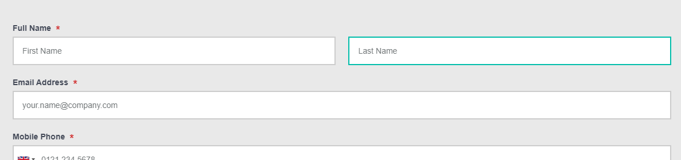

The green focus state indicator on the form may be difficult for some users to see clearly due to the low contrast ratio of the foreground and background colours. The focus state indicator should have a contrast ratio of 3:1 with all adjacent colours.

Foreground: #00BDAA
Background: #FFFFFF
The contrast ratio is: 2.4:1
1.4.11 Non-text Contrast (AA)
Fail for UI components and graphical objects

Current Code Ref(s):
<input aria-label="Full Name (Last name)" class="form-control ng-pristine ng-valid" type="text" placeholder="Last Name" style="width: 49%;" ng-model="values[field.id]['last_name']" autocomplete="family-name">

.form-control:focus {
border-color: #00bdaa;
}

Solution:
Ensure that the colour used for the focus state indicator has a contrast ratio of at least 3:1 with all adjacent colours.

Buttons – Ambiguous Text
There are buttons which have text which is not fully descriptive of the purpose of the button and may confuse screen reader users.

WCAG Reference:
2.4.6 Headings and Labels
Understanding Headings and Labels |How to Meet Headings and Labels
(Level AA)

Issue ID: DAC_Buttons_02

URL: https://univeastlond.prod.acquia-sites.com/
Page title: Homepage | UEL
Journey: 1 step 1

Screenshot:

The buttons within the cookies message may not be clear to screen reader users, especially when navigating out of context using the elements list. The button to ‘Reject’ and ‘Preferences’ are ambiguous.

Current Code Ref(s):
<button id="ccc-notify-reject" class="ccc-notify-button ccc-link ccc-tabbable ccc-reject-button"><span>REJECT</span></button>

<button class="ccc-notify-button ccc-link ccc-tabbable "><span>PREFERENCES</span></button>

Solution:
Add further text to the buttons to ensure that the purpose of the buttons is clear to screen reader users. The text can be visually hidden.

Example
<button id="ccc-notify-reject" class="ccc-notify-button ccc-link ccc-tabbable ccc-reject-button"><span>REJECT<span class="visually-hidden"> Cookies</span></span></button>

Issue ID: DAC_Buttons_04

URL: https://univeastlond.prod.acquia-sites.com/about/alumni-supporters
Page title: Alumni and supporters | UEL
Journey: 1 Step 2

Screenshot:

The button to launch the video has text of ‘Celebrating Alumni Success -…’ which does not accurately describe the purpose of the button to users who rely on audio feedback. There is no way for screen reader users to understand that the button will launch a video.

Current Code Ref(s):
<div class="coh-container coh-component coh-component-instance-a538e612-9897-4dbd-b7c8-1d56030fbbb0 contextual-component gallery-item video-item listing-item" data-modal-open="gallery-item-modal-0" role="button" id="gallery-modal-trigger-0" tabindex="0"> <div class="coh-container coh-ce-cpt_gallery_item_video-1587afec"> <div class="coh-container coh-instance-670579018 coh-ce-cpt_gallery_item_video-cd07cd0"> </div> <div class="coh-container coh-ce-cpt_gallery_item_video-e4340ae8"> <h4 class="coh-heading gallery-item-title coh-style-header-4 coh-ce-cpt_gallery_item_video-127fa281"> Celebrating Alumni Success - ...</h4> </div> </div> </div>

Solution:
Use an aria-label to add text to the button to make the purpose clear to screen reader users.

Example
<h4 aria-label="Celebrating Alumni Success Video" class="coh-heading gallery-item-title coh-style-header-4 coh-ce-cpt_gallery_item_video-127fa281"> Celebrating Alumni Success - ...</h4>

Focus Visible
Button has no visible focus state.

WCAG Reference:
2.4.7 Focus Visible
Understanding Focus Visible |How to Meet Focus Visible
(Level AA)

Issue ID: DAC_Focus_State_03

URL: https://univeastlondstg.prod.acquia-sites.com/test-search-listing
Page: Test search listing
Journey and Step: 1 Step 11

Screenshot:
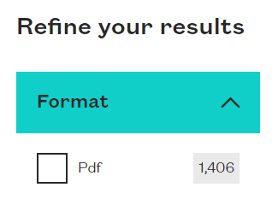

The button to expand or collapse the filter section has no visible focus state indicator to allow keyboard only users to see when the element has focus. Outline: 0; has been set in CSS which will disable the focus highlighting for the element.

Current Code Ref(s):
<span class="module-filter__item-title open" aria-haspopup="true" aria-expanded="true" tabindex="0">Format</span>

Screen reader comments:
“There is no highlighting present on the ‘format’ click to expand element. This meant that I did not know when I had focus on it.”

Solution:
Ensure all interactive components have a highly visible focus state indicator. Do not use outline: 0;

Status Message
There are status messages which are not announced to screen reader users.

WCAG Reference:
4.1.3 Status Messages
Understanding Status Messages |How to Meet Status Messages
(Level AA)

Issue ID: DAC_Status_Message_01

URL: https://univeastlond.prod.acquia-sites.com/elaines-accessibility-page
Page title: Elaine's Accessibility page | UEL
Journey: 1 step 13

Screenshot:

The character count is not announced to screen reader users when it changes.

Current Code Ref(s):
<div class="help-block text-right ng-scope" ng-if="field.max_length">
<span ng-class="{'text-danger': (values[field.id] || '').length > field.max_length}" class="ng-binding">
Total characters:
0/2000
</span>
</div>

Solution:
Use role=status to announce the status message to screen reader users.

Example
<div role="status" class="help-block text-right ng-scope" ng-if="field.max_length">
<span ng-class="{'text-danger': (values[field.id] || '').length > field.max_length}" class="ng-binding">
Total characters:
14/2000
</span>
</div>

Low Priority – WCAG AAA

Non-Descriptive Links (Out of Context)
There are links which are not descriptive for screen reader users when browsing out of context using the elements list.

WCAG Reference:
2.4.9 Link Purpose (Link Only)
Understanding Link Purpose (Link Only) |How to Meet Link Purpose (Link Only)
(Level AAA)

Issue ID: DAC_Links_05

URL: https://univeastlond.prod.acquia-sites.com/about/alumni-supporters
Page title: Alumni and supporters | UEL
Journey: 1 Step 2

Screenshot:

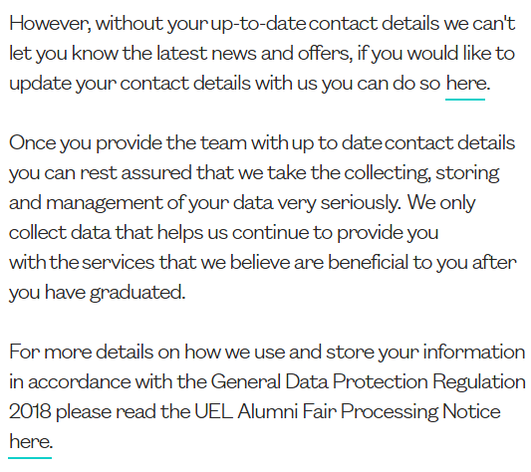

There are links with text of ‘here’ which refer to different destinations, screen reader users will not be able to distinguish the difference between the links when navigating out of context. Link text should be descriptive of the purpose or destination of the link when navigating in or out of context. The links also open in a new browser window without informing screen reader users which can be disorientating for users.

Current Code Ref(s):
<a href="https://app-eu.geckoform.com/public/#/modern/FOEU0250XGkno2Fj" rel="noreferrer noopener" target="_blank">here</a>

Screen reader comments:
“When testing the links out of context on the Alumni and supporters page I located two ‘here’ links. These links are non-descriptive as they do not clearly convey the destination page of these links.”

Solution:
Consider expanding the link text so it can be understood in or out of context. Users should be informed if the link opens in a new tab.

Example
<a href="/sites/default/files/6354.pdf" rel="noreferrer noopener" target="_blank">UEL Alumni Fair Processing Notice.<span class="visually-hidden"> Opens in new tab</span></a>

Issue ID: DAC_Links_06

URL: https://univeastlond.prod.acquia-sites.com/about/alumni-supporters
Page title: Alumni and supporters | UEL
Journey: 1 Step 2

Screenshot:

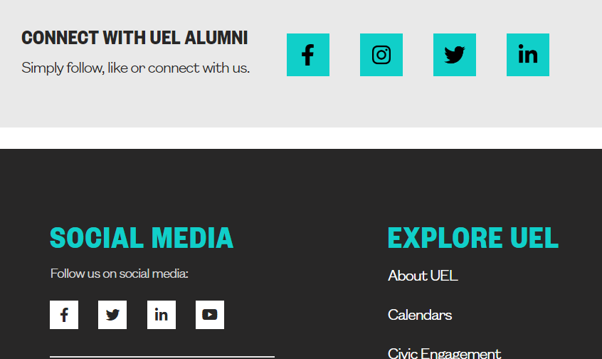

There are two sets of social media links, one for UEL Alumni and one for UEL. This may be confusing for screen reader users.

Current Code Ref(s):
<article> <a href="https://www.facebook.com/uelalumni" class="coh-container social-link-item coh-ce-556d80d6" target="_self">
<div><article>

<div> <img src="/sites/default/files/styles/medium/public/5241.png?itok=8rPoNSJD" width="138" height="220" alt="facebook" title="facebook" typeof="foaf:Image">

</div>

</article>
</div>
</a> </article>

Screen reader comments:
“When viewing the links out of context on the ‘sports dock’ page I noticed that the social media links are announced to me by Jaws as ‘articles. I do not understand this as these are links to social media rather than articles.”

Solution:
If there are links with the same text pointing to different destinations, then consider adding further text to the link, in this case the alt attribute of the image to ensure the links are fully descriptive for screen reader users.

Example
<a href="https://www.facebook.com/uelalumni" class="coh-container social-link-item coh-ce-556d80d6" target="_self">
<div><article>

<div> <img src="/sites/default/files/styles/medium/public/5241.png?itok=8rPoNSJD" width="138" height="220" alt="facebook - UEL Alumni" title="facebook" typeof="foaf:Image">

</div>

</article>
</div>
</a>

Issue ID: DAC_Links_07

URL: https://univeastlond.prod.acquia-sites.com/undergraduate/courses/bsc-hons-accounting-finance
Page title: BSc (Hons) Accounting and Finance | UEL
Journey: 1 step 5

Screenshot:

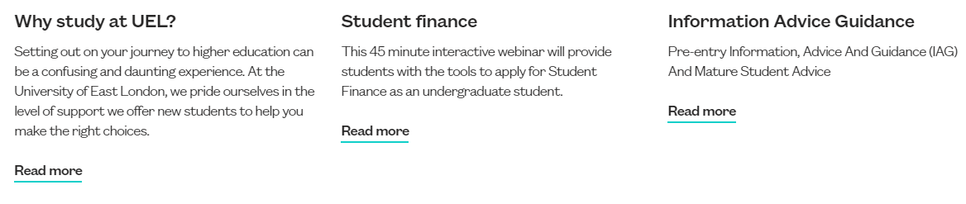

There are multiple links with text of ‘Read more’ which means that screen reader users will not be able to select the links when browsing out of context using the links list. Links should have text which describes the purpose or destination of the link in or out of context.

Current Code Ref(s):
<a href="https://univeastlond.prod.acquia-sites.com/node/preview/db99d8c9-d294-400c-a6aa-3955651e867c/full" class="coh-link coh-style-inline-link coh-ce-cpt_image_pod-82ffdfa5" target="_self" tabindex="0"> Read more </a>

<a href="https://univeastlond.prod.acquia-sites.com/node/preview/0030fa54-c4e0-4147-ab24-b7d3720d6256/full" class="coh-link coh-style-inline-link coh-ce-cpt_image_pod-82ffdfa5" target="_self" tabindex="0"> Read more </a>

<a href="https://univeastlond.prod.acquia-sites.com/study/students/information-advice-guidance" class="coh-link coh-style-inline-link coh-ce-cpt_image_pod-82ffdfa5" target="_self" tabindex="0"> Read more </a>

Solution:
Ensure all links have text which is fully descriptive when browsing in or out of context. Further text can be added to the link and hidden with CSS if required.

Example
<a href="https://univeastlond.prod.acquia-sites.com/node/preview/db99d8c9-d294-400c-a6aa-3955651e867c/full" class="coh-link coh-style-inline-link coh-ce-cpt_image_pod-82ffdfa5" target="_self" tabindex="0"> Read more <span class="visually-hidden">About studying at UEL</span></a>

Usability Issues

Reflow
When viewed as a single column, there are sticky elements which reduce the viewport.

WCAG Reference:
N/A - Usability

Issue ID: DAC_Reflow_01

URL: https://univeastlond.prod.acquia-sites.com/
Page title: Homepage | UEL
Journey: 1 step 1

Screenshot:

When the page is viewed as a single column at 1280CSS pixels wide and 400% magnification, there are sticky banners which obscure the viewport making the content difficult to read as the viewport is drastically reduced.

Current Code Ref(s):
<div class="coh-container sticky-cta-row__main coh-ce-b063d911">

Solution:
We would recommend that sticky elements are minimised to allow users who require a single column view to read the content clearly.

Article use
HTML Article has been used excessively which may be frustrating for screen reader users.

WCAG Reference:
N/A - Usability

Issue ID: DAC_Articles_01

URL: https://univeastlond.prod.acquia-sites.com/about/alumni-supporters
Page title: Alumni and supporters | UEL
Journey: 1 Step 2

Screenshot:

All of the content on the page has been set as articles which can be frustrating for screen reader users. Article use should be used specifically for articles and not as a container for other html elements. The social media links for the UEL Alumni are particularly frustrating to read with screen reading software as each link is read as a separate article.

This is consistent on other pages of the site.

Current Code Ref(s):
<article role="article" about="/node/1846"> <div class="coh-container coh-ce-9e378092"> <div class="coh-container coh-ce-25edd221"> <div class="coh-container coh-ce-e635fc7d"> <h3 class="coh-heading coh-style-heading-3 coh-ce-b5a8c363"> Connect with UEL Alumni </h3> <p class="coh-paragraph coh-style-body">Simply follow, like or connect with us.</p> </div> <div class="coh-container"> <ul class="coh-list-container coh-unordered-list"> <li class="coh-list-item coh-ce-a30ce19e"> <article> <a href="https://www.facebook.com/uelalumni" class="coh-container social-link-item coh-ce-556d80d6" target="_self">
<div><article>
<div> <img src="/sites/default/files/styles/medium/public/5241.png?itok=8rPoNSJD" width="138" height="220" alt="facebook - UEL Alumni" title="facebook" typeof="foaf:Image">
</div>
</article>
</div>
</a> </article>
</li> <li class="coh-list-item coh-ce-a30ce19e"> <article> <a href="https://www.instagram.com/uelalumni/" class="coh-container social-link-item coh-ce-556d80d6" target="_self">
<div><article>
<div> <img src="/sites/default/files/styles/medium/public/5242.png?itok=dGbcQ9l0" width="193" height="220" alt="instagram" title="instagram" typeof="foaf:Image">
</div>
</article>
</div>
</a> </article>
</li> <li class="coh-list-item coh-ce-a30ce19e"> <article> <a href="https://twitter.com/uelalumni" class="coh-container social-link-item coh-ce-556d80d6" target="_self">
<div><article>
<div> <img src="/sites/default/files/styles/medium/public/5243.png?itok=U0wlIkLf" width="220" height="220" alt="twitter" title="twitter" typeof="foaf:Image">
</div>
</article>
</div>
</a> </article>
</li> <li class="coh-list-item coh-ce-a30ce19e"> <article> <a href="https://www.linkedin.com/groups/4596501/" class="coh-container social-link-item coh-ce-556d80d6" target="_self">
<div><article>
<div> <img src="/sites/default/files/styles/medium/public/5536.png?itok=yOW5aFKL" width="193" height="220" alt="linkedin-in" title="linkedin-in" typeof="foaf:Image">
</div>
</article>
</div>
</a> </article>
</li> </ul> </div> </div> </div> </article>

Screen reader comments:
“Beneath the H3 on the home page, JAWS announces ‘article end’. I would expect textual information relating to the heading.”

“When viewing the links out of context on the ‘sports dock’ page I noticed that the social media links are announced to me by JAWS as ‘articles. I do not understand this as these are links to social media rather than articles.”

Solution:
Consider revising article usage to contain only the articles on the page. The social media links can be contained within an unordered list.

Duplicated Landmarks
There are multiple ‘main’ landmarks which may confuse screen reader users.

WCAG Reference:
N/A - Usability

Issue ID: DAC_Landmarks_01

URL: https://univeastlondstg.prod.acquia-sites.com/study/undergraduate/andrew-test-page-do-not-edit/clearing-search
Page title: Clearing Search | UEL
Journey: 1 step 11

Screenshot:

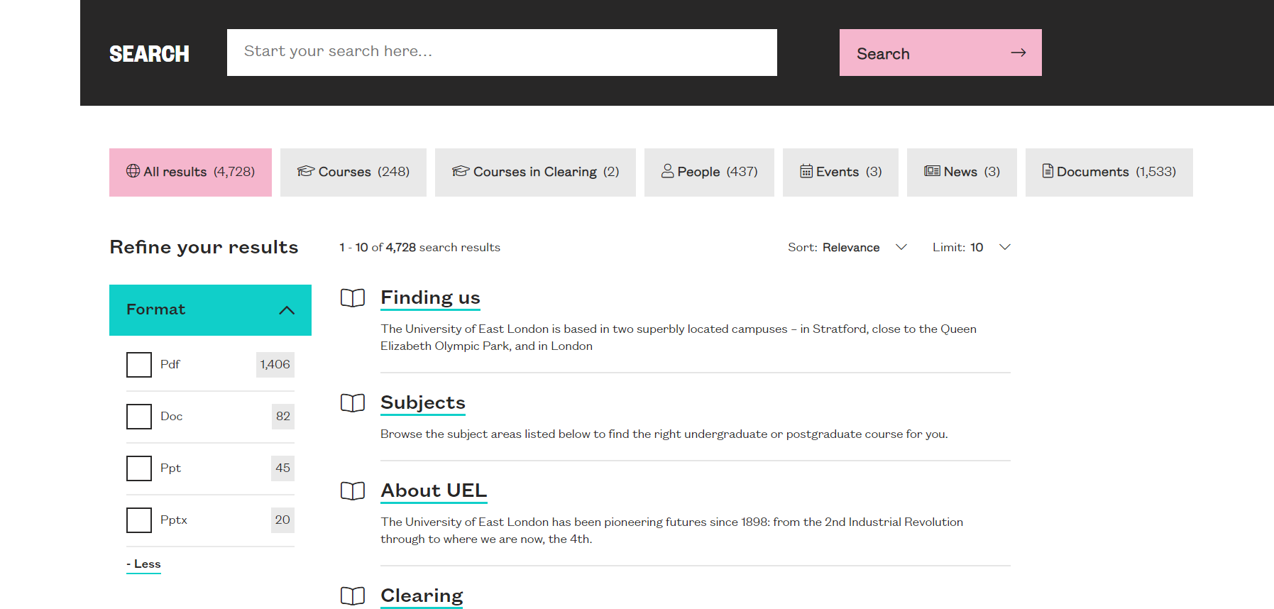

There are two ‘main’ landmarks present which may confuse screen reader users. There should only be one main landmark. Role=main is not necessary on a <main> element.

Current Code Ref(s):
<main id="main-content" role="main">

<main class="main " role="main">
<!-- project.SearchForm -->

Solution:
Remove one of the main landmarks and the role=main.

Input Wrapped in Label
There are radio inputs which are wrapped in the label which will not be accessible for Voice Activation users.

WCAG Reference:
N/A - Usability

Issue ID: DAC_Forms_03

URL: https://univeastlond.prod.acquia-sites.com/elaines-accessibility-page
Page title: Elaine's Accessibility page | UEL
Journey: 1 step 13

Screenshot:

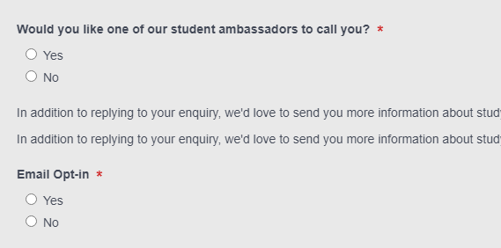

The radio inputs are wrapped in the label which will prevent Voice Activation users from accessing the radio inputs with standard commands. This is due to a bug with Dragon.

Current Code Ref(s):
<div ng-switch-when="radio" ng-class="{hide : field.hidden == 1}" class="ng-scope">
<!-- ngIf: field.option_id == null || field.option_id == 0 -->
<!-- ngIf: field.option_id > 0 --><div ng-if="field.option_id > 0" role="radiogroup" class="ng-scope">
<!-- ngRepeat: option in field.option.values track by $index --><div class="radio ng-scope" ng-repeat="option in field.option.values track by $index">
<label class="ng-binding">
<input aria-label="Would you like one of our student ambassadors to call you? - Yes" type="radio" value="Yes" ng-model="values[field.id]" class="ng-pristine ng-valid" name="02L">
Yes
</label>
</div><!-- end ngRepeat: option in field.option.values track by $index --><div class="radio ng-scope" ng-repeat="option in field.option.values track by $index">
<label class="ng-binding">
<input aria-label="Would you like one of our student ambassadors to call you? - No" type="radio" value="No" ng-model="values[field.id]" class="ng-pristine ng-valid" name="02N">
No
</label>
</div><!-- end ngRepeat: option in field.option.values track by $index -->
</div><!-- end ngIf: field.option_id > 0 -->
</div>

Solution:
We would recommend that grouped inputs are not wrapped in the label. We would also recommend that grouped form controls use a fieldset and legend to provide a shared or common label instead of using an aria-label.

Example
<fieldset>
<legend>Output format</legend>
<div>
<input type="radio" name="format" id="txt" value="txt" checked=""> <label for="txt">Text file</label>
</div>
<div>
<input type="radio" name="format" id="csv" value="csv"> <label for="csv">CSV file</label>
</div>
<div>
<input type="radio" name="format" id="html" value="HTML"> <label for="html">HTML file</label>
</div>
</fieldset>

Bypass Blocks
There is a twitter widget which may be frustrating for users who navigate using a keyboard only.

WCAG Reference:
N/A - usability

Issue ID: DAC_Bypass_Blocks_01

URL: https://univeastlond.prod.acquia-sites.com/elaines-accessibility-page
Page title: Elaine's Accessibility page | UEL
Journey: 1 step 13

Screenshot:

Keyboard only users may be frustrated by tabbing through all of the interactive elements in the twitter feed. Providing a skip link to move past the widget may be beneficial.

Current Code Ref(s):
<div class="coh-container col-right"> <div class="coh-container coh-component coh-component-instance-975597f1-9fdb-415a-9934-f276b490f07a contextual-component field-embedded-code">

Solution:
Consider providing a skip link before the twitter feed to allow keyboard only users to bypass the section.

Radio Buttons
There are radio buttons which do not behave in the expected manner for keyboard only users.

WCAG Reference:
N/A - Usability

Issue ID: DAC_Radio_Buttons_01

URL: https://univeastlond.prod.acquia-sites.com/international/regions/africa
Page title: Africa | UEL
Journey: 2 step 3
Screenshot:

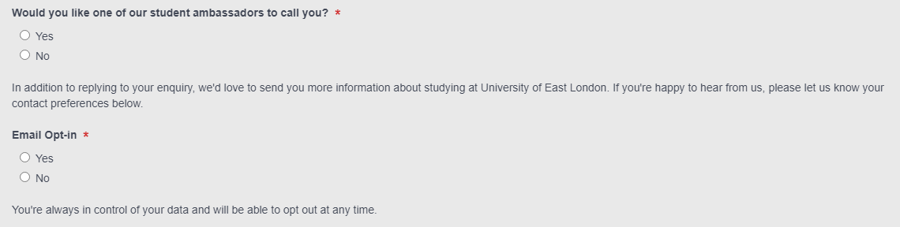

The radio inputs do not behave in the expected manner for keyboard only users. Users would expect to tab to the radio inputs then use the cursor keys to toggle between each input. As the inputs have different names, users are required to tab to each radio input which may be confusing for some users.

Current Code Ref(s):
<div ng-if="field.option_id > 0" role="radiogroup" class="ng-scope">
<!-- ngRepeat: option in field.option.values track by $index --><div class="radio ng-scope" ng-repeat="option in field.option.values track by $index">
<label class="ng-binding">
<input aria-label="Would you like one of our student ambassadors to call you? - Yes" type="radio" value="Yes" ng-model="values[field.id]" class="ng-pristine ng-valid" name="02L">
Yes
</label>
</div><!-- end ngRepeat: option in field.option.values track by $index --><div class="radio ng-scope" ng-repeat="option in field.option.values track by $index">
<label class="ng-binding">
<input aria-label="Would you like one of our student ambassadors to call you? - No" type="radio" value="No" ng-model="values[field.id]" class="ng-pristine ng-valid" name="02N">
No
</label>
</div><!-- end ngRepeat: option in field.option.values track by $index -->
</div>

Keyboard only user comments:
“I was able to tab onto both the yes and no radio buttons separately. I found this a little confusing as usually I am able to tab onto the first radio button then use the arrow keys to access the other. This is what I was expecting to happen here.”

Solution:
Ensure radio input which are part of the same group have the same name to preserve the expected keyboard navigation behaviour.

End of Report

Appendix I

Journeys
Journey 1 – URL Tests

1. Home URL:
https://univeastlond.prod.acquia-sites.com/
2. Generic Content URL:
https://univeastlond.prod.acquia-sites.com/about-uel/alumni-supporters
3. Generic Content URL 2:
https://univeastlond.prod.acquia-sites.com/study/undergraduate/why-uel
4. Generic Hub URL:
https://univeastlond.prod.acquia-sites.com/student-life/sport/sportsdock
5. Course Detail URL:
https://univeastlond.prod.acquia-sites.com/undergraduate/courses/bsc-hons-accounting-finance
6. Locate the ‘Download course specifications’ heading and then download one of the PDF’s below to test
7. Staff Profile URL:
https://univeastlond.prod.acquia-sites.com/about-uel/staff/rachel-tribe
8. News Detail URL:
https://univeastlond.prod.acquia-sites.com/about-uel/news/2021/march/sinkholes-when-ground-fights-back-after-centuries-exploitation
9. Events Detail URL:
https://univeastlond.prod.acquia-sites.com/study/postgraduate/postgraduate-open-events
10. Campaign Landing URL:
https://univeastlond.prod.acquia-sites.com/study/clearing
11. Site Search URL:
https://univeastlondstg.prod.acquia-sites.com/test-search-listing
12. Student finance URL:
https://univeastlond.prod.acquia-sites.com/about-uel/events/2021/april/student-finance
13. Accessibility page URL:
https://univeastlond.prod.acquia-sites.com/elaines-accessibility-page
14. MSc URL:
https://univeastlond.prod.acquia-sites.com/postgraduate/courses/msc-engineering-management

Journey 2 - Forms

1. First Form to complete:
https://univeastlond.prod.acquia-sites.com/international/regions/africa
2. Click the ‘contact us’ button
3. Test all form fields with dummy data then click ‘Submit’
4. Second form to complete:
https://univeastlondstg.prod.acquia-sites.com/undergraduate/courses/bsc-hons-biomedical-science
5. Click ‘Apply now’
6. Select ‘Full-time’
7. Select ‘UK’

Appendix II

Classification of Accessibility Issues

The following scoring system was used to indicate the status of the sites with regards to each W3C WAI checkpoint up to and including Level AAA:

Status | Description
Pass (H)  Pass (M)  Pass (L) | The site meets the requirements of the checkpoint.
Fail (L) Low Priority | The site almost meets the requirements of the checkpoint. Only a small number of minor problems were identified. The site fails to meet the requirements against AAA criteria measured against WCAG 2.1
Fail (M) Medium Priority | The site fails to meet the requirements against AA criteria measured against WCAG 2.1
Fail (H) High Priority | The site fails to meet the requirements against A criteria measured against WCAG 2.1 and more severe accessibility issues were identified.
Not Applicable (N/A) | No content was found on the site to which the checkpoint would relate.

Principle 1: Perceivable – Information and users interface components must be presentable to users in ways they can perceive.
Non-text Content:  1.1.1 All non-text content that is presented to the user has a text alternative that serves the equivalent purpose.  (Level A) | Fail (H)
Audio-only and Video-only (Pre-recorded):  1.2.1 For pre-recorded audio-only and pre-recorded video-only media, the following are true, except when the audio or video is a media alternative for text and is clearly labelled as such:  Understanding Success Criterion 1.2.1  - Pre-recorded Audio-only: An alternative for time-based media is provided that presents equivalent information for pre-recorded audio-only content.  - Pre-recorded Video-only: Either an alternative for time-based media or an audio track is provided that presents equivalent information for pre-recorded video-only content.  (Level A) | Fail (H)
Captions (Pre-recorded):  1.2.2 Captions are provided for all pre-recorded audio content in synchronized media, except when the media is a media alternative for text and is clearly labelled as such.  (Level A) | Fail (H)
Audio Description or Media Alternative (Pre-recorded):  1.2.3 An alternative for time-based media or audio description of the pre-recorded video content is provided for synchronized media, except when the media is a media alternative for text and is clearly labelled as such.  (Level A) | Fail (H)
Captions (Live):  1.2.4 Captions are provided for all live audio content in synchronized media.  (Level AA) | (N/A)
Audio Description (Pre-recorded):  1.2.5 Audio description is provided for all pre-recorded video content in synchronized media.  (Level AA) | (N/A)
Sign Language (Pre-recorded):  1.2.6 Sign language interpretation is provided for all pre-recorded audio content in synchronized media.  (Level AAA) | (N/A)

Extended Audio Description (Pre-recorded):  1.2.7 Where pauses in foreground audio are insufficient to allow audio descriptions to convey the sense of the video, extended audio description is provided for all pre-recorded video content in synchronized media.  (Level AAA) | (N/A)
Media Alternative (Pre-recorded):  1.2.8 An alternative for time-based media is provided for all pre-recorded synchronized media and for all pre-recorded video-only media.  (Level AAA) | (N/A)
Audio-only (Live):  1.2.9 An alternative for time-based media that presents equivalent information for live audio-only content is provided.  (Level AAA) | (N/A)
Info and Relationships:  1.3.1 Information, structure, and relationships conveyed through presentation can be programmatically determined or are available in text.  (Level A) | Fail (H)
Meaningful Sequence:  1.3.2 When the sequence in which content is presented affects it’s meaning, a correct reading sequence can be programmatically determined.  (Level A) | Pass (H)
Sensory Characteristics:  1.3.3 Instructions provided for understanding and operating content do not rely solely on sensory characteristics of components such as shape, size, visual location, orientation, or sound.  (Level A) | Pass (H)

Orientation: (WCAG 2.1)  1.3.4 Content does not restrict its view and operation to a single display orientation, such as portrait or landscape, unless a specific display orientation is essential.  Note: Examples where a particular display orientation may be essential are a bank check, a piano application, slides for a projector or television, or virtual reality content where binary display orientation is not applicable.  (Level AA) | Pass (M)
Identify Input Purpose: (WCAG 2.1)  1.3.5 The purpose of each input field collecting information about the user can be programmatically determined when :  - The input field serves a purpose identified in the Input Purposes for User Interface Components section; and  - The content is implemented using technologies with support for identifying the expected meaning for form input data.  (Level AA) | Pass (M)
Identify Purpose: (WCAG 2.1)  1.3.6 In content implemented using mark-up languages, the purpose of User Interface Components, icons, and regions can be programmatically determined.  (Level AAA) | (N/A)
Use of Colour:  1.4.1 Colour is not used as the only visual means of conveying information, indicating an action, prompting a response, or distinguishing a visual element.  (Level A) | Pass (H)
Audio Control:  1.4.2 If any audio on a Web page plays automatically for more than 3 seconds, either a mechanism is available to pause or stop the audio, or a mechanism is available to control audio volume independently from the overall system volume level.  (Level A) | (N/A)

Contrast (Minimum):  1.4.3 The visual presentation of text and images of text has a contrast ratio of at least 4.5:1, except for the following:  - Large Text: Large-scale text and images of large-scale text have a contrast ratio of at least 3:1;  - Incidental: Text or images of text that are part of an inactive user interface component, that are pure decoration, that are not visible to anyone, or that are part of a picture that contains significant other visual content, have no contrast requirement.  - Logotypes: Text that is part of a logo or brand name has no minimum contrast requirement.  (Level AA) | Fail (M)
Resize text:  1.4.4 Except for captions and images of text, text can be resized without assistive technology up to 200 percent without loss of content or functionality.  (Level AA) | Pass (M)
Images of Text:  1.4.5 If the technologies being used can achieve the visual presentation, text is used to convey information rather than images of text except for the following:  Understanding Success Criterion 1.4.5  - Customizable: The image of text can be visually customized to the user's requirements;  - Essential: A particular presentation of text is essential to the information being conveyed.  Note: Logotypes (text that is part of a logo or brand name) are considered essential.  (Level AA) | (N/A)

Contrast (Enhanced):  1.4.6 The visual presentation of text and images of text has a contrast ratio of at least 7:1, except for the following:  - Large Text: Large-scale text and images of large-scale text have a contrast ratio of at least 4.5:1;  - Incidental: Text or images of text that are part of an inactive user interface component, that are pure decoration, that are not visible to anyone, or that are part of a picture that contains significant other visual content, have no contrast requirement.  - Logotypes: Text that is part of a logo or brand name has no minimum contrast requirement.  (Level AAA) | Fail (L)
Low or No Background Audio:  1.4.7 For pre-recorded audio-only content that (1) contains primarily speech in the foreground, (2) is not an audio CAPTCHA or audio logo, and (3) is not vocalization intended to be primarily musical expression such as singing or rapping, at least one of the following is true:  Understanding Success Criterion 1.4.7  - No Background: The audio does not contain background sounds.  - Turn Off: The background sounds can be turned off.  - 20 dB: The background sounds are at least 20 decibels lower than the foreground speech content, with the exception of occasional sounds that last for only one or two seconds.  Note: Per the definition of "decibel," background sound that meets this requirement will be approximately four times quieter than the foreground speech content.  (Level AAA) | Pass (L)

Visual Presentation:  1.4.8 For the visual presentation of blocks of text, a mechanism is available to achieve the following:  Understanding Success Criterion 1.4.8  - Foreground and background colours can be selected by the user.  - Width is no more than 80 characters or glyphs (40 if CJK).  - Text is not justified (aligned to both the left and the right margins).  - Line spacing (leading) is at least space-and-a-half within paragraphs, and paragraph spacing is at least 1.5 times larger than the line spacing.  - Text can be resized without assistive technology up to 200 percent in a way that does not require the user to scroll horizontally to read a line of text on a full-screen window.  (Level AAA) | (N/A)
Images of Text (No Exception):  1.4.9 Images of text are only used for pure decoration or where a particular presentation of text is essential to the information being conveyed.  Note: Logotypes (text that is part of a logo or brand name) are considered essential.  (Level AAA) | Pass (L)
Reflow: (WCAG 2.1)  1.4.10 Content can be presented without loss of information or functionality, and without requiring scrolling in two dimensions for :  - Vertical scrolling content at a width equivalent to 320 CSS pixels;  - Horizontal scrolling content at a height equivalent to 256 CSS pixels.  Except for parts of the content which require two-dimensional layout for usage or meaning.  Note: 320 CSS pixels is equivalent to a starting viewport width of 1280 CSS pixels wide at 400% zoom. For web content which are designed to scroll horizontally (e.g. with vertical text), the 256 CSS pixels is equivalent to a starting viewport height of 1024px at 400% zoom.  Note: Examples of content which require two-dimensional layout are images, maps, diagrams, video, games, presentations, data tables, and interfaces where it is necessary to keep toolbars in view while manipulating content.  (Level AA) | Pass (M)

Non-text Contrast: (WCAG 2.1)  1.4.11 The visual presentation of the following have a contrast ratio of at least 3:1 against adjacent color(s):  - User Interface Components  Visual information required to identify user interface components and states, except for inactive components or where the appearance of the component is determined by the user agent and not modified by the author;  - Graphical Objects  Parts of graphics required to understand the content, except when a particular presentation of graphics is essential to the information being conveyed.  (Level AA) | Fail (M)
Text Spacing: (WCAG 2.1)  1.4.12 presentation of graphics is essential to the information being conveyed.  In content implemented using mark-up languages that support the following text style properties, no loss of content or functionality occurs by setting all of the following and by changing no other style property:  - Line height (line spacing) to at least 1.5 times the font size;  - Spacing following paragraphs to at least 2 times the font size;  - Letter spacing (tracking) to at least 0.12 times the font size;  - Word spacing to at least 0.16 times the font size.  Exception: Human languages and scripts that do not make use of one or more of these text style properties in written text can conform using only the properties that exist for that combination of language and script.  (Level AA) | Pass (M)

Content on Hover or Focus: (WCAG 2.1)  1.4.13 Where receiving and then removing pointer hover or keyboard focus triggers additional content to become visible and then hidden, the following are true:  - Dismissible  A mechanism is available to dismiss the additional content without moving pointer hover or keyboard focus, unless the additional content communicates an input error or does not obscure or replace other content;  - Hoverable  If pointer hover can trigger the additional content, then the pointer can be moved over the additional content without the additional content disappearing;  - Persistent  The additional content remains visible until the hover or focus trigger is removed, the user dismisses it, or its information is no longer valid.  Exception: The visual presentation of the additional content is controlled by the user agent and is not modified by the author.  Note: Examples of additional content controlled by the user agent include browser tooltips created through use of the HTML title attribute.  Note: Custom tooltips, sub-menus, and other nonmodal popups that display on hover and focus are examples of additional content covered by this criterion.  (Level AA) | (N/A)

Principle 2: Operable – User interface components and navigation must be operable.
Keyboard:  2.1.1 All functionality of the content is operable through a keyboard interface without requiring specific timings for individual keystrokes, except where the underlying function requires input that depends on the path of the user's movement and not just the endpoints.  Note: This exception relates to the underlying function, not the input technique. For example, if using handwriting to enter text, the input technique (handwriting) requires path-dependent input but the underlying function (text input) does not.  Note: This does not forbid and should not discourage providing mouse input or other input methods in addition to keyboard operation.  (Level A) | Fail (H)
No Keyboard Trap:  2.1.2 If keyboard focus can be moved to a component of the page using a keyboard interface, then focus can be moved away from that component using only a keyboard interface, and, if it requires more than unmodified arrow or tab keys or other standard exit methods, the user is advised of the method for moving focus away.  Note: Since any content that does not meet this success criterion can interfere with a user's ability to use the whole page, all content on the Web page (whether it is used to meet other success criteria or not) must meet this success criterion.  (Level A) | Pass (H)
Keyboard (No Exception):  2.1.3 All functionality of the content is operable through a keyboard interface without requiring specific timings for individual keystrokes.  (Level AAA) | Fail (L)

Character Key Shortcuts: (WCAG 2.1)  2.1.4 If a keyboard shortcut is implemented in content using only letter (including upper- and lower-case letters), punctuation, number, or symbol characters, then at least one of the following is true:  - Turn off: A mechanism is available to turn the shortcut off;  - Remap: A mechanism is available to remap the shortcut to use one or more non-printable keyboard characters (e.g. Ctrl, Alt, etc);  - Active only on focus: The keyboard shortcut for a user interface component is only active when that component has focus.  (Level A) | (N/A)
Timing Adjustable:  2.2.1 For each time limit that is set by the content, at least one of the following is true:  - Turn off: The user is allowed to turn off the time limit before encountering it;  - Adjust: The user is allowed to adjust the time limit before encountering it over a wide range that is at least ten times the length of the default setting;  - Extend: The user is warned before time expires and given at least 20 seconds to extend the time limit with a simple action (for example, "press the space bar"), and the user is allowed to extend the time limit at least ten times;  - Real-time Exception: The time limit is a required part of a real-time event (for example, an auction), and no alternative to the time limit is possible;  - Essential Exception: The time limit is essential and extending it would invalidate the activity;  - 20 Hour Exception: The time limit is longer than 20 hours.  Note: This success criterion helps ensure that users can complete tasks without unexpected changes in content or context that are a result of a time limit. This success criterion should be considered in conjunction with Success Criterion 3.2.1, which puts limits on changes of content or context as a result of user action.  (Level A) | (N/A)

Pause, Stop, Hide:  2.2.2 For moving, blinking, scrolling, or auto-updating information, all of the following are true:  Understanding Success Criterion 2.2.2  - Moving, blinking, scrolling: For any moving, blinking or scrolling information that (1) starts automatically, (2) lasts more than five seconds, and (3) is presented in parallel with other content, there is a mechanism for the user to pause, stop, or hide it unless the movement, blinking, or scrolling is part of an activity where it is essential; and  - Auto-updating: For any auto-updating information that (1) starts automatically and (2) is presented in parallel with other content, there is a mechanism for the user to pause, stop, or hide it or to control the frequency of the update unless the auto-updating is part of an activity where it is essential.  Note: For requirements related to flickering or flashing content, refer to Guideline 2.3.  Note: Since any content that does not meet this success criterion can interfere with a user's ability to use the whole page, all content on the Web page (whether it is used to meet other success criteria or not) must meet this success criterion.  Note: Content that is updated periodically by software or that is streamed to the user agent is not required to preserve or present information that is generated or received between the initiation of the pause and resuming presentation, as this may not be technically possible, and in many situations could be misleading to do so.  Note: An animation that occurs as part of a preload phase or similar situation can be considered essential if interaction cannot occur during that phase for all users and if not indicating progress could confuse users or cause them to think that content was frozen or broken.  (Level A) | Fail (H)
No Timing:  2.2.3 Timing is not an essential part of the event or activity presented by the content, except for non-interactive synchronized media and real-time events.  (Level AAA) | (N/A)

Interruptions:  2.2.4 Interruptions can be postponed or suppressed by the user, except interruptions involving an emergency.  (Level AAA) | (N/A)
Re-authenticating:  2.2.5 When an authenticated session expires, the user can continue the activity without loss of data after re-authenticating.  (Level AAA) | (N/A)
Timeouts: (WCAG 2.1)  2.2.6 Users are warned of the duration of any user inactivity that could cause data loss, unless the data is preserved for more than 20 hours when the user does not take any actions.  Note: Privacy regulations may require explicit user consent before user identification has been authenticated and before user data is preserved. In cases where the user is a minor, explicit consent may not be solicited in most jurisdictions, countries or regions. Consultation with privacy professionals and legal counsel is advised when considering data preservation as an approach to satisfy this success criterion.  (Level AAA) | (N/A)
Three Flashes or Below Threshold:  2.3.1 Web pages do not contain anything that flashes more than three times in any one second period, or the flash is below the general flash and red flash thresholds.  Note: Since any content that does not meet this success criterion can interfere with a user's ability to use the whole page, all content on the Web page (whether it is used to meet other success criteria or not) must meet this success criterion.  (Level A) | Fail (H)
Three Flashes:  2.3.2 Web pages do not contain anything that flashes more than three times in any one-second period.  (Level AAA) | Fail (L)

Animation from Interactions: (WCAG 2.1)  2.3.3 Motion animation triggered by interaction can be disabled, unless the animation is essential to the functionality or the information being conveyed.  (Level AAA) | (N/A)
Bypass Blocks:  2.4.1 A mechanism is available to bypass blocks of content that are repeated on multiple Web pages.  (Level A) | Fail (H)
Page Titled:  2.4.2 Web pages have titles that describe topic or purpose.  (Level A) | Fail (H)
Focus Order:  2.4.3 If a Web page can be navigated sequentially and the navigation sequences affect meaning or operation, focusable components receive focus in an order that preserves meaning and operability.  (Level A) | Fail (H)
Link Purpose (In Context):  2.4.4 The purpose of each link can be determined from the link text alone or from the link text together with its programmatically determined link context, except where the purpose of the link would be ambiguous to users in general.  (Level A) | Fail (H)
Multiple Ways:  2.4.5 More than one way is available to locate a Web page within a set of Web pages except where the Web Page is the result of, or a step in, a process.  (Level AA) | Pass (M)
Headings and Labels:  2.4.6 Headings and labels describe topic or purpose.  (Level AA) | Fail (M)

Focus Visible:  2.4.7 Any keyboard operable user interface has a mode of operation where the keyboard focus indicator is visible.  (Level AA) | Fail (M)
Location:  2.4.8 Information about the user's location within a set of Web pages is available.  (Level AAA) | Pass (L)
Link Purpose (Link Only):  2.4.9 A mechanism is available to allow the purpose of each link to be identified from link text alone, except where the purpose of the link would be ambiguous to users in general.  (Level AAA) | Fail (L)
Section Headings:  2.4.10 Section headings are used to organize the content.  Note: "Heading" is used in its general sense and includes titles and other ways to add a heading to different types of content.  Note: This success criterion covers sections within writing, not user interface components. User Interface components are covered under Success Criterion 4.1.2.  (Level AAA) | Fail (L)
Pointer Gestures: (WCAG 2.1)  2.5.1 All functionality that uses multipoint or path-based gestures for operation can be operated with a single pointer without a path-based gesture, unless a multipoint or path-based gesture is essential.  Note: This requirement applies to web content that interprets pointer actions (i.e. this does not apply to actions that are required to operate the user agent or assistive technology).  (Level A) | (N/A)

Pointer Cancellation: (WCAG 2.1)  2.5.2 For functionality that can be operated using a single pointer, at least one of the following is true:  - No Down-Event  The down-event of the pointer is not used to execute any part of the function;  - Abort or Undo  Completion of the function is on the up-event, and a mechanism is available to abort the function before completion or to undo the function after completion;  - Up Reversal  The up-event reverses any outcome of the preceding down-event;  - Essential  Completing the function on the down-event is essential.  Note: Functions that emulate a keyboard or numeric keypad key press are considered essential.  Note: This requirement applies to web content that interprets pointer actions (i.e. this does not apply to actions that are required to operate the user agent or assistive technology).  (Level A) | Pass (H)
Label in Name: (WCAG 2.1)  2.5.3 For user interface components with labels that include text or images of text, the name contains the text that is presented visually.  Note: A best practice is to have the text of the label at the start of the name.  (Level A) | Pass (H)

Motion Actuation: (WCAG 2.1)  2.5.4 Functionality that can be operated by device motion or user motion can also be operated by user interface components and responding to the motion can be disabled to prevent accidental actuation, except when:  - Supported Interface  The motion is used to operate functionality through an accessibility supported interface;  - Essential  The motion is essential for the function and doing so would invalidate the activity.  (Level A) | (N/A)
Target Size (WCAG 2.1):  2.5.5 The size of the target for pointer inputs is at least 44 by 44 CSS pixels except when:  - Equivalent  The target is available through an equivalent link or control on the same page that is at least 44 by 44 CSS pixels;  - Inline  The target is in a sentence or block of text;  - User Agent Control  The size of the target is determined by the user agent and is not modified by the author;  - Essential  A particular presentation of the target is essential to the information being conveyed.  (Level AAA) | (N/A)
Concurrent Input Mechanisms (WCAG 2.1):  2.5.6 Web content does not restrict use of input modalities available on a platform except where the restriction is essential, required to ensure the security of the content, or required to respect user settings.  (Level AAA) | (N/A)

Principle 3: Understandable – Information and the operation of user interface must be understandable.
Language of Page:  3.1.1 The default human language of each Web page can be programmatically determined.  (Level A) | Pass (H)
Language of Parts:  3.1.2 The human language of each passage or phrase in the content can be programmatically determined except for proper names, technical terms, words of indeterminate language, and words or phrases that have become part of the vernacular of the immediately surrounding text.  (Level AA) | Pass (L)
Unusual Words:  3.1.3 A mechanism is available for identifying specific definitions of words or phrases used in an unusual or restricted way, including idioms and jargon.  (Level AAA) | (N/A)
Abbreviations:  3.1.4 A mechanism for identifying the expanded form or meaning of abbreviations is available.  (Level AAA) | (N/A)
Reading Level:  3.1.5 When text requires reading ability more advanced than the lower secondary education level after removal of proper names and titles, supplemental content, or a version that does not require reading ability more advanced than the lower secondary education level, is available.  (Level AAA) | (N/A)
Pronunciation:  3.1.6 A mechanism is available for identifying specific pronunciation of words where meaning of the words, in context, is ambiguous without knowing the pronunciation.  (Level AAA) | (N/A)

On Focus:  3.2.1 When any component receives focus, it does not initiate a change of context.  (Level A) | Pass (H)
On Input:  3.2.2 Changing the setting of any user interface component does not automatically cause a change of context unless the user has been advised of the behaviour before using the component.  (Level A) | Pass (H)
Consistent Navigation:  3.2.3 Navigational mechanisms that are repeated on multiple Web pages within a set of Web pages occur in the same relative order each time they are repeated, unless a change is initiated by the user.  (Level AA) | Pass (M)
Consistent Identification:  3.2.4 Components that have the same functionality within a set of Web pages are identified consistently.  (Level AA) | Pass (M)
Change on Request:  3.2.5 Changes of context are initiated only by user request or a mechanism is available to turn off such changes.  (Level AAA) | (N/A)
Error Identification:  3.3.1 If an input error is automatically detected, the item that is in error is identified and the error is described to the user in text.  (Level A) | Pass (H)
Labels or Instructions:  3.3.2 Labels or instructions are provided when content requires user input.  (Level A) | Fail (H)
Error Suggestion:  3.3.3 If an input error is automatically detected and suggestions for correction are known, then the suggestions are provided to the user, unless it would jeopardize the security or purpose of the content.  (Level AA) | Pass (M)

Error Prevention (Legal, Financial, Data):  3.3.4 For Web pages that cause legal commitments or financial transactions for the user to occur, that modify or delete user-controllable data in data storage systems, or that submit user test responses, at least one of the following is true:  - Reversible: Submissions are reversible.  - Checked: Data entered by the user is checked for input errors and the user is provided an opportunity to correct them.  - Confirmed: A mechanism is available for reviewing, confirming, and correcting information before finalizing the submission.  (Level AA) | (N/A)
Help 3.3.5 Context-sensitive help is available.  • Provide instructions and cues in context to help inform completion and submission.  (Level AAA) | (N/A)
Error Prevention (All):  3.3.6 For Web pages that require the user to submit information, at least one of the following is true:  - Reversible: Submissions are reversible.  - Checked: Data entered by the user is checked for input errors and the user is provided an opportunity to correct them.  - Confirmed: A mechanism is available for reviewing, confirming, and correcting information before finalizing the submission.  (Level AAA) | (N/A)

Principle 4: Robust – Content must be robust enough that it can be interpreted reliably by a wide variety of user agents, including assistive technologies
Parsing:  4.1.1 In content implemented using mark-up languages, elements have complete start and end tags, elements are nested according to their specifications, elements do not contain duplicate attributes, and any IDs are unique, except where the specifications allow these features.  Note: Start and end tags that are missing a critical character in their formation, such as a closing angle bracket or a mismatched attribute value quotation mark are not complete.  (Level A) | Fail (H)
Name, Role, Value:  4.1.2 For all user interface components (including but not limited to: form elements, links and components generated by scripts), the name and role can be programmatically determined; states, properties, and values that can be set by the user can be programmatically set; and notification of changes to these items is available to user agents, including assistive technologies.  Note: This success criterion is primarily for Web authors who develop or script their own user interface components. For example, standard HTML controls already meet this success criterion when used according to specification.  (Level A) | Fail (H)
Status Messages (WCAG 2.1)  4.1.3 In content implemented using mark-up languages, status messages can be programmatically determined through role or properties such that they can be presented to the user by assistive technologies without receiving focus.  (Level AA) | Fail (M)

Appendix III

The Process

The website is measured against the Web Accessibility Initiative’s (WAI) Web Content Accessibility Guidelines 2.1 (WCAG 2.1) to give an accurate feedback on any non-compliant issues. To attain our standard accreditation all A and AA criteria must be achieved.

To give a more accurate review of the website the DAC team employ two differing testing processes.

The first is a manual technical audit using automated tools and the second a dedicated team of user testers with differing disabilities test using a range of adaptive technologies. The findings of both testing teams are then combined to give the client far more accurate feedback on the website.

By using the testing team in conjunction with an automated procedure a more accurate set of results are made available.

This report combines technical auditing with disabled user feedback. The test does not list each specific area that requires change but highlights patterns of problems where they exist. Each section of the report includes a qualifying statement of pass, fail or recommendation to help developers quickly identify which parts of the website need the most urgent attention.

CRITERIA

High
The digital product has one or more issues that urgently need remediation. There will be a list of actions that the developers need to address to make sure that the product is functional for users of assistive technology.

Medium
The digital product has one or more issues that need remediation before meeting the WCAG 2.1 AA Standard. There will be a list of actions that the developers need to address to make sure that the product meets the expectations of the DAC testing team.

Low
The digital product has one or more issues that would cause minor barriers to users of assistive technology. While not necessary to meet the WCAG 2.1 AA Standard, these issues affect users negatively and should be remediated.

Usability
The digital product may have one or more issues that could cause minor difficulties to users of assistive technology. While not necessary to meet the WCAG 2.1 AA Standard, these issues were found to hinder users.

DAC Testing Procedure
The website is tested by a team of experienced auditors and analysts, many of who are disabled individuals and users of adaptive technology. The combination of subjective pan-disability user feedback and comprehensive technical auditing allows us to measure how the website performs technically and practically, thereby offering an essential added dimension to our test results that other methods of testing cannot provide.

User Testing
Manual accessibility checking was conducted by a team of disabled individuals, using a range of adaptive technologies (hardware and software designed to facilitate the use of computers by people with disabilities). This may include:

NVDA: a screen reader and application used by those who are blind.
ZoomText: a magnification application used by those with low vision.
JAWS: a screen reader used by blind people to access pages.
Dragon Naturally Speaking: voice activated software used by those that do not use a conventional input device such as a keyboard or mouse.
Switch Access: used by those with severe mobility impairments to input commands to a computer.
Keyboard Only: some users with mobility impairments have difficulty making precise movements required by pointing devices such as a mouse; therefore, a keyboard is used as the exclusive input device.
Readability: Manual checks were made to assess the suitability of a page for those with colour blindness and dyslexia.
Deaf/Hard of hearing: Manual checks were made to assess the suitability of a page for those with hearing impairments.
Learning difficulties: Manual checks were made to assess the suitability of a page for those with learning difficulties.

Technical Auditing
Technical auditing involves the experienced application of a number of technical auditing and standards compliance assessment tools. This combined with an extensive knowledge of WCAG, its application and wider global practice provides the DAC website with further credibility and quality.

